
Reception distance learning – wb 29.6.2020
Sports week!
For more detailed information on activities, please see plans below the timetable!
Monday | Daily mile | Sport skills - Catching | Playtime! | Design your own team kit! | Lunchtime! | Mrs Bowles’ daily challenge | Circuit training
Tuesday | Daily mile | Sport skills - Balancing | Playtime! | Writing – What happens to your body during exercise? | Lunchtime! | Mrs Bowles’ daily challenge | Basketball
Wednesday | Daily mile | Sport skills –  Agility | Playtime! | Design a healthy meal. | Lunchtime! | Mrs Bowles’ daily challenge | Dance
Thursday | Daily mile | Sport skills – Throwing | Playtime! | Computing – sport activities | Lunchtime! | Mrs Bowles’ daily challenge | Football
Friday | Daily mile | Sport skills –  Reaction time | Playtime! | Olympic sport wordsearch | Lunchtime! | Mrs Bowles’ daily challenge | Yoga

Sports week is one of the best weeks of the entire school year! We normally spend the whole week learning about health and physical fitness, with loads of visitors who coming in to teach us different sports and physical activities. This weeks learning is a bit different to other weeks, so please enjoy all the sports and games!

Daily mile
During sports week, all children and staff in the school run a mile every day. Mr Johnson has done an introduction video on the class page to talk all about the daily mile. Normally this is 6 laps around the school field, but if you are at home you can use the website ‘https://gb.mapometer.com/’ to plan a 1 mile route or the free app ‘Strava’ to measure your distance.

Here are some local routes that are (roughly) one mile long that you could do. Time your run each day. Can you beat your time and run faster the next day?

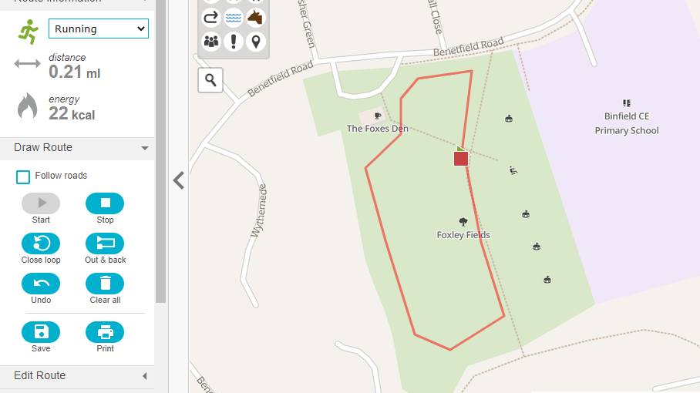  5 Laps of Foxley Field | 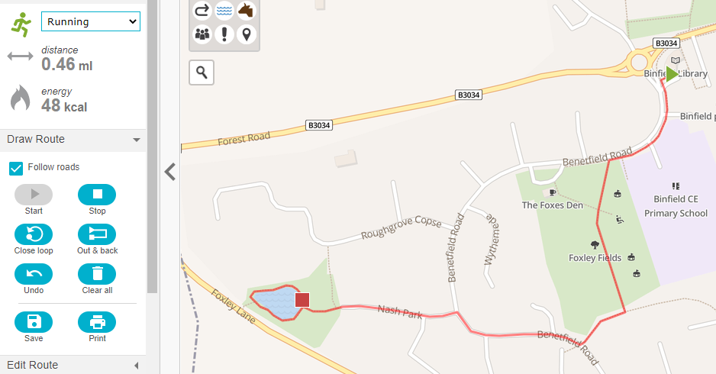  Start at the Library and run through Foxley fields to the pond, round the pond and back to the Library. | 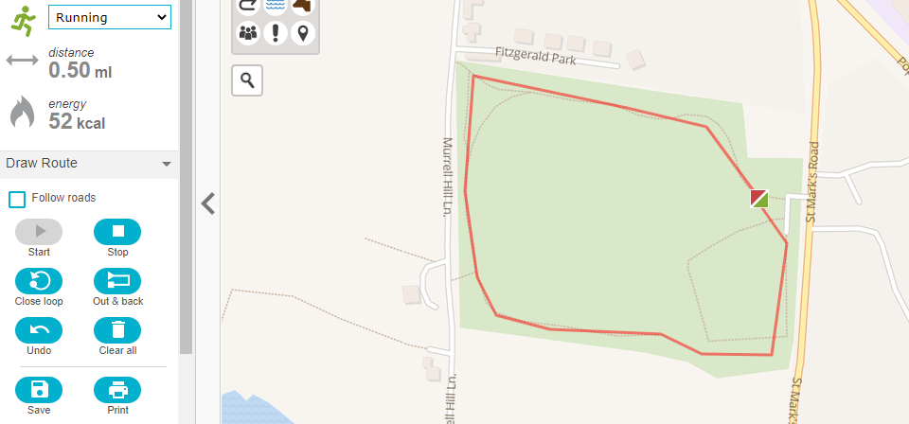  2 Big loops around Popes Meadow
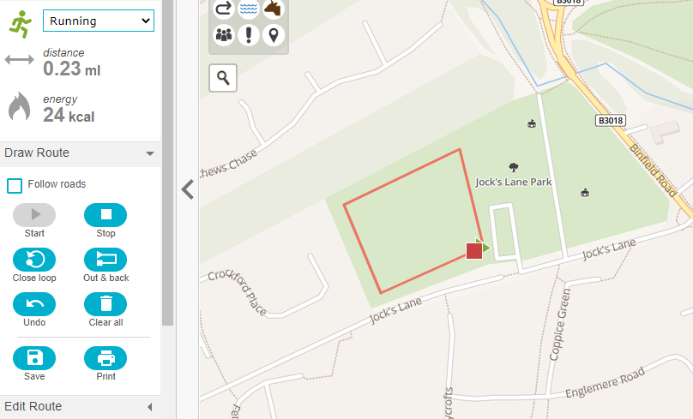  5 laps of the Big Field at Jocks Lane | 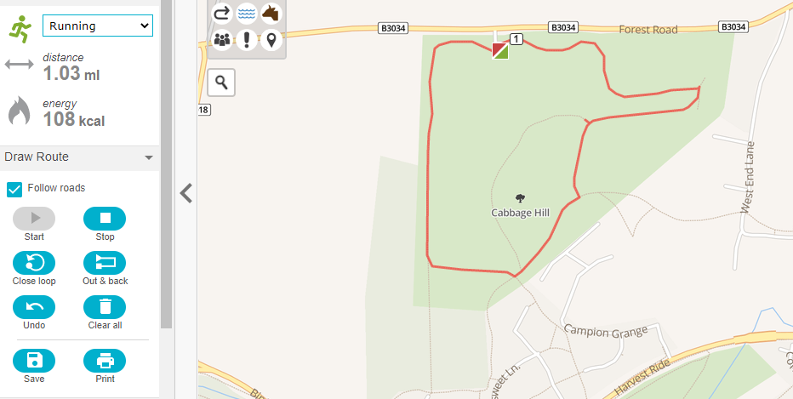  1 Lap around Cabbage Hill | 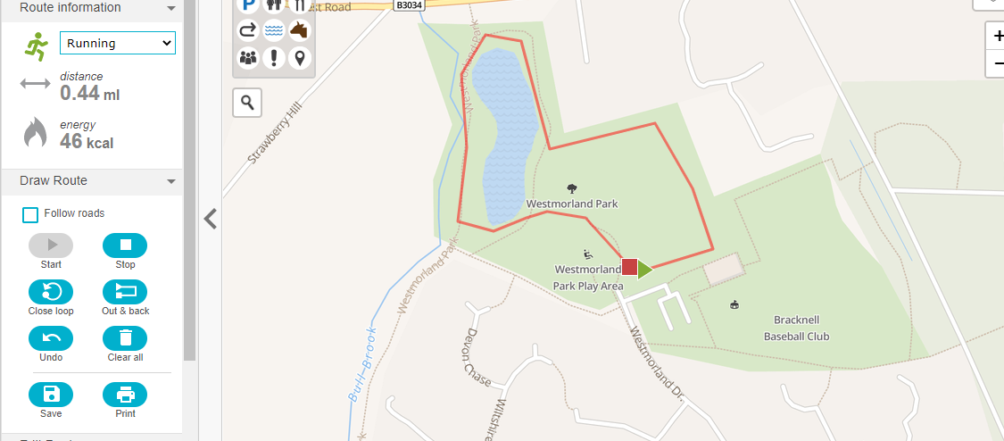  2 laps around the pond and bottom field at Westmorland Park

Sport Skills
Monday: Catching – Catching is really important in lots of sports! Mr Gooch is our school PE teacher and has made a catching challenge video on the class page. Then you could have a go at these catching games from All Stars Cricket https://www.ecb.co.uk/video/383668/week-one-catching?tagNames=All%20Stars%20garden%20games What sports can you think of where you have to catch a ball?
Tuesday: Balancing – Balance is a really important skill in lots of sports. Have a go at this game, you can use a cardboard box instead of a paper bag. https://www.youtube.com/watch?v=5KG_GtNUDOk
Wednesday: Agility – Agility is how quickly you can change the direction you are moving. Watch this video of Mr Corbett, one of the coaches you might have teaching your PE lessons next year, showing you a game to improve your agility (https://twitter.com/ProActiveTE/status/1247509451596337154)
Thursday: Throwing – Watch Mr Gooch’s Target practice throwing game on the class page. Can you think of a time in sport where throwing accurately is important?
Friday: Reaction time – Reaction time is how quickly you can see something happening and do something about it. Watch the video of Mr Johnson explaining two reaction time games that you can play. Can you think of a time in sport when you would need to react quickly?

Mrs Bowles’ daily challenge
Mrs Bowles has filmed a new challenge for you to have a go at every day, check the video out on the class page! You could try it again each day and see if you could beat yesterday’s score/time!
Sport/fitness activities
Monday: Circuit Training - First watch the video of Mrs Bowles explaining how to warm up properly before exercising. You wan watch this video to warm up before all the activities this week! Then, watch the video of Mrs Bowles explaining circuit training and then make up a fitness circuit in your house or garden. You can choose any exercises you want! Complete one exercise, have a rest and then move on to the next station. You could use this video timer to help you https://www.youtube.com/watch?v=sliowOd_1f0
Tuesday: Basketball – Watch the video of Mr Johnson explaining basketball. Can you learn some of the key skills like bouncing the ball, walking around while bouncing the ball and shooting the ball into a target. You could put a box or basket somewhere instead of a hoop for you to aim the ball into.
Wednesday: Dance – Here are a couple of funny dances that you can learn https://www.youtube.com/watch?v=fpD9kRyBn8o & https://www.youtube.com/watch?v=GxKb_VHCYdc. You could also search on youtube for the dance to your favourite song or the ‘just dance’ versions.
Thursday: Football – Watch Mr Johnson’s video showing you some football practice activities. Have a go at the dribbling and shooting games!
Friday: Yoga – Lots of people have been doing yoga while at home because it is a good way to relax and do some exercise at the same time. There are some poses in the resource section that you can copy. Then you can choose a video to do some more yoga – either https://www.youtube.com/watch?v=oWLSLpcF0iY if you want a quiet yoga session or choose a ‘Cosmic Kids yoga’ video on youtube if you want an active version with a story to follow (there are loads of different video themed ones).
Other activities
Monday: Design your own team kit – Imagine that you want to make your own sports team. You can choose any sport and design clothes for that team. Here are some examples of interesting kits that you could borrow ideas from.
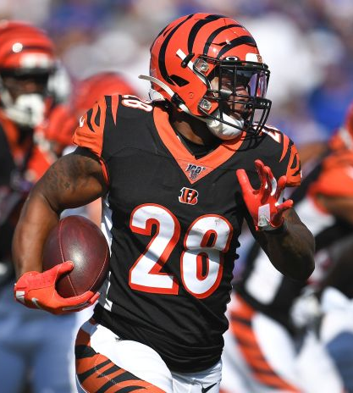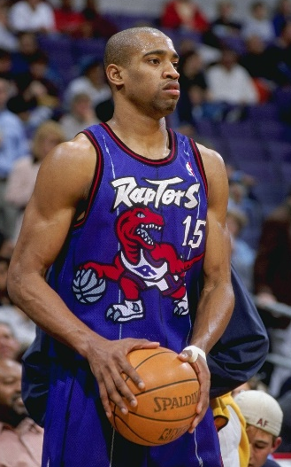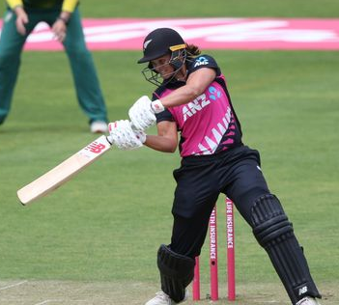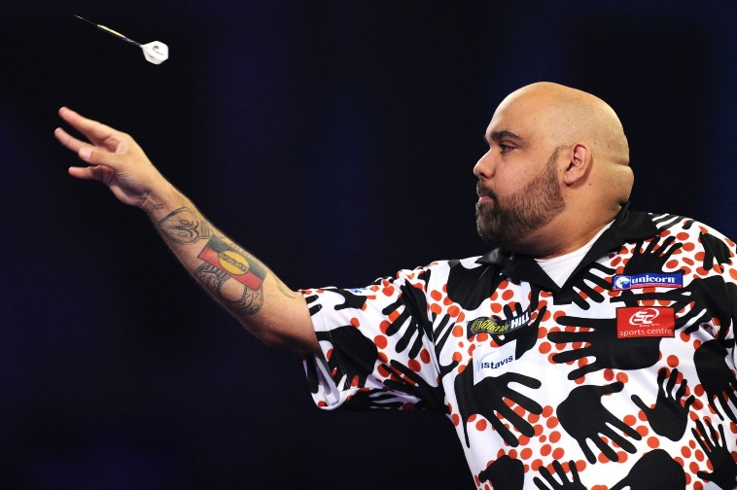
Tuesday – Think about what happens to your body during exercise. Can you write some sentences to explain what happens. Think about your heart, how hot you feel, your breathing and how much energy you have left!
Wednesday – When you exercise you need lots of healthy food to repair your body and give you more energy. Can you design a healthy meal that you could eat after doing some exercise? You could draw a picture and label it or maybe even make a cooking video.
Thursday – Have a look at the sport activities on Purple mash and choose one or more to complete https://www.purplemash.com/#tab/pm-home/topics/sport
Friday – Have a go at the Olympic sports crossword in the resources section. We haven’t done one at school before so you may need a grown up to explain it to you! They are great for spelling practice!
Friday – Yoga poses
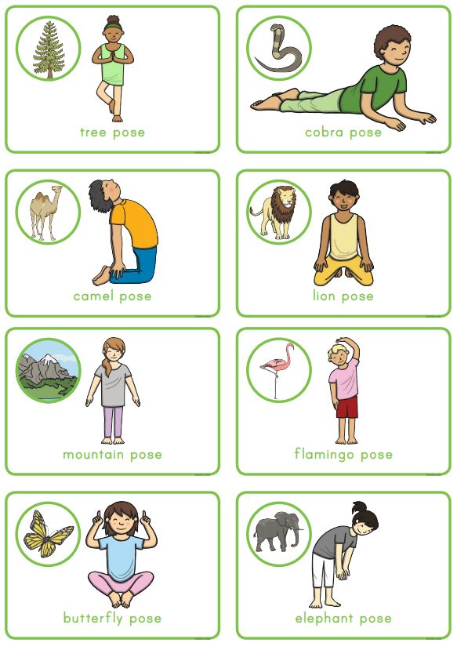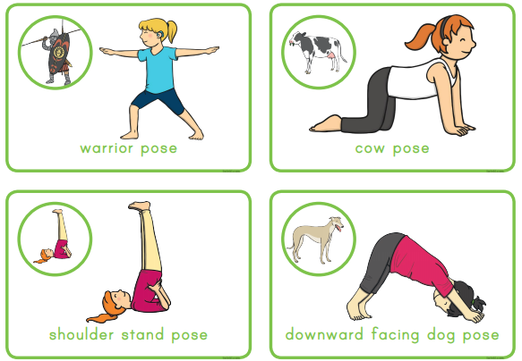
Friday - Olympic sport Crossword


