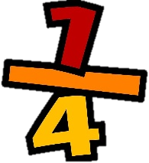
19/05/2021 LO: To use fractions C: To recognise and find a 1/4.
Definition
Facts and/or characteristics
Examples
Non - examples
Concept

