
Reception distance learning – wb 27.4.2020
For more detailed information on activities, please see plans below the timetable!
Monday | PE | Read Write Inc | Reading | Playtime! | Writing | Maths | Lunchtime! | Handwriting/ Fine motor skills | Personal, Social and emotional development | Story time
Tuesday | PE | Read Write Inc | Reading | Playtime! | Writing | Maths | Lunchtime! | Handwriting/ Fine motor skills | Expressive arts and design (music) | Mindfulness
Wednesday | PE | Read Write Inc | Reading | Playtime! | Writing | Maths | Lunchtime! | Handwriting/ Fine motor skills | Understanding the world (Geography) | Communication and language
Thursday | PE | Read Write Inc | Reading | Playtime! | Writing | Maths | Lunchtime! | Handwriting/ Fine motor skills | Expressive arts and design (Art/DT)
Friday | PE | Read Write Inc | Reading | Playtime! | Writing | Maths | Lunchtime! | Handwriting/ Fine motor skills | Mindfulness | Story time

Read Write Inc.
Monday – Watch the video of Mrs Evans teaching the ‘air’ sound. Write a list of the ‘air’ words you can think of.
Tuesday - Watch the video of Mrs Evans teaching the ‘igh’ sound. How many ‘igh’ words can you think of?
Wednesday - Watch the video of Mrs Evans explaining some RWI games you can play. Choose a game and play it with someone else.
Thursday – Find a book that a grown up in your family likes reading. Can you use your phonics to rad some of the words that are in that book?
Friday – Play a different game from Mrs Evans RWI games video.

Reading
Monday – visit https://www.booktrust.org.uk/books-and-reading/have-some-fun/storybooks-and-games/rumble-in-the-jungle/ see how many words you can read along with. At end of the story answer: what animals were in the story? Where were they? What are the similarities and differences between the animals?
Tuesday – Watch the video of the book ‘Commotion in the Ocean’ https://www.youtube.com/watch?v=DgNmD7xgvzU Listen carefully to the words. What do you notice about the sounds in some of the words? Are some of the sounds the same or similar? Why do you think the book is written in this way? How does it make you feel? Is it similar to ‘Rumble in the Jungle’? Why? How?
Wednesday – Go onto Oxford Owl. Search ‘animals’ in the search bar. Choose either ‘When Animals Invade ‘or ‘Incredible Animals’ to read with someone who can support you. Talk to an adult or sibling about what facts you have found out.
Thursday –Read the story ‘The Gruffalo’ by Julia Donaldson. If you do not have the book you can access it here https://www.youtube.com/watch?v=6_N6ydYWiCs The Gruffalo is a made up animal that does not exist in real life. How is the Gruffalo described? What are his favourite foods? Design your own made up animal and think of how you would describe it. Also, think about what its favourite things to eat are! You can watch The Gruffalo short film for free on BBC iplayer.
Friday – Go onto Oxford Owl and complete the word endings online activity. It can be accessed here: https://www.oxfordowl.co.uk/api/interactives/24641.html
Writing
Monday – Watch the videos on the class page of Mrs Bowles telling you some fun facts about animals. There are videos about tigers, elephants and Mrs Bowles’ dog Noah! Create a fact file about some animals that you would like to write about. You can use fact books or research on the internet about the animals.
Tuesday – After reading the story ‘Commotion in the Ocean’ write sentences about the various animals that live in the ocean. Use the wordmat in the resources section at the end of this document to help you.
Wednesday – What can you see under the sea? Use this picture to help you write about the things you can see in the sea. For example: ‘the fish can swim and they have yellow, shiny fins’. Remember to use your finger spaces and full stops!
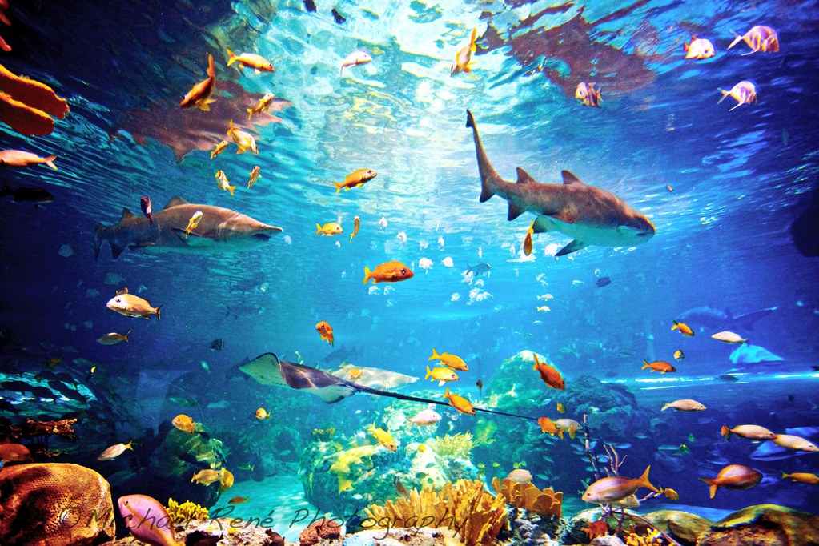
Thursday – Write labels on the Gruffalo picture at the end of this document. Can you remember how Julia Donaldson described him?

Friday – Add labels to your picture of your imaginary animal. How do you describe them? Write a sentence below your picture about what your animal’s favourite food is!

Spelling
Practice learning these words each day. You could copy them out, go on a word hunt or set a spelling challenge for yourself or someone else
put push pull full one

Handwriting/ Fine motor skills
Monday- Practise these handwriting patterns below:
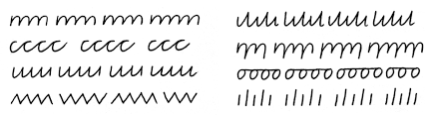
Tuesday- Carefully trace over the dots to create a picture of a hammerhead shark!
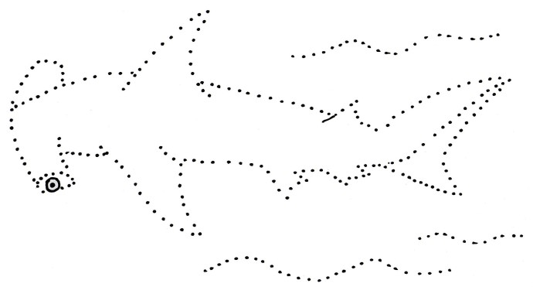
Wednesday- Practise cursive writing carefully using the sheet below:
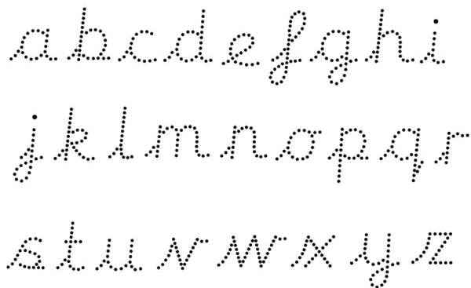

Thursday- Visit https://www.gruffalo.com/activities/activities/new-the-gruffalo-finger-puppets! Complete the cutting activity!

Friday- Copy the words from the tricky word sheet in the resources section of this document.

Monday | Tuesday | Wednesday | Thursday | Friday
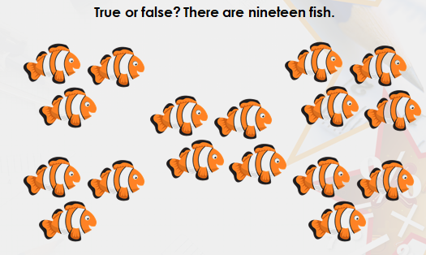  How do you know? What is the best way to check?  Draw your own representation of the number nineteen | 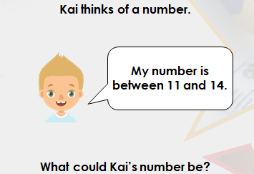  Next, Complete the challenge on Showbie! | 1.Circle the numbers that are more than 13:  11 16 19  2. Circle the numbers that are less than 17:  16 18 7  3. Write 3 numbers less than 12, write 3 numbers more than 12  4. Write 3 numbers more than 10, write 3 numbers less than 10 | Complete the 1 more than worksheet in the resources section  Watch the video of Mr Johnson explaining how to use a numberline to help you. | Complete the what comes before and after worksheet in the resources section
Maths

PE
Watch how animals move on this video https://www.bbc.co.uk/bitesize/clips/z6ntsbk and practise moving like the different kinds of animals. Next, play https://www.youtube.com/watch?v=25_u1GzruQM
Remember you can also do the daily Joe Wicks exercise video!

Personal, Social and Emotional Development
Create a worry tree: Are you worried about something? You can write down your worries and talk to an adult about them. By writing down your worries, the worry tree will take them from you. Visit the Well-being class page on the website for resources and support if you are worried about anything.
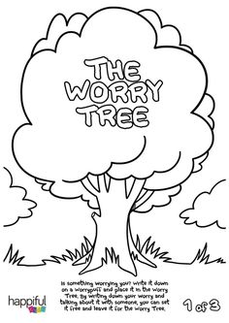

Expressive Art and Design
Use Junk and any craft resources you have around the house to make a junk animal. Mrs Bowles has made a video to show the model she has made, you can find it on the class page! Here are some other ideas that you can use for inspiration!
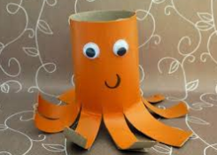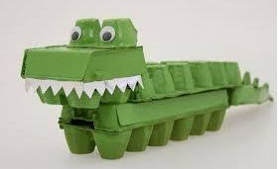
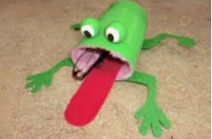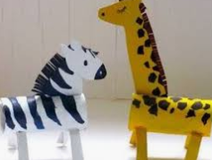

Communication and Language
Go on a sound hunt. You can do this in your garden or when you go out for your daily exercise. What can you hear? Tell the person you are with how many different things you can hear!
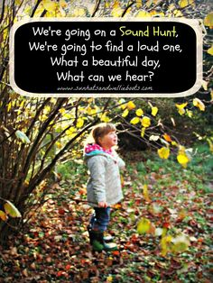

Understanding the world
Science - Complete the activity on Oxford Owl (Crack the Code – Animal Colours and Markings) you can find it here: https://cdn.oxfordowl.co.uk/2019/04/24/09/58/39/30/ColourCodes_CrackTheCode.pdf
Geography - Complete the animal homes activity on Purple Mash

Resources
Writing
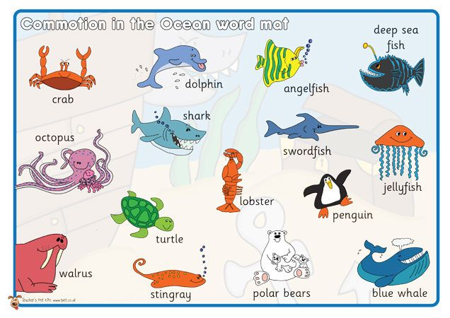
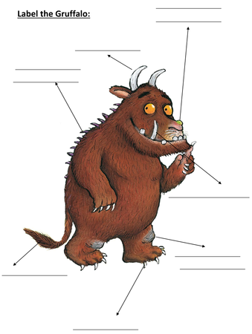
Handwriting

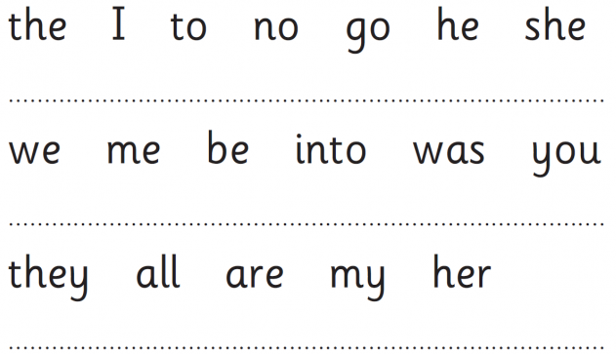

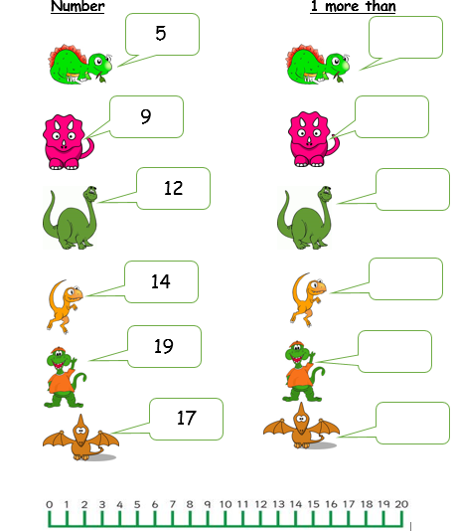
Maths


