
Reception distance learning – wb 06.07.2020
For more detailed information on activities, please see plans below the timetable!
Monday | Maths | Read Write Inc | Playtime! | Reading | RE | Lunchtime! | Fine motor skills | Writing
Tuesday | Maths | Read Write Inc | Playtime! | Reading | PE | Lunchtime! | Fine motor skills | Writing
Wednesday | Maths | Read Write Inc | Playtime! | Reading | Art | Lunchtime! | Fine motor skills | Writing
Thursday | Maths | Read Write Inc | Playtime! | Reading | Music | Lunchtime! | Fine motor skills | Writing
Friday | Maths | Read Write Inc | Playtime! | Reading | Mindfulness | Lunchtime! | Fine motor skills | Writing

For the next two (and a bit) weeks, the focus will be on transition from Reception to Year 1. While this will not involve our usual activities, especially working in the Year 1 classrooms as much as possible, we will try our best to support your child through the process!

Maths

Weekly focus – Advanced Calculations (including more than two numbers and missing numbers)

Monday – Watch Mr Johnsons introduction video on adding more than 2 numbers together. Play the game he shows you and draw pictures to prove your answers.
Tuesday – Draw your own 0-20 numberline. Complete the add 3 numbers sheet in the resources section. Discuss with an adult whether you find using a numberline or using objects/pictures easier.
Wednesday – Today we are going to try and do some subtraction calculations with more than two numbers. It will be easier for you to start with the biggest number and take the smaller numbers away. Use objects, draw pictures or use a numberline to help you calculate answers to the questions in the resource section.
Thursday – New topic – missing number calculations. Watch the video of Mr Johnson introducing missing number calculations. Work through the questions along with the video! Now try the calculations in the resource section.
Friday – Today, to make it a bit trickier, there are addition and subtraction calculations with missing numbers. Work through the calculations below. M<ake sure you do the right process so look carefully to see if it is an add or subtract calculation!
5 + = 7
7 - = 3
4 + = 5
10 - = 6
2 + = 2
1 + = 4
5 - = 3

Read Write Inc.
Monday – Watch the letter formation video on the class page. Write out all the letters just like the video. Make sure you are starting on the line and remembering your lead-ins!
Tuesday – In year one you do lots of alien word reading! Have a go at the first page of alien words in the resource section!
Wednesday – Can you write a word that begins with every letter of the alphabet?
Thursday – Have a go at the next page of alien words. These ones have special friends in. Can you spot them?
Friday – Have a go at this alien escape phonics game! - https://www.phonicsbloom.com/uk/game/alien-escape?phase=3

Reading
Monday – Go to the stories on the Year 1 class page. Listen to the poem ‘Now we are six’. Look at the words on the screen and tell an adult any red words you can see.
Tuesday – Complete the reading comprehension activity in the resources section. Read the words carefully to see what you need to draw/colour. Try and do it without an adults help!
Wednesday – Watch Mrs Bagshaw read the story ‘A Tiger who came to tea’. Talk about what would happen if your favourite animal came to tea at your house!
Thursday – Have a look at the red words in the resource section. How many can you read? Some of these are really tricky!
Friday – Find the matching game in the resources section. Can you read the sentences and then match them up with the correct animal?

Fine Motor skills/Handwriting
On each day this week, choose an activity from the Year 1 ‘fine motor skills’ section on their class page! Lots of the skills are the same as in Reception, so you already know what you are doing!

Writing
Weekly focus: Transition booklet – writing for a purpose
Monday – Watch the Video of Mr Johnson explaining our transition booklets that will tell our new teacher all about us (and show off our best writing!) Today your challenge is to draw a picture of you and write at least 3 sentences to tell your new teacher what you look like. Remember your capital letters, finger spaces and full stops!
Tuesday – On today’s page, draw a picture of you doing your favourite activities in Reception. It could be playing on the scooters, going to the bole, working at the art table or anything else we have done. Use the word ‘favourite’ to write a sentence or two about what activity your picture shows.
Wednesday – Today, draw a picture of some of your friends at school. Write sentences to explain why they are your friend and tell your new teacher something that person does that is kind and makes you want to be their friend.
Thursday – Today, draw a picture and write about what you like doing when you are not at school. Your new teacher would love to know about your hobbies or your favourite things to do at weekends.
Friday – On today’s page, write some questions that you would like to ask your year one teacher. You can ask them about Year 1 things or you could ask them about some of their favourite things. Remember to show them how great your question marks are!

RE
Watch the story of the lost sheep (https://www.youtube.com/watch?v=094upaf4BME). Think about how kind the shepherd was in the story. Have you been kind to someone else recently? What did you do? Has anyone been kind to you recently? What did they do? Its much nicer when everyone is kind to each other! What could you do today to be kind to your family?
PE
Watch the video of Mr Johnsons catching activities. Have a go yourself and practice your catching!
Music
Have a go at this online music maker. Can you make a really cool song? https://musiclab.chromeexperiments.com/Song-Maker/
Art
Have a go at the ‘how to draw a dog’ challenge in the resources section.

Mindfulness
Watch the video on the ‘Mindfulness’ page of the school website of Mrs Duncan talking about worries. Are there any things you are worried about when you think about Year 1? Write them down on a piece of paper and you can speak to your new teacher about them when they call you to say hello soon. Also, Mr Johnson was a teacher at Binfield in Year 1 for 3 years, so you could ask him about them in your weekly call or get your parents to email the school!

Resources
RWI – Tuesday
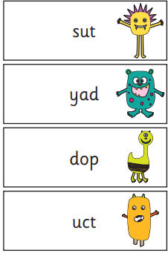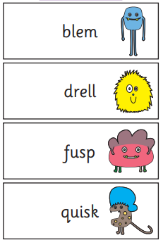

RWI – Thursday
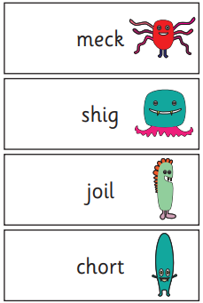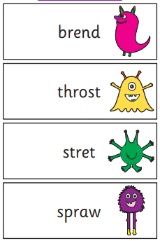

Reading – Tuesday
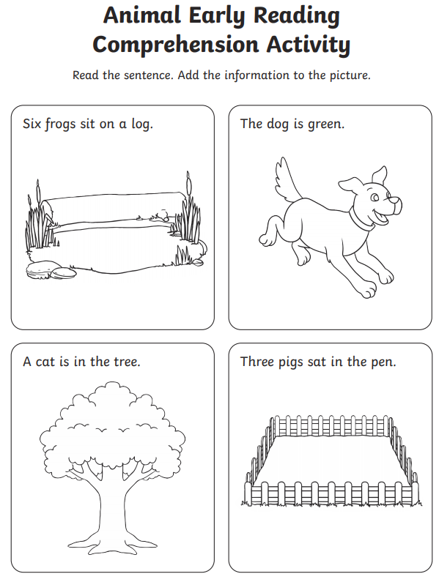

Reading - Thursday
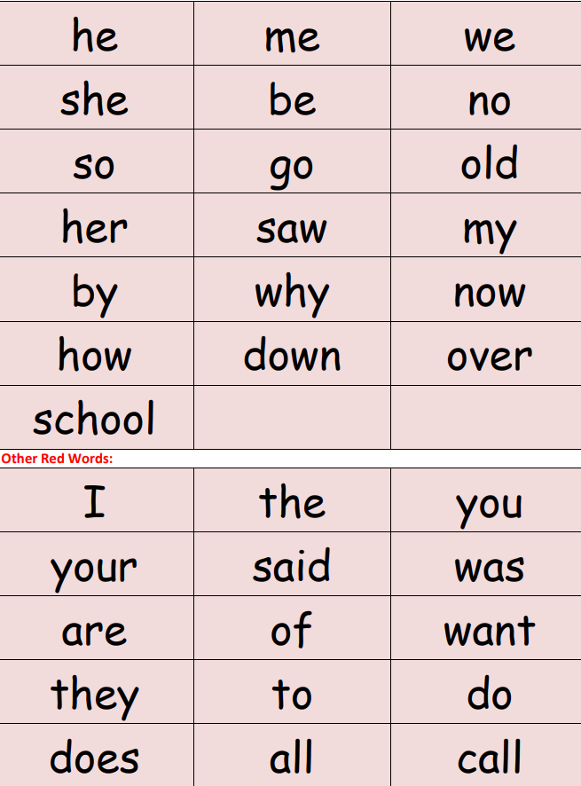
Reading - Friday
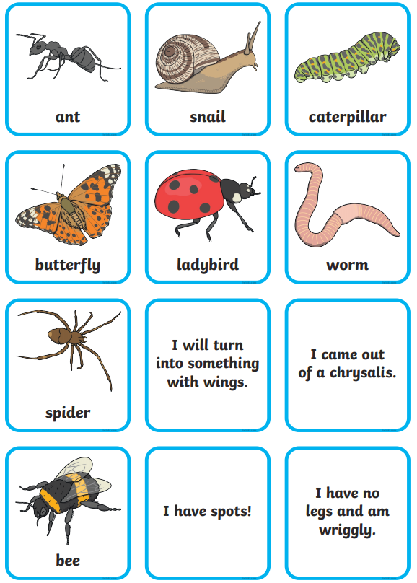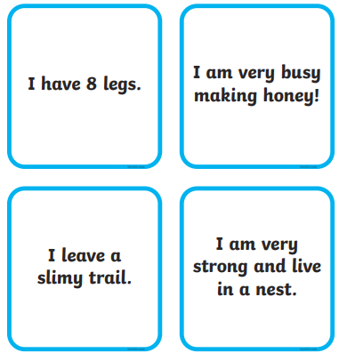

Maths – Tuesday

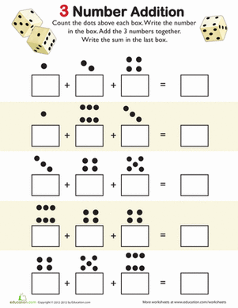

Maths – Wednesday
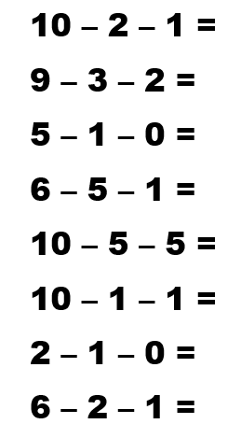

Maths – Thursday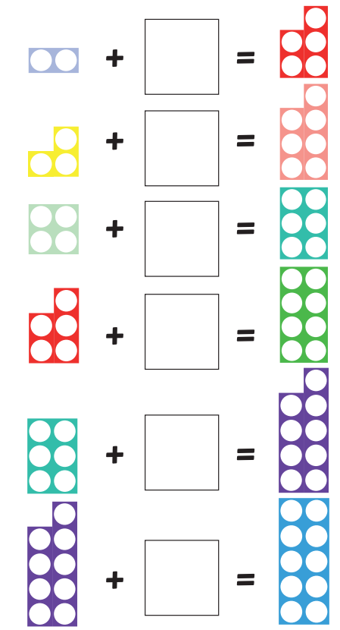

Art


