
Reception distance learning – wb 22.6.2020
For more detailed information on activities, please see plans below the timetable!
Monday | Maths | Read Write Inc | Playtime! | Reading | RE | Lunchtime! | Fine motor skills | Writing
Tuesday | Maths | Read Write Inc | Playtime! | Reading | PE | Lunchtime! | Fine motor skills | Writing
Wednesday | Maths | Read Write Inc | Playtime! | Reading | Art | Lunchtime! | Fine motor skills | Writing
Thursday | Maths | Read Write Inc | Playtime! | Reading | Music | Lunchtime! | Fine motor skills | Writing
Friday | Maths | Read Write Inc | Playtime! | Reading | Mindfulness | Lunchtime! | Fine motor skills | Writing

Maths –

Weekly focus – Addition

Monday – Watch the video of Mrs Gogarty on addition. Complete the robot addition game (select addition to 20) https://www.topmarks.co.uk/addition/robot-addition
Tuesday – Complete the word problems found in the resources section!
Wednesday – Watch Mr Johnson’s video on using number lines again. Then, complete the addition sums found in the resource section.
Thursday – Go to http://www.ictgames.com/funkyMummy/index.html and complete the funky Mummy game (click on + up to 20 button)
Friday – Complete the numicon worksheet found in the resource section!

Read Write Inc.

Monday – Go to https://www.oxfordowl.co.uk/api/interactives/26331.html click on ‘set 2 speed sounds slideshow’ see how speedy you can be with your set 2 sounds! Can you think of any words that have these sounds in? Have a go at writing some words with these sounds in!
Tuesday – Just like yesterday, go to https://www.oxfordowl.co.uk/api/interactives/26334.html and click on ‘set 3 speed sounds slideshow’ see how speedy you can be with your set 3 sounds! Can you think of any words that have these sounds in? Have a go at writing some words with these sounds in!
Wednesday – Go to https://www.oxfordowl.co.uk/api/interactives/29093.html and complete the speedy set 2 sound green words. Choose some green words from the slideshow and write sentences including these words.
Thursday – https://www.oxfordowl.co.uk/api/interactives/29317.html download the RWI set 2 and set 3 sound books. Go through each sound, how speedy can you be? Can you remember the rhymes? Did you find any tricky? If you found some of the sounds tricky, watch the video again found on the class page under the RWI stage 2 and stage 3 teaching videos.
Friday – Go onto Oxford Owl ebooks page https://www.oxfordowl.co.uk/for-home/find-a-book/library-page/?view=image&query=&type=book&age_group=&level=&level_select=&book_type=&series=Read+Write+Inc.# choose a book that you would like to read that includes set 2 or set 3 sounds (this is displayed on the front cover)

Reading
Monday – Complete the worksheet found in the resource section!
Tuesday – Watch the video of Mrs Gogarty reading the first few pages of Charlie and the Chocolate factory by Roald Dahl. You may want to close your eyes and imagine whilst you listen to the story! What do you think will happen next?
Wednesday – Watch Mrs Gogarty read the final few pages of Charlie and the Chocolate factory, chapter one.
Thursday – Complete the quiz found on the class page!
Friday – Look at the picture of the characters, what do you think they are going to be like, why?
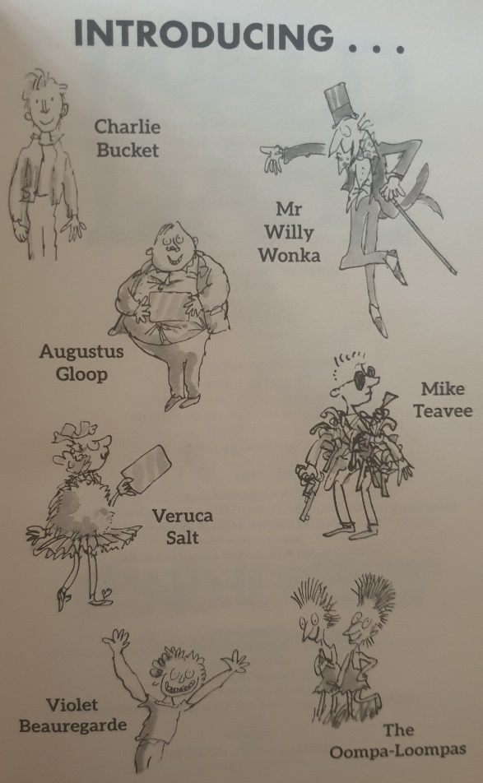

Fine Motor skills/Handwriting
Monday – Colour in the Willy Wonka door hanger carefully! We would love to see them on Showbie!
Tuesday – Use playdough to create your own imaginary sweets/ chocolates! You can add glitter, food colourings and flavourings to make some fun dough! You could even make up some names for your candy inventions!
Wednesday – Complete the mindfulness colouring in sheet of Willy Wonka’s golden ticket!
Thursday – Sprinkle some coco powder into a small tray or container, practise your cursive letters by using your finger!
Friday – Practise writing these words: chocolate, sweet, factory, candy, lolly pop, ticket.

Writing
Weekly focus (Roald Dahl- Charlie and the Chocolate factory)
Monday – Look at the Roald Dahl powerpoint presentation. Draw a picture of something that you have learnt from the presentation or draw your favourite Roald Dahl character. Then, write some new facts that you have found out about Roald Dahl.
Tuesday – Read the character description of Willy Wonka (found in the resource section). Draw a picture from the description, listening carefully to the detail and label it. Then, you can watch the grand opening clip here https://www.youtube.com/watch?v=qsgQvZOBhEY and you can see how Willy Wonka was portrayed in the original film. Does it match the book? How?
Wednesday – Design your own Wonka Chocolate bar, you can see the template in the resource section! Write sentences below describing what is in your Wonka bar!
Thursday – Willy Wonka themed science experiment – put a gummy bear in warm water and one in cold water. What happened to the gummy bears? Write sentences about the experiment using the words, ‘first’, ‘next’, ‘then’. We would love to see pictures on Showbie!
Friday – Willy Wonka themed science experiment – you will need a round plate and some skittles. Place your skittles or sweets onto a white plate, carefully pour water into the container, if the skittles move, just push them back into place quickly. What happened? Complete the worksheet found in the resource section! We would love to see pictures on Showbie!

RE
Song time! This little light of mine https://www.youtube.com/watch?v=recdOYUmSRQ join in with the actions! Let’s dance! https://www.youtube.com/watch?v=MPvnZILn6EY
PE
Watch the Oompa Loompa dance tutorial https://www.youtube.com/watch?v=nFxyUAjayyI join in with the dance moves! Can you make up your own dance to the Oompa Loompa song?
Music
Watch the video of Willy Wonka singing ‘Pure Imagination’ https://www.youtube.com/watch?v=LIYNk4ARUR8 How does it make you feel? Why? Then watch the Oompa Loompa’s singing https://www.youtube.com/watch?v=QkC8wPSmcPg. Listen to the instrumental version https://www.youtube.com/watch?v=IBsLWNWep3M use musical instruments to play and dance along to the song. You may want to create your own musical instruments by using pots and pans or putting rice into a bottle for a shaker!
Art
Use Lego or some blocks in paint to create Willy Wonka’s factory:
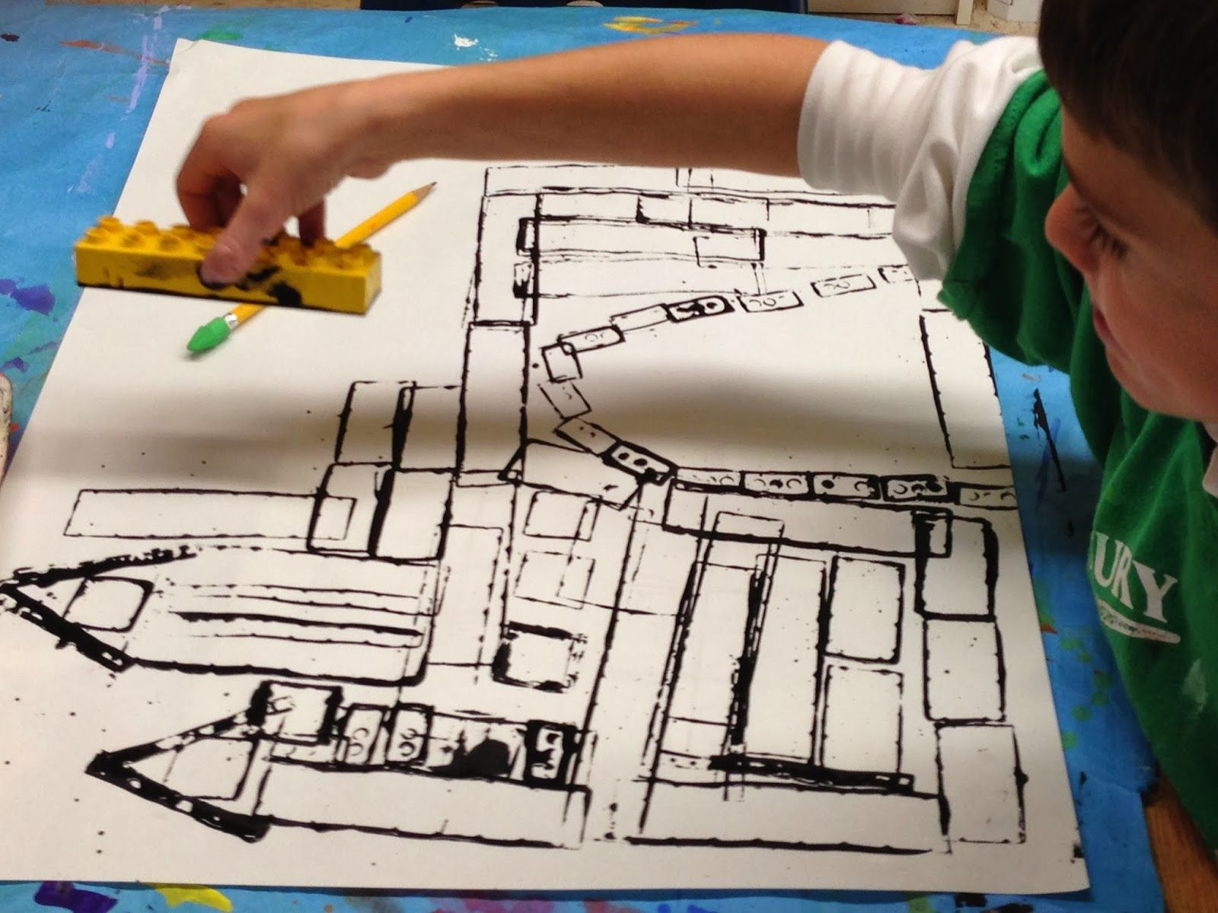

Mindfulness
Listen to ‘The Chocolate Room’ being described below, design your own Chocolate Room. What beautiful and yummy things would you have in your room?
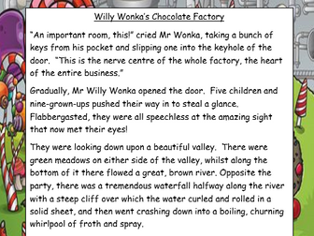

Resources
Maths – Tuesday
Sarah counted 5 birds in a tree and 4 more birds eating seeds. How many birds did Sarah see altogether?


Billy had 5 marbles and then his dad gave him 4 more. How many marbles did Billy have altogether?
+
=

Alvin counted 10 people in a queue, then 2 more came along. How many people were in the queue in total?
+
=

Hope went to the park with 9 friends, then 3 more friends came along. How many people were in the group altogether?
+
=

Theo had 5 toy cars, then he added 7 more. How many cars does that make?
+
=

Ted had 3 sweets, Fred gave him 12 more. How many sweets did Fred have in total?
+
=

Maths -Wednesday
6 + 5 = ____

1 2 3 4 5 6 7 8 9 10 11 12 13 14 15 16 17 18 19 20

16 + 4 = ____

1 2 3 4 5 6 7 8 9 10 11 12 13 14 15 16 17 18 19 20

9 + 5 = ____

1 2 3 4 5 6 7 8 9 10 11 12 13 14 15 16 17 18 19 20
7 + 3 = ____

1 2 3 4 5 6 7 8 9 10 11 12 13 14 15 16 17 18 19 20

4 + 11 = ____

1 2 3 4 5 6 7 8 9 10 11 12 13 14 15 16 17 18 19 20

Maths – Friday
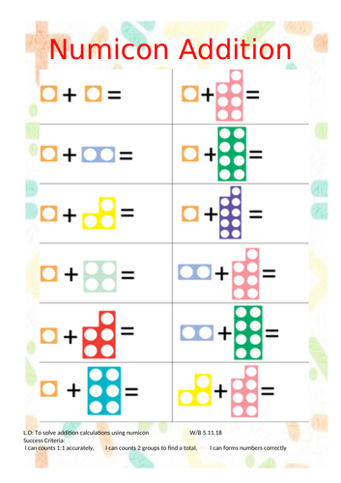

Reading – Monday
Why do you think it is called Charlie and the Chocolate Factory? | Read the blurb on the back of the book, does it make you want to read the book? Why? | What is your favourite part so far? Why?

Fine Motor/ handwriting -Monday
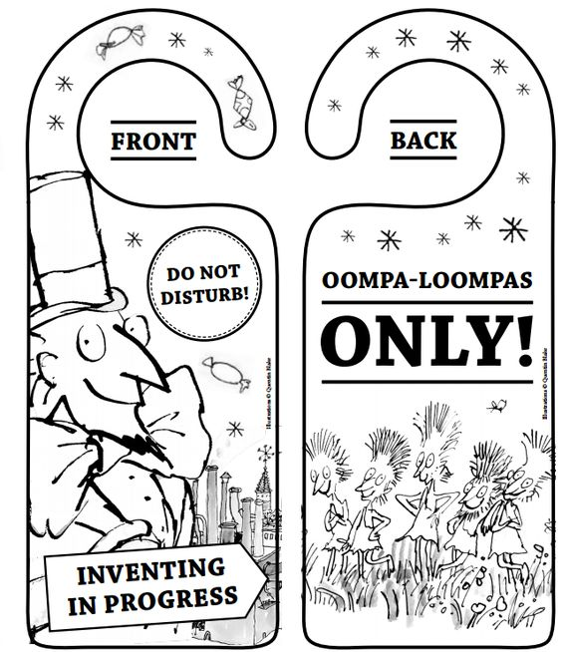

Fine motor/Handwriting– Tuesday
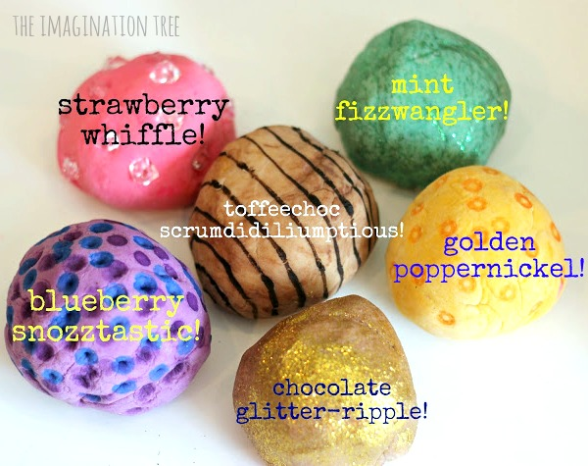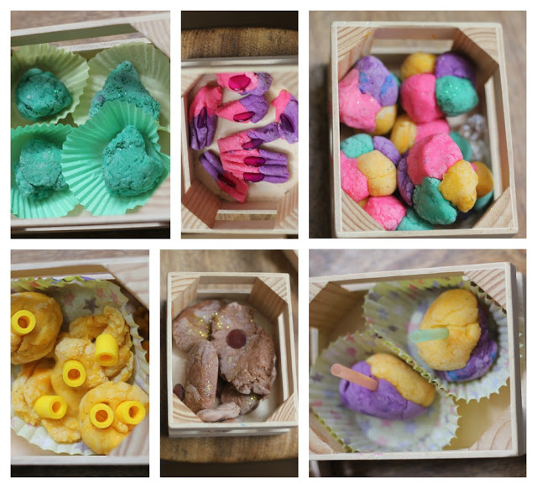

Fine motor/ Handwriting - Wednesday
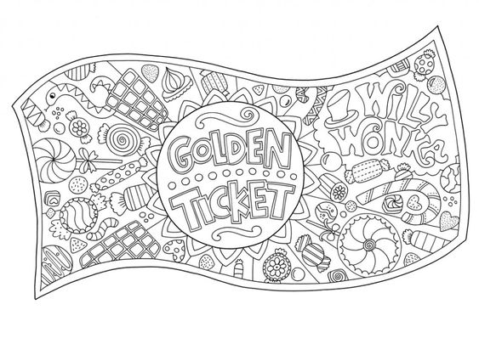

Writing -Tuesday
Willy Wonka
Mr Wonka was standing all alone just inside the open gates of the factory. And what an extraordinary little man he was! He had a black top hat on his head. He wore a tail coat made of a beautiful plum-coloured velvet. His trousers were bottle green. His gloves were pearly grey. And in one hand he carried a fine gold-topped walking cane. Covering his chin, there was a small, neat, pointed black beard- a goatee. And his eyes- his eyes were most marvellously bright. They seemed to be sparkling and twinkling at you all the time. The whole face, in fact, was alight with fun and laughter. And oh, how clever he looked! How quick and sharp and full of life! He kept making quick jerky little movements with his head, cocking it this way and that, and taking everything in with those bright twinkling eyes. He was like a squirrel in the quirkiness of his movements, like a quick clever old squirrel from the park.
Suddenly, he did a funny little skipping dance in the snow, and he spread his arms wide, and he smiled at the five children who were clustered near the gates, and he called out’ Welcome, my little friends! Welcome to the factory!’ His voice was high and flutey. ‘Will you come forward one at a time, please,’ he called out, ‘and bring your parents. Then show me your Golden Ticket and give me your name. Who’s first?’ The big fat boy stepped up. ‘I’m Augustus Gloop,’ he said. ‘Augustus!’ cried Mr Wonka, seizing his hand and punping it up and down with terrific force. ‘My dear boy, how good to see you! Delighted! Charmed! Overjoyed to have you with us! And these are your parents? How nice! Come in! Come in! That’s right! Step through the gates!

Writing – Wednesday
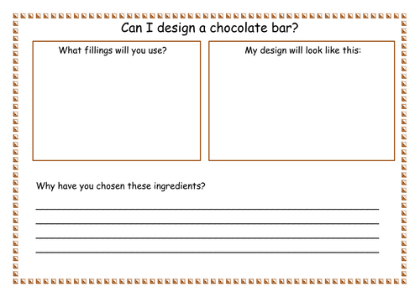
Writing -Friday


