
Reception distance learning – wb 4.5.2020
For more detailed information on activities, please see plans below the timetable!
Monday | PE | Read Write Inc | Reading | Playtime! | Writing | Maths | Lunchtime! | Handwriting/ Fine motor skills | Personal, Social and emotional development | Story time
Tuesday | PE | Read Write Inc | Reading | Playtime! | Writing | Maths | Lunchtime! | Handwriting/ Fine motor skills | Expressive arts and design (music) | Mindfulness
Wednesday | PE | Read Write Inc | Reading | Playtime! | Writing | Maths | Lunchtime! | Handwriting/ Fine motor skills | Understanding the world (Geography) | Communication and language
Thursday | PE | Read Write Inc | Reading | Playtime! | Writing | Maths | Lunchtime! | Handwriting/ Fine motor skills | Expressive arts and design (Art/DT)
Friday | PE | Read Write Inc | Reading | Playtime! | Writing | Maths | Lunchtime! | Handwriting/ Fine motor skills | Mindfulness | Story time

Read Write Inc.
Monday – Word hunt! Grab a few books and see how long it takes you to find the word ‘What’
Tuesday - How many things can you find in your house that begin with the Letter S? How many things can you find that start with the letter T? Write a list of both. Which has more?
Wednesday - Watch the video of Mrs Evans explaining some RWI games you can play. Choose a game and play it with someone else.
Thursday – Watch Mrs Evans teach you the ‘oy’ sound. Make a list of Rhyming words! Think of todays ‘oy sound’ – What words rhyme with ‘toy’?
Friday – Play jump in with an adult. You could choose one of your books or one of their books!

Reading
Monday – Look at the front cover of the book ‘Dear Zoo’. What animal do you think is in the cage? Why? Read the blurb and discuss what animals may be in the book. What animals do you see at the zoo? What would you like as a pet from the zoo? Read the story, if you don’t have the book at home you can view it here: https://www.youtube.com/watch?v=rudDGRQ9QGA Can you guess which animal is behind each flap?
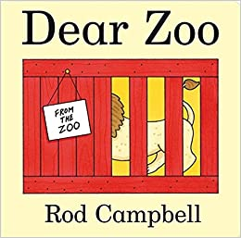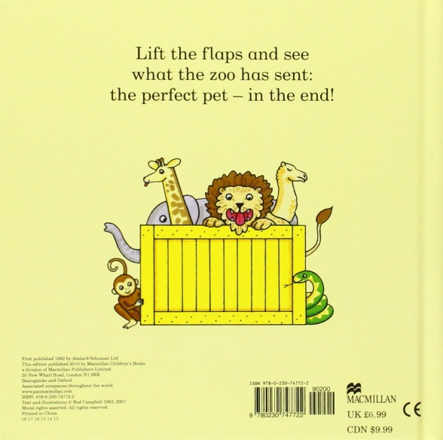
Tuesday – Watch Justin Fletcher’s video of him reading the story ‘Dear Zoo’. You can watch it here: https://www.youtube.com/watch?v=UywEnHKTMXk. Can you copy the Makaton actions for the animals? Can you remember what happens next? How are the actions similar to the words in the book? What actions can you think of for the animals?
Wednesday – Log on to Oxford Owl. Get someone to help you select an ebook that you are able to read. You may like to find a story about an animal. Here are some examples: ‘Fat Frog’, ‘Rag the Rat’, ‘Cats’.
Thursday – Listen and read along to the story ‘The Snail and the Whale’ by Julia Donaldson. https://www.youtube.com/watch?v=G_8QS_nyzM8. You can watch the Snail and the Whale for free on BBC iplayer. Discuss how the film is similar to the book, were there any differences?
Friday – Complete the phonics ‘The Snail and the Whale’ worksheet below:

Writing
Monday – Go to Marwell zoo’s online live webcams. Choose a video and write sentences about what you saw the animals get up to! This is also your task for Showbie this week, we would love to see your writing!
https://www.marwell.org.uk/zoo/keep-in-touch/webcams?rmsrc=1&gclid=EAIaIQobChMIwODP5uOG6QIVE-3tCh1AzQHUEAAYASAAEgIIkPD_BwE
Tuesday – Write your own letter to a zoo. What you like the zoo to send you as a pet? See template in the resources section.
Wednesday – Draw and write 4 things that the snail sees worksheet. Please see resource section.
Thursday – Write sentences about where you would like to go on an adventure just like the snail! You can use the template sheet in the resource section!
Friday – Think and discuss with an adult what might happen next in the story. If there was another page in the book, what could happen? Draw a picture and write sentences describing what is happening. Watch the video with Mrs Gogarty on the class page to give you some ideas!

Spelling
Practice learning these words each day. You could copy them out, go on a word hunt or set a spelling challenge for yourself or someone else
put push pull full one

Fine Motor/Handwriting
Monday – The Snail and the Whale colouring sheet. Please find colouring sheet within the resource section.
Tuesday – Decorate a new snail shell sheet. Please find sheet within the resource section.
Wednesday – Go to https://panmacmillan.azureedge.net/pmk11/panmacmillan/files/media/panmacmillan/blog-images/childrens/may%2019/make-a-whale-snail-and-the-whale-activity-sheet.pdf and see if you can create your own whale by carefully following the instructions. You will need some support from an adult for this activity and remember to use scissors safely!
Thursday – Complete the maze from the snail to the whale! Please find this in the resource section.
Friday – Can you make a snail using playdough? You can find a recipe for this in the resource section.
Maths
Monday | Tuesday | Wednesday | Thursday | Friday
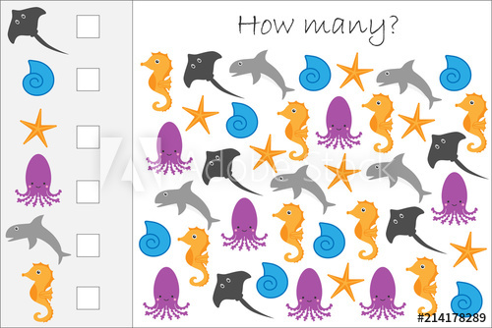  Create your own picture and count how many of each creature there are?  Challenge: Can you add some of the creatures together for example: Shells + dolphins =  Can you write this as a number sentence? | Go to:  https://mathsframe.co.uk/en /resources/resource/  547/Animal-Sorting-Maths-Game  Click on addition, then numbers to 20!  See how many calculations you can get correct! You may need support from an adult if you find it a bit tricky! | Go to Oxford Owl and complete the number sorting game to 20:  https://www.oxfordowl.co.uk /api/interactives/24461.html  Then play add to 20:  https://home.oxfordowl.co.uk / kids-activities/fun-maths-games-and-activities/ | 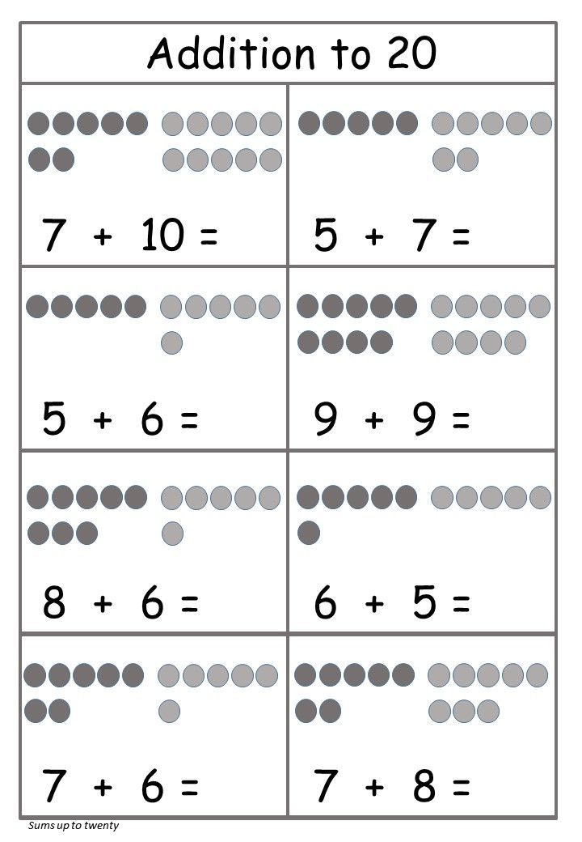 | Go to:  https://nrich.maths. org /7789  Look at the mathematical problem. You will need an adult to support you with this!  Who do you think won each race? Do you think the caterpillar changing to a butterfly made a difference? Why?
PE
Watch Cosmic Kids ‘Lulu the Lion’ and copy the actions https://www.youtube.com/watch?v=ZvJH8Kbzj54. Can you make up some of your own movements?
Remember you can do the Joe Wick’s workout on every day at 9am too!

Personal, Social and Emotional Development
Think back to the story of the snail and the whale (you could listen to it again!) Talk about these questions with a grown up.
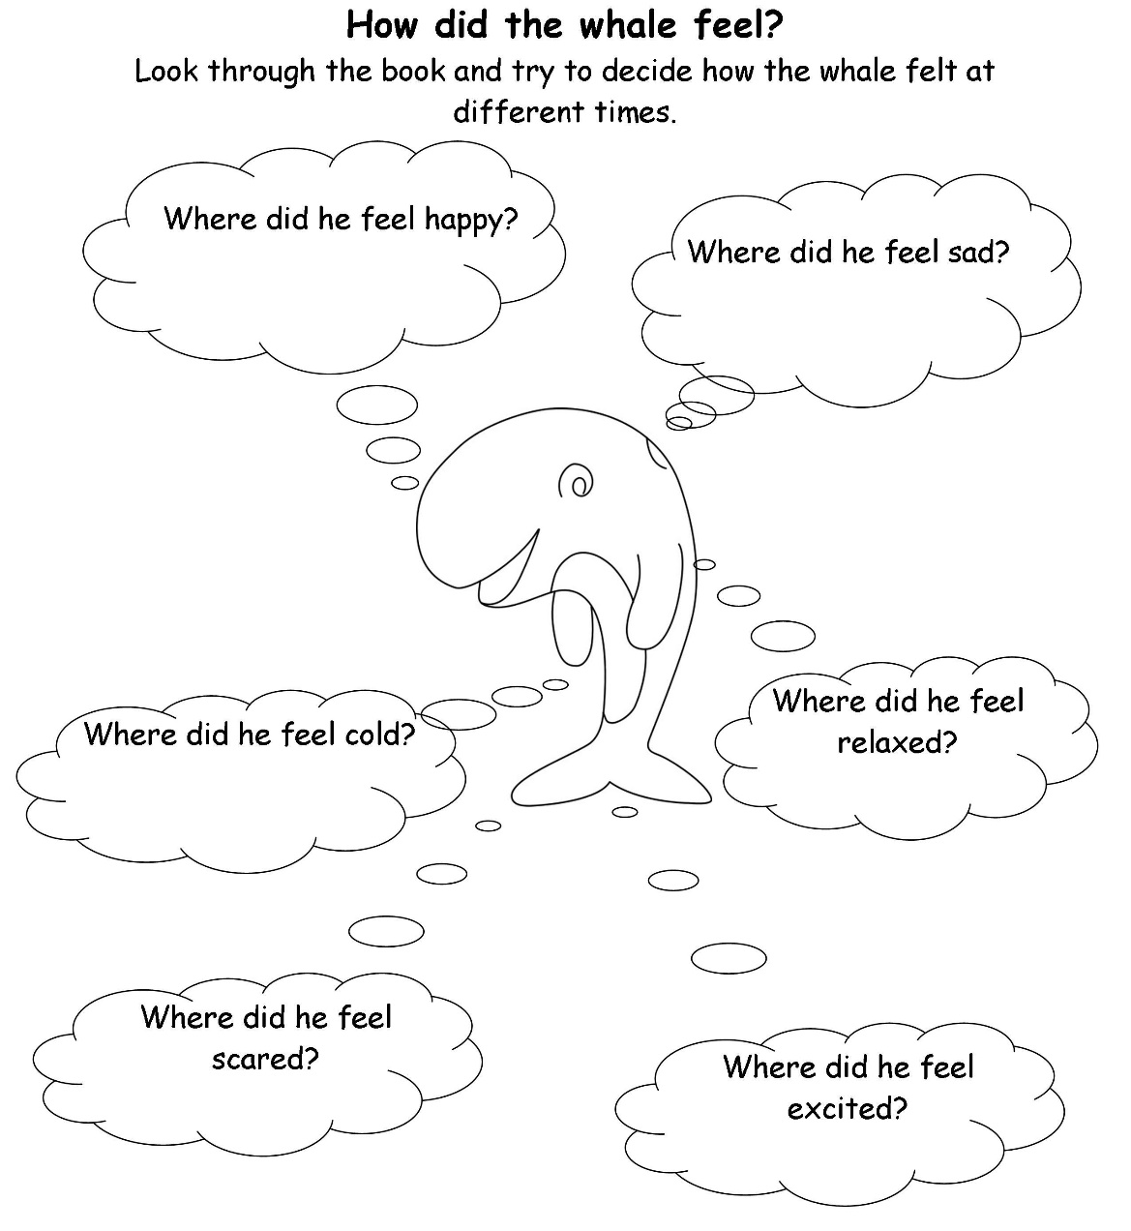

Expressive Art and Design
Music: Look on the class page and sing along with Mrs Bowles and Mrs Evans to some of their favourite animal rhymes!
Art: Watch Mrs Bowles’ video on toilet roll animals, see if you can make one yourself!

Communication and Language
Watch Andy’s Baby Animal’s here: https://www.bbc.co.uk/iplayer/episode/b08d61jw/ad/andys-baby-animals-11-playtime Discuss with a sibling or an adult what you saw during the episode. You could even draw a picture and explain what is happening in your drawing to someone!

Understanding the world
Geography - Visit https://www.bbc.co.uk/bitesize/dailylessons, click on age group (5-6years) and complete the daily lesson on ‘introduction to Africa’ in the geography section. This will be available every day from Tuesday!
Technology - Create your own fish on Purple Mash!

Resources
Writing activity – Wednesday
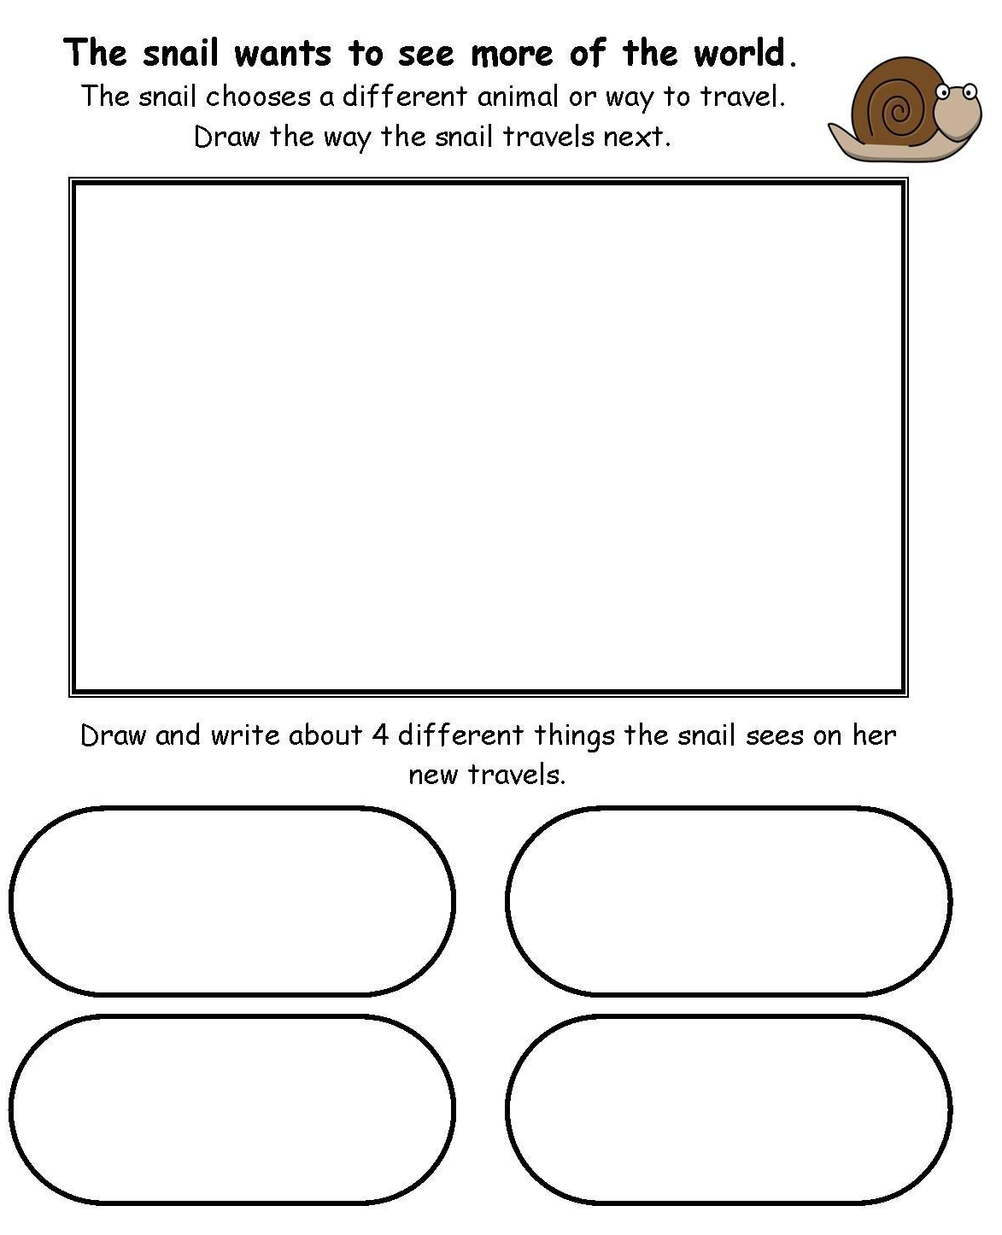
Writing – Thursday
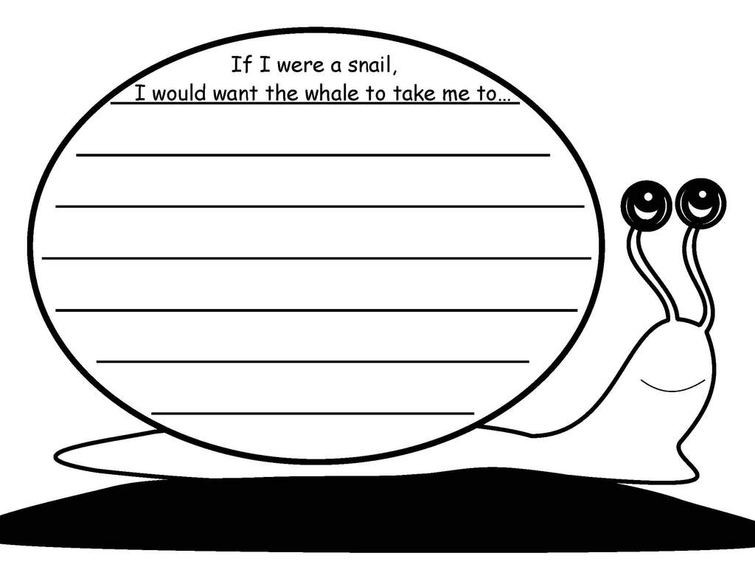
Fine motor activity - Monday
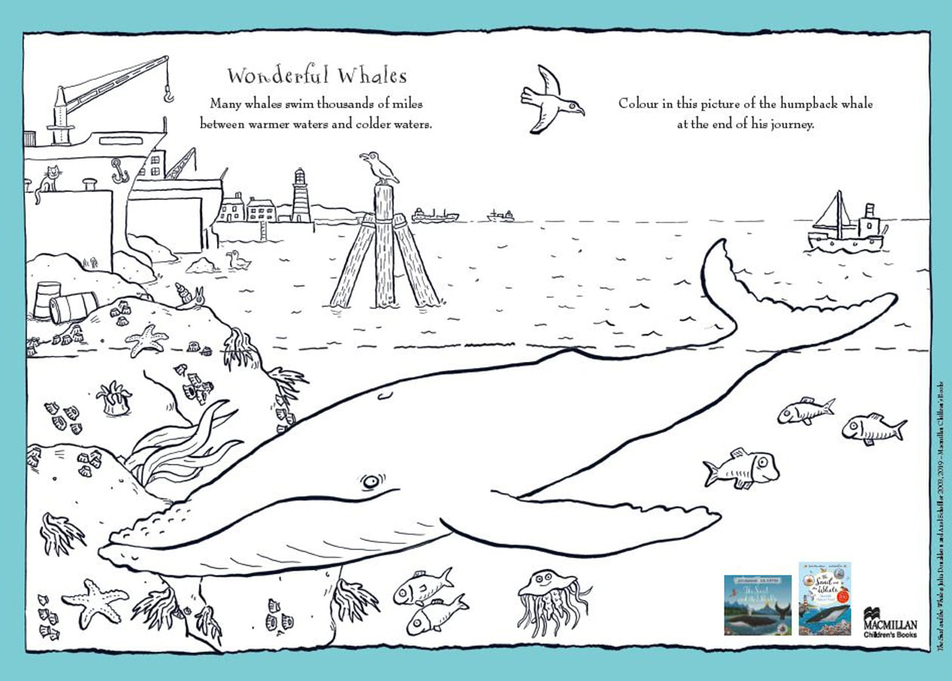

Fine Motor – Tuesday
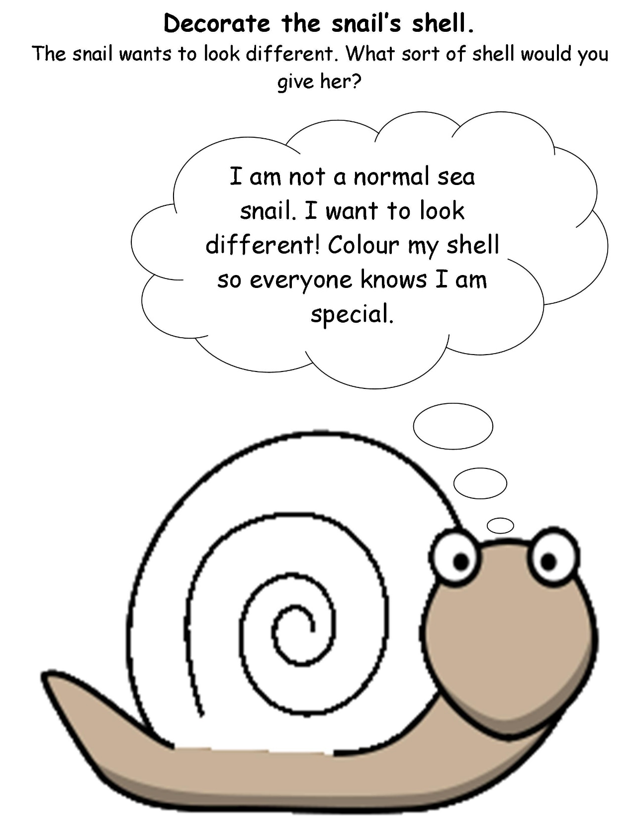
Fine motor – Thursday


