
Reception distance learning – wb 13.07.2020
For more detailed information on activities, please see plans below the timetable!
Monday | Maths | Read Write Inc | Playtime! | Reading | RE | Lunchtime! | Fine motor skills | Transition task
Tuesday | Maths | Read Write Inc | Playtime! | Reading | PE | Lunchtime! | Fine motor skills | Writing
Wednesday | Maths | Read Write Inc | Playtime! | Reading | Art | Lunchtime! | Fine motor skills | Writing
Thursday | Maths | Read Write Inc | Playtime! | Reading | Music | Lunchtime! | Fine motor skills | Writing
Friday | Maths | Read Write Inc | Playtime! | Reading | Mindfulness | Lunchtime! | Fine motor skills | Writing

Transition task
Your Year One teacher is going to call you this week to say hello and talk about Year One. If you haven’t had a chance to do it yet, have a look on the website at the 1BC (for Leopards) or 1LS (for Tigers) transition page (https://www.binfieldschool.co.uk/transition/) and watch the Hello videos and complete your challenge. If you have already done it, you can think of some questions to ask your teacher about Year One.

Maths –

Weekly focus – recap of years topics – Watch Mr Johnsons introduction video

Monday – Can you make a pattern with more than 2 colours or objects. You can get as complicated as you like!
Tuesday – How high can you count? Can you write all those numbers in order?
Wednesday – Complete the doubling activity in the resources section
Thursday – Complete the halving activity in the resources section
Friday – Practice using your number bonds to 10. These are really important in Year 1! You could write them down, draw pictures, use your fingers or use a numberline to work them out.

Read Write Inc.
Monday – Complete the ‘ng’ worksheet in the resources section
Tuesday – Complete the ‘oo’ worksheet in the resources section
Wednesday – Complete the ‘ai’ worksheet in the resources section
Thursday – Complete the ‘ar’ worksheet in the resources section
Friday – Complete the ‘th’ worksheet in the resources section

Reading
Monday – Go to Oxford Owl and click on the story Dragon Bay here: https://www.oxfordowl.co.uk/api/digital_books/1245.html, first practise reading the speed sounds, you could make flashcards of these sounds by writing them on a piece of paper and hiding them around a room or outside! When they bring you the sound ask them which sound it is! How speedy can they be!
Tuesday – Watch Mrs Evans’ and Mrs Bowles’ video on ‘ay’ ‘th’ and ‘ng’ sound found on the class page. Go back to the book Dragon Bay on Oxford Owl and look at the green words. Read these words from the book, then click on ‘play activity 1’
Wednesday – Go back to Dragon Bay on Oxford Owl and then read the Red words, go over these several times until the children are confident with these words. Briefly go back over the speed sounds and green words, then read the story.
Thursday – Go to Dragon Bay on Oxford Owl and click on ‘play activity 2’. Discuss what happened in the story, answer the comprehension questions found on page 21 of the ebook.
Friday- Watch https://www.youtube.com/watch?v=IlRrb5LOnM4 ‘Puff the Magic Dragon’ listen to the song and look at the pictures. What happened in the story? How did it make you feel? Why? How to the illustrations help to show what is being sung?

Fine Motor skills
In Year One you have to wear a tie! Mr Johnson has made a video to show you how or you can get a grown up at home to show you. This is a bit tricky and takes a bit of practice! Borrow a tie and start practicing how to put one on. Your new teacher will be amazed if you can do this when you start Year One! This will take a lot of practice so get a headstart now!

Writing
Weekly focus: Year One themes – Watch Mr Johnsons introduction video!
Tuesday – Draw a picture of your favourite toy. Write at least one sentence using the word ‘because’ to explain why it is your favourite toy!
Wednesday – Write down some things you remember about another country or place in the world from our ‘all around the world’ topic.
Thursday – In Year One you (normally….) get to go on school trips. Where would you like to go on a school trip? What would you learn there? Draw a picture and write some sentences!
Friday – Washing your hands will still be very important when we go back to school. Watch Johnsons video about writing instructions on washing your hands and then write your own instructions.

RE
Go to https://www.youtube.com/watch?v=b6czcGvXQcM and sing along to the song ‘One more step along the world I go’. How does this song help us think about our last year and moving on to year one? Then go to https://scottishbiblesociety.org/resources/daniel-and-the-lions-den/ click on the video showing the story of Daniel and the Lions. Discuss that prior to the story of Daniel in the Lions’ den Daniel has been forced to live in a new place and a new culture. By exploring his story we learn how despite this change, he remembers what is important to him and what he holds onto from his past. Our Daniel ‘Learn at Home resources’ will help children enjoy the story, explore the Christian belief found in it and consider their upcoming change and transition. They will also reflect on what is important to them to remember from this season and take forward to the next. You can find more activities and free home learning resources here: https://scottishbiblesociety.org/resources/daniel-and-the-lions-den/
PE
Watch the video and create your own obstacle course at home, in the garden or in a park. You could time yourself and race someone in your home! https://www.youtube.com/watch?v=4fkIXxkzPcc&t=144s
Music
Make your own rainstick! You can decorate it however you want. Experiment with different ‘fillings’. Which makes the best sound?
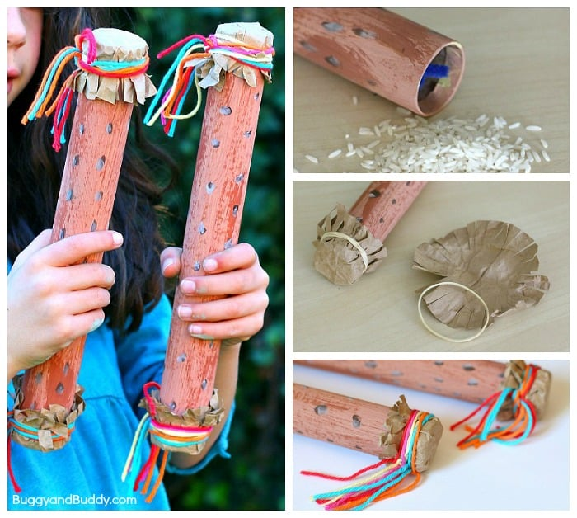
Art
You have been a superhero this year! Design your own superhero mask! You can use the template in the resources section.
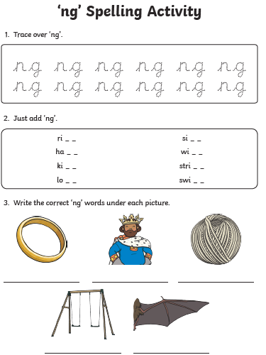
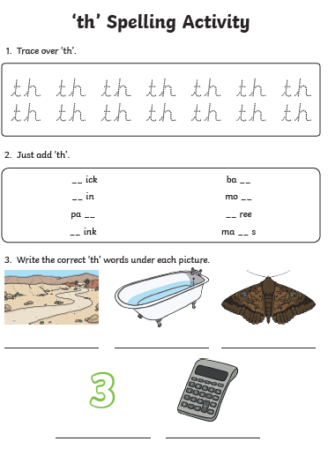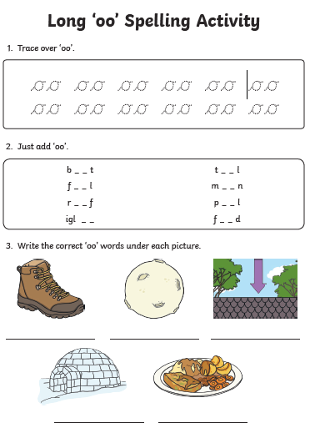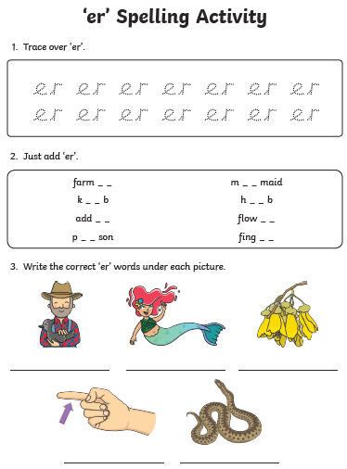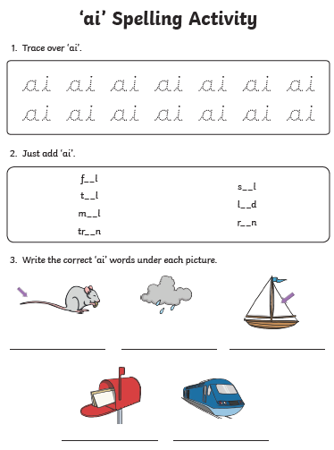

Art


