
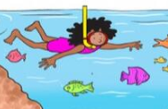
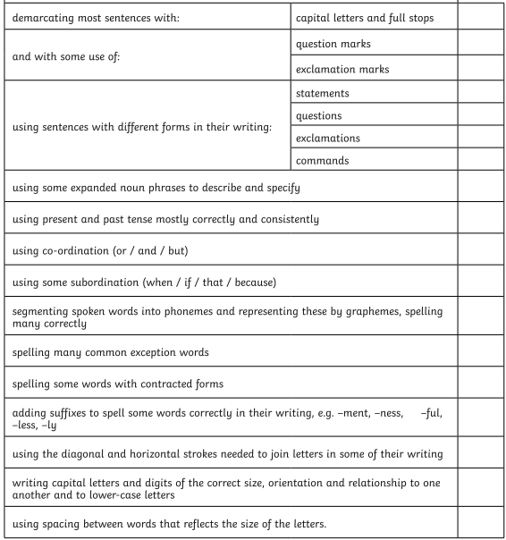
Today we read through our work with our partners and used our red pens to edit our work.
Today we read through our work with our partners and used our red pens to edit our work.

