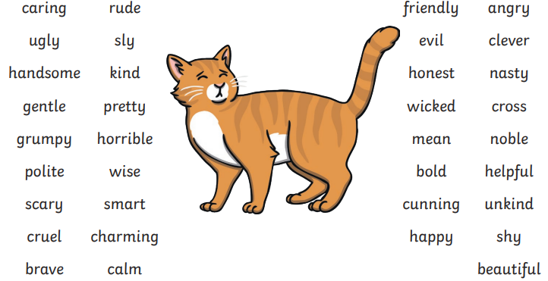


Write an expanded noun phrase to describe the character of the cat.

___________________________________________________________________
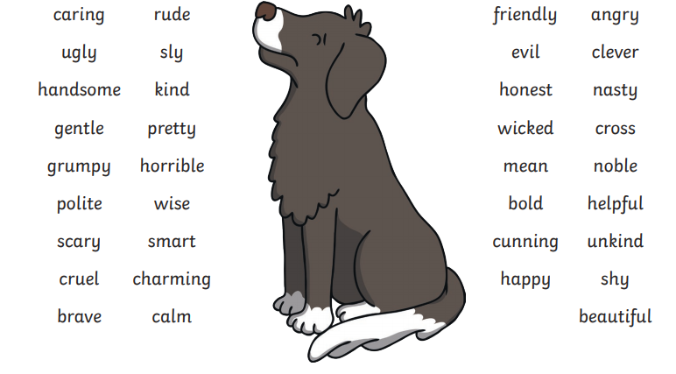
Write an expanded noun phrase to describe the character of the dog.

___________________________________________________________________
Use these adjectives to write expanded noun phrases for your own characters.

