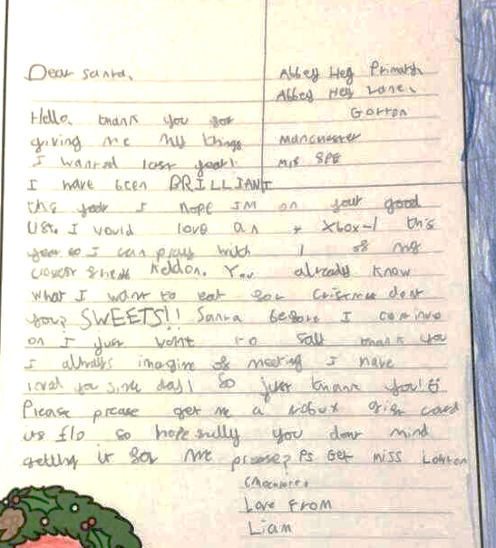
Can you use your red pen to edit this work?

