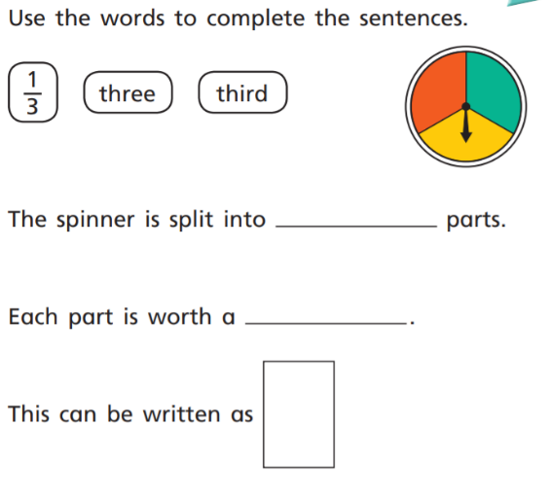
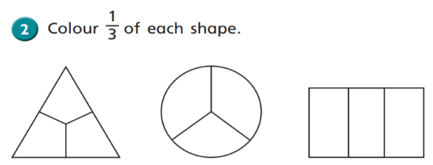
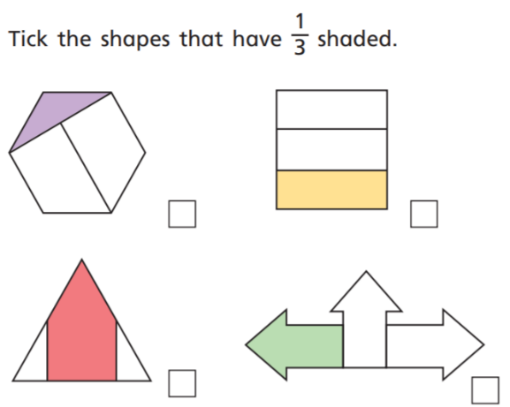
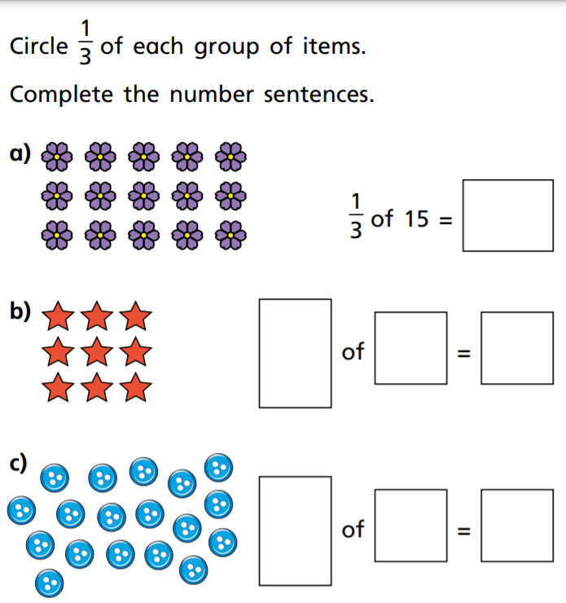

20/05/2021 LO: To use fractions C: Recognise and find fractions
1)
2)
3)
4)
20/05/2021 LO: To use fractions C: Recognise and find fractions
1)
2)
3)
4)

