Year 2 distance learning – wb 29.6.2020
For more detailed information on activities, please see plans below the timetable!
Sports Week!
Monday |   P.E. | Gross Motor Skills  Air Balloon Challenge  Can you keep the ball in the air for 60 seconds? | Walk a Mile! | Writing | Playtime! | Maths | Spelling | Lunchtime! | PSHE  What can you do to be healthy?  https://www.youtube.com/watch?v=B7Kop21r3WE | Reflection Time
Tuesday | P.E. | Gross Motor Skills  Around the World Challenge  How many times can you pass the ball around your waist in 60 seconds? | Walk a Mile! | Writing | Playtime! | Maths | Spelling | Lunchtime! | Science  Part of being healthy is eating healthy! Imagine you are an athlete. What would you eat for dinner? Complete the plate on purplemash.com | Reflection Time
Wednesday | P.E. | Gross Motor Skills  Figure of 8  How many times can you pass a ball through both of your legs in 60 seconds? | Walk a Mile! | Writing | Playtime! | Maths | Spelling | Lunchtime! | Music / P.E.  https://www.youtube.com/watch?v=k2RPKMJmSp0  Read the cards called ‘The Carnival of the Animals’. You can print them off or read them online. They are activities for you to do alongside the music. You can follow these instructions or make up your own movements. | Reflection Time
Thursday | P.E. | Gross Motor Skills  Socks in the Box  How many socks can you pair up and put in the box in 60 seconds? | Walk a Mile! | Writing | Playtime! | Maths | Spelling | Lunchtime! | Computing  https://www.purplemash.com/#tab/pm-home/topics/sport  There are a range of different sporting activities to do in Purple Mash. Please choose one to complete. | Reflection Time
Friday | P.E. | Gross Motor Skills  Obstacle Challenge  How many obstacles can you run around or jump over in 60 seconds? | Walk a Mile! | Writing | Playtime! | Maths | Spelling | Lunchtime! | Art  Design your own football or sports kit.  There are also pictures from the Commonwealth Games. Can you recreate a scene? | Reflection Time

Dear Parents,
Welcome to sports week! This week we are focusing on being healthy which involves both physical and mental well-being. At this point in the year we would be hosting a sporting week in school so we want to encourage you to enjoy the outdoors and get your hearts pumping as a whole family. Mr Gooch has created daily challenges for you to complete with equipment you should be able to find around the house. We have also decided to include ‘Gross Motor Skills’ challenges to develop flexibility and coordination. Sports week is all about being active. That could be a sporting activity, yoga, gardening or going for walks. However you get your heart pumping we want to say well done! Please continue to focus on the core skills of reading, writing and maths. Anything extra is a bonus. We wanted to say as a team well done for all of your hard work!
Have a wonderful week,
Miss Tissot, Miss Ridnell, Mrs Phillips and Mrs Spender

Lexia If you have a login please use this programme to support your child’s math and reading skills.
P.E.
Mr Gooch has put some daily challenges up. Please use this opportunity to complete your personal bests! Don’t forget to get your parents involved to
Gross Motor Skills
https://www.youthsporttrust.org/60-second-physical-activity-challenges
This week we are challenging you to complete a ‘Gross Motor Task’ which focuses on using your body to create big movements. There are 5 challenges on our webpage. The goal is to compete with yourself to get the best score within 60 seconds. Can you get your times down? Use the challenge tracker to time yourselves, try and beat your time! If you complete the challenges, the link above has others to try.

There is also a sheet of challenges for you to complete throughout the week as a family should you wish.

Daily mile
During sports week, all children and staff in the school run a mile every day. Mr Johnson has done an introduction video on the class page to talk all about the daily mile. Normally this is 6 laps around the school field, but if you are at home you can use the website ‘https://gb.mapometer.com/’ to plan a 1 mile route or the free app ‘Strava’ to measure your distance.

Here are some local routes that are (roughly) one mile long that you could do. Time your run/walk each day. Can you beat your time and run faster the next day?

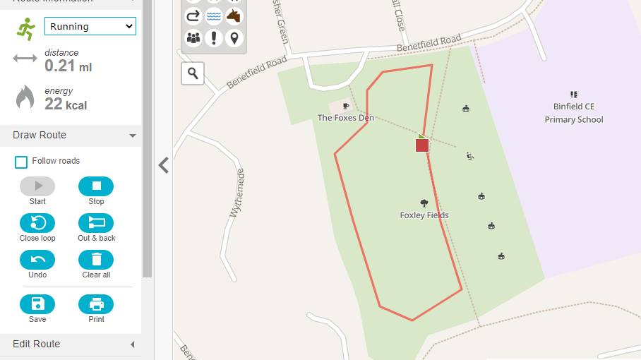  5 Laps of Foxley Field | 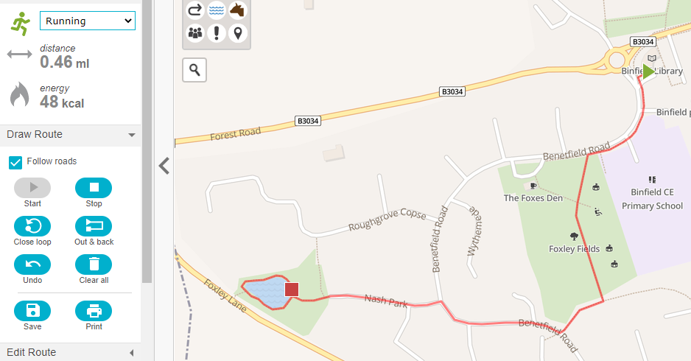  Start at the Library and run through Foxley fields to the pond, round the pond and back to the Library. | 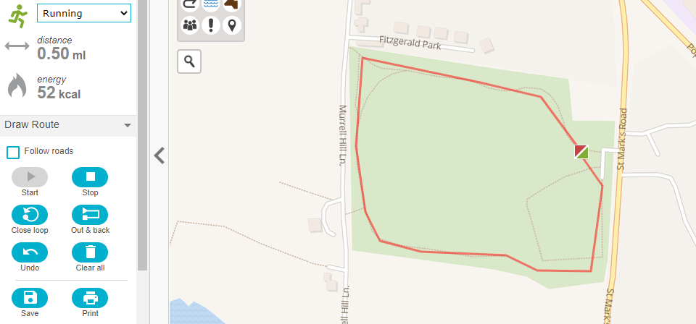  2 Big loops around Popes Meadow
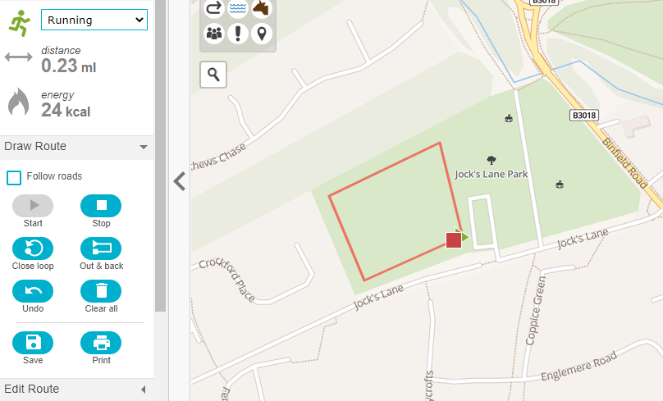  5 laps of the Big Field at Jocks Lane | 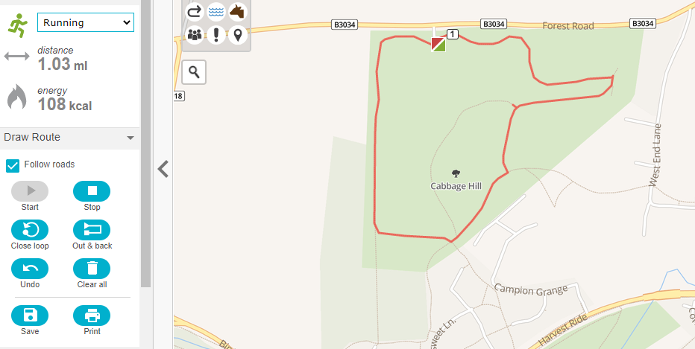  1 Lap around Cabbage Hill | 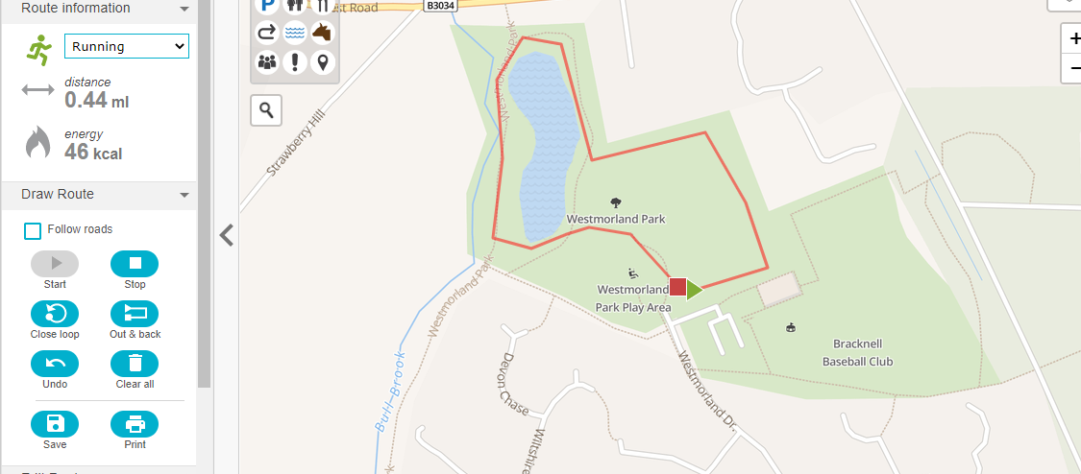  2 laps around the pond and bottom field at Westmorland Park

Maths
https://whiterosemaths.com/homelearning/year-2/

Please use these White Rose online resources. Watch the videos and work with your child to answer the questions. There is one video and two worksheets per day. Worksheets and answers are on our webpage. As part of your on-going learning please complete one of these tasks per day. Please continue to use TT Rockstars to practise your multiplication. You can also use https://www.bbc.co.uk/bitesize/levels/z3g4d2p to support your learning. https://www.topmarks.co.uk/ is also a good resource.

You may wish to practise your time keeping and number skills by recording your personal best’s throughout the week.

Spellings
Daily: Please practise the following spellings every day this week. Can you find out what these sports are? Are there different ways to play the same sport?
hockey | karate | judo | fencing | dressage | badminton
Look at the word, cover it and then write it down. Get your adult to check your spelling. Extension: Can you use it in a sentence?
If you feel that your child would benefit from a refresher on phonics sounds please visit: https://www.youtube.com/channel/UCo7fbLgY2oA_cFCIg9GdxtQ

Writing
It’s SPORTS WEEK! Below are some options for your writing this week. This is your opportunity to find out about your favourite sport or sporting event! Choose from one of the stories on our webpage or your own books from home. What new facts can you find out? Write 5 new things on Showbie this week. Please choose ONE task to do over the course of the week and present your work on Showbie.
Choose a brand new sport to research. Write down instructions on how to play and the rules of the game. | Write a simple biography (fact file of someone that you admire in the sports world. Research where that person was born and their journey to where they are today. | Write a letter to your sporting hero. What questions could you ask them? | Write a diary entry as one of your sports heroes at a sporting activity. | Watch the video of the Extreme Mountain Biker. How is he feeling? Can you write a story based on his climb? | You may also wish to read active books such as Where the Wild Things Are and act them out. Write a play script which include dance directions.
Watch the classic story of ‘The Tortoise and the Hare’. Rewrite the story in your own words. | Use BBC Bitesize to research the original Olympics. Compare that to the modern day London 2012. Write an explanation about which you would prefer to compete in. | Watch some of the sporting events from London 2012 (link on our webpage). Pretend to be a newspaper journalist and report on what you see. | Watch the audience reaction video on our webpage. What are they responding to? Write a story of a sporting event that matches their reactions | Research the Olympic Ring meanings. Present your findings a poster. | Write a diary of sports week. What did you do each day? What was your favourite activity? What did you learn about yourself?

Reflection Time
What have you enjoyed this week? Did anything challenge you? Take a few minutes to think about your emotions and how you have felt this week. As we come towards the end of June you may wish to look at the ‘Go Wild’ activities you have been completing. What has happened and changed in your garden?

