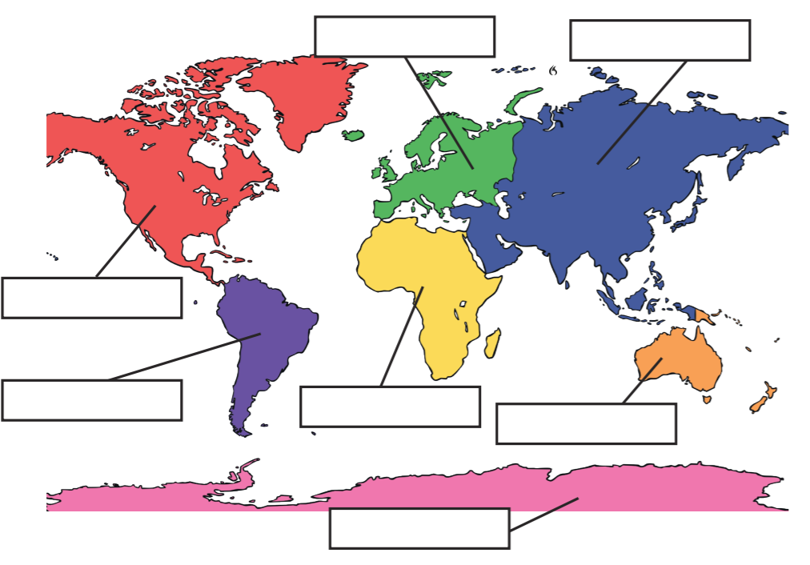
LO: To investigate places. C: Name and locate the world’s continents and oceans.

