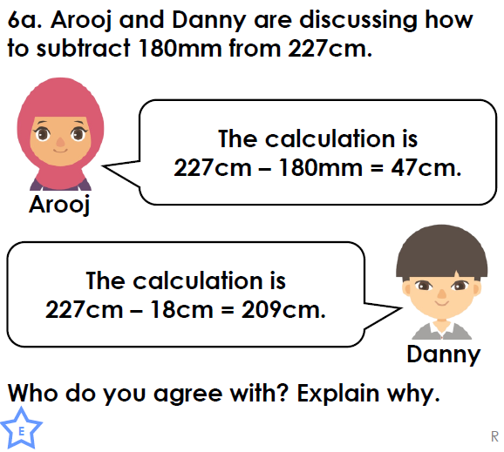
RED PEN QUESTION

RED PEN QUESTION

RED PEN QUESTION

RED PEN QUESTION

RED PEN QUESTION

RED PEN QUESTION

