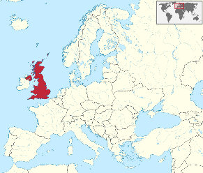

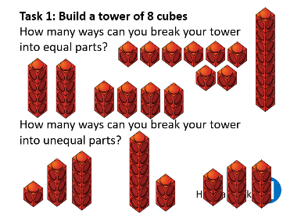
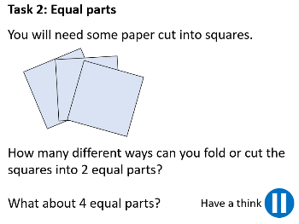
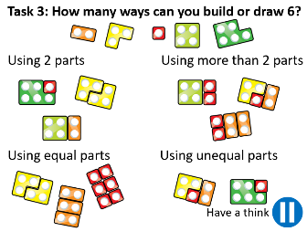
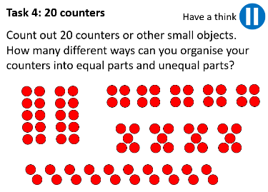
17/05/2021
LO: To use fractions
C: Working with wholes and parts
Today, we explored fractions. We focussed on understanding the difference between parts and wholes. Here is an example of what we learnt.

Then, we completed the following 4 activities.

Red pen question:
- Circle the shapes which have been divided into equal parts.

If ______________________ is the part, then _______________________ is the whole.

If ______________________ is the part, then _______________________ is the whole.

17/05/2021
LO: To use fractions
C: Working with wholes and parts
Today, we explored fractions. We focussed on understanding the difference between parts and wholes. Here is an example of what we learnt.

Then, we completed the following 4 activities.

Red pen question:
- Circle the shapes which have been divided into equal parts.

If ______________________ is the part, then _______________________ is the whole.

If ______________________ is the part, then _______________________ is the whole.

