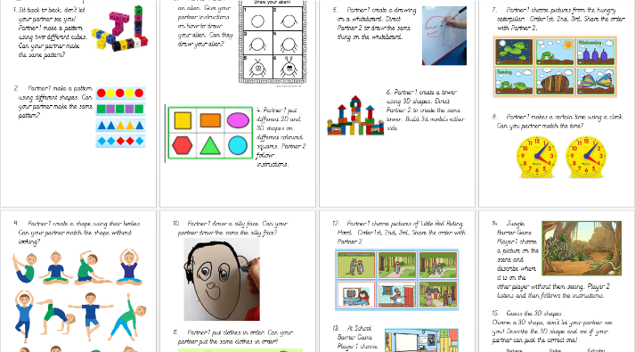
Barrier Games Reflection:
What did you do today?
What language were you using?
What was the most challenging aspect of the lesson?

Barrier Games Reflection:
What did you do today?
What language were you using?
What was the most challenging aspect of the lesson?

Barrier Games Reflection:
What did you do today?
What language were you using?
What was the most challenging aspect of the lesson?

Barrier Games Reflection:
What did you do today?
What language were you using?
What was the most challenging aspect of the lesson?

