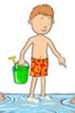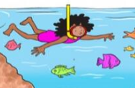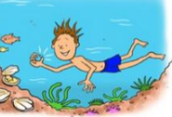
COLD TASK
This piece of writing was completed at the beginning of a unit on instructional writing.
To write with purpose
______________________________________________________________________________________________________________________________________________________________________________________________________________________________________________________________________________________________________________________________________________________________
____________________________________________________________________________________________________________________________________________________________________________________________________________________________________________________________________________________________________________
____________________________________________________________________________________________________________________________________________________________________________________________________________________________________________________________________________________________________________
____________________________________________________________________________________________________________________________________________________________________________________________________________________________________________________________________________________________________________

