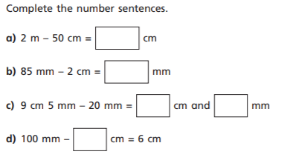

Complete the number sentence. Make sure you show your workings out.
Complete the number sentence. Make sure you show your workings out.
Complete the number sentence. Make sure you show your workings out.
Complete the number sentence. Make sure you show your workings out.

