
Year 2 distance learning – wb 22.6.2020
For more detailed information on activities, please see plans below the timetable!
Monday | P.E. | Spelling, Punctuation and Grammar (SPAG)  This week we are learning about COMPOUND words. https://www.bbc.co.uk/bitesize/topics/zcgv39q/articles/z38t6fr Watch the video. | Handwriting/fine motor skills activities  Tweezer Tasks!  Have a look at our webpage to see our tweezer tasks!  If you don’t have tweezers you can use tongs from the kitchen. | Writing  Watch Miss Tissot teach you how to plan your own Rainbow Fish story. | Playtime! | Mathshttps://pbskids.org/peg/games/hungry-pirates | Spelling | Lunchtime! | R.E.  https://www.truetube.co.uk/film/charlie-and-blue-celebrate-passover  Watch as Charlie and Blue learn about Passover. Use this information to fill in the worksheet on the Seder plate. |  | Reflection Time
Tuesday | P.E. | SPAG https://www.bbc.co.uk/bitesize/topics/zcgv39q/articles/z38t6fr  Complete the quiz and watch the videos. |  | Writing  Write the beginning of your story. | Playtime! | Maths | Spelling | Lunchtime! | PSHE  ‘A good friend’ Peter was a good friend to Jesus in the Bible. Use purplemash.com to fill out the sheet on what makes a good friend.  https://www.purplemash.com/#app/pup/faith_christian_good_friend |  | Reflection Time
Wednesday | P.E. | SPAG  Complete the worksheet creating compound words. |  | Writing  Write the middle of your story. | Playtime! | Maths | Spelling | Lunchtime! | Art  Create a collage of your main character and scene. You can do this online using purplemash.com or on paper. |  | Reflection Time
Thursday | P.E. | SPAG  https://www.purplemash.com/#app/games/2diy/Compound_Nouns  Find the matching pair of words that make a compound noun. |  | Writing  Write the ending of your story. | Playtime! | Maths | Spelling | Lunchtime! | Science  http://www.greatgrubclub.com/match-and-learn#.XuCwVkVKiHs  Can you match fruits and vegetables? |  | Reflection Time
Friday | P.E. | SPAG  Use the words you have learned this week in a range of sentences including question, exclamation, command and statement. |  | Writing  Edit your story. Have you included all of your punctuation? Read it to your adults, make sure it makes sense! | Playtime! | Maths | Spelling | Lunchtime! | Music (1)  Listen to ‘Allegro’ on our webpage. How do these pieces of music make you feel? | Music (2)  Log onto https://berkshire.charanga.com/ and complete an assignment | Reflection Time

Dear Parents and Carers,
Welcome to another week of home learning. We know how hard you are all working and have been very impressed with your children’s work on Showbie and Purple Mash. Please focus on the core skills of reading, writing and maths. The afternoon activities are there to support your child’s learning if you wish to complete them. If your child is not in school, your teacher will continue to call weekly to catch up with them.
Have a wonderful week, Miss Tissot, Miss Ridnell, Mrs Spender and Mrs Phillips

Lexia - If you have a login please use this programme to support your child’s math and reading skills.

P.E.
To start your day on an active note:
https://www.youtube.com/thebodycoachtv Joe Wicks continues to keep our nation’s children fit and active with daily half hour sessions to get your day off to an active start. https://www.bbc.co.uk/programmes/p06tmmvz Andy’s Wild Workouts
https://www.youtube.com/user/CosmicKidsYoga Cosmic Kids Yoga
https://www.youtube.com/watch?v=dhCM0C6GnrY Jumping Jack’s Gym
home.jasmineactive.com This is the link to the Real P.E. home learning site. You have all been emailed the username and password. Any issues please let us know.

SPAG
Please follow the links on the webpage and timetable to learn about compound words.

Maths
https://whiterosemaths.com/homelearning/year-2/

Please use these White Rose online resources. Watch the videos and work with your child to answer the questions. There is one video and two worksheets per day. Worksheets and answers are on our webpage. As part of your on-going learning please complete one of these tasks per day. Please continue to use TT Rockstars to practise your multiplication. You can also use https://www.bbc.co.uk/bitesize/levels/z3g4d2p to support your learning. https://www.topmarks.co.uk/ is also a good resource.

Spellings
Daily: Please practise the following spellings every day this week.
fisherman | rainbow | lighthouse | moonlight | bedroom | basketball | football
This week we’re continuing to look at compound words! Look at the word, cover it and then write it down. Get your adult to check your spelling. Extension: Can you use it in a sentence? If you feel that your child would benefit from a refresher on phonics sounds please visit: https://www.youtube.com/channel/UCo7fbLgY2oA_cFCIg9GdxtQ

Writing
This week we are writing our own version of the Rainbow Fish! Watch the videos on our webpage to support your learning.
R.E
https://www.truetube.co.uk/film/charlie-and-blue-celebrate-passover Watch as Charlie and Blue learn about Passover. Use this information to fill in the worksheet about the Seder Plate. You could also use purple mash to label a Seder plate. https://www.purplemash.com/#app/pap/celebrations/seder_plate

Reflection Time
Over the 30 days of June, we are encouraging you to go outside and join in with the 'random acts of wildness'. The link offers a 30 day printable as well as some great ideas to support all areas of learning and wellbeing. https://www.wildlifetrusts.org/30-days-wild-individuals-pack

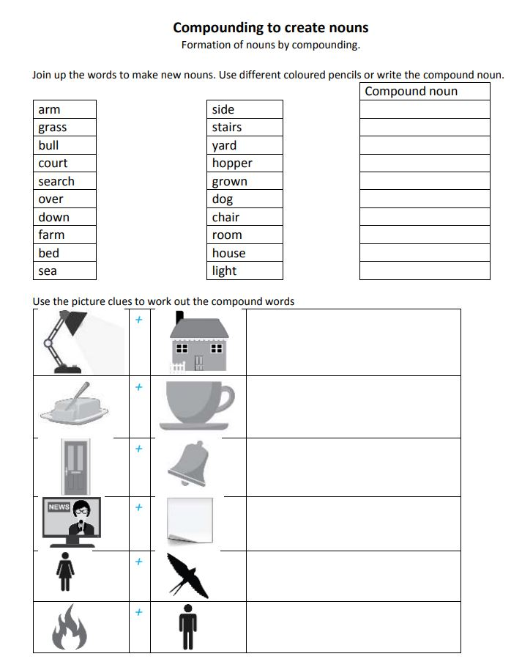
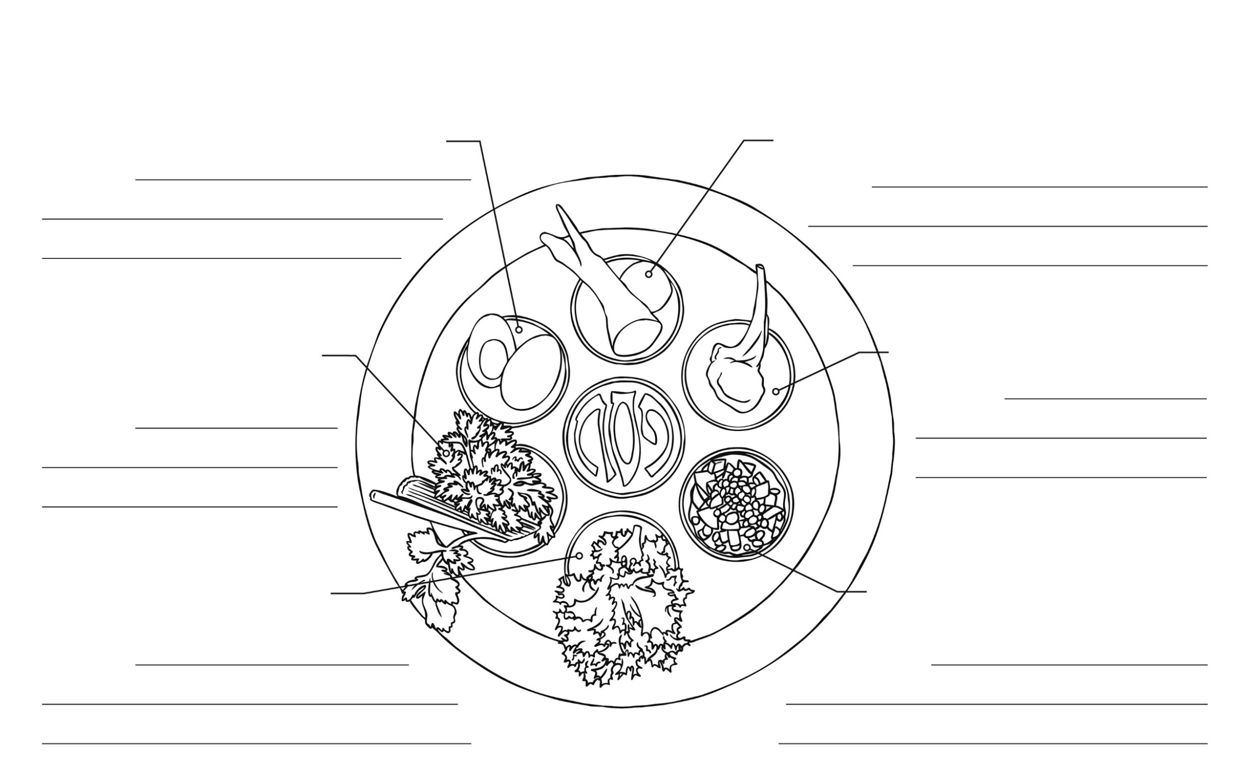
Seder Plate
Maror – a bitter herb made from horseradish.
Meaning…
Beitzah – a hard-boiled egg.
Meaning…
Karpas – a vegetable dipped in salt water.
Meaning…
Chazeret – a bitter herb, usually romaine lettuce.
Meaning…
Charoset – a paste of apples, walnuts and wine.
Meaning…
Z’ro’a – a roasted lamb bone.
Meaning…
Maror – a bitter herb made from horseradish.
Meaning…
Seder Plate
My Story Plan
My setting

My main character

What makes my character special? | Who asks my character to share? | Who does my character ask for help? | Who helps him? | What happens at the end?

