

Year 6 Learning timetable – w/b 20.7.2020 Last week of Primary School
For more information on these activities, please see the separate documents on this week’s Class Page

20.7.20 | 6JS – Leavers’ Celebration | Playtime | 6JS – Leavers’ Celebration |  | 6KM - Art  Dream Summer
20.7.20 | 6KM – The Mystery of the Pirate Captain | Playtime | 6KM – The Mystery of the Egg and Spoon Swindler |  | 6KM - Art  Dream Summer
21.7.20 | 6KM– Leavers’ Celebration | Playtime | 6KM– Leavers’ Celebration |  | 6JS - Art  Dream Summer
21.7.20 | 6JS – The Mystery of the Pirate Captain | Playtime | 6JS – The Mystery of the Egg and Spoon Swindler |  | 6JS - Art  Dream Summer
22.7.20 | D.T.  Origami | Playtime | Puzzles |  | The Big End of year Odd one out Quiz



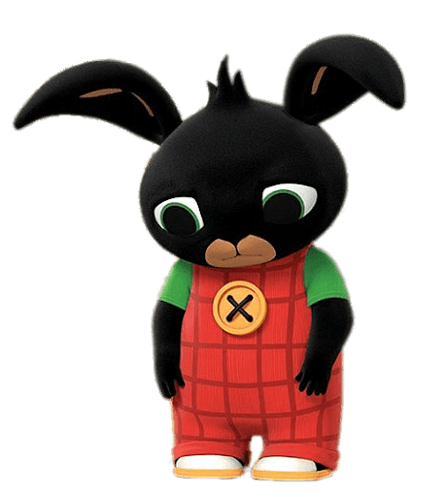

SUMMER
HOLIDAYS

