Y6 Bubble Timetable 2020 w/c 23.11.2020
 |   08:30 – 10:00 |  | 10:00 – 10:15 | 10:15 – 11:45 |  | 11:50 – 12:10 | 12:10 – 12:40 | 12:40 –  1:00 | 1:00 – 1:30 | 1:30 – 2:30 |  | 2:30 – 2:40
MONDAY | TTRS / CT | English  Suspense | Morning Break | Reading | Maths  Equivalent fractions / Simplifying  https://vimeo.com/466488832  https://vimeo.com/467396285 | Eat lunch in classrooms | Outside lunch break | Spelling | Outdoor time | Doors  (See below for lyrics and instructions) | Angels Assembly | Collect things and Pick up from Junior Playground
TUESDAY | TTRS / CT | English  Suspense | Morning Break | Reading | Maths  Fractions on a Number line  https://vimeo.com/468943588 | Eat lunch in classrooms | Outside lunch break | Spelling | Outdoor time | Doors  (See below for lyrics and instructions) | Class Assembly | Collect things and Pick up from Junior Playground
WEDNESDAY | TTRS / CT | English  Suspense | Morning Break | Reading | Maths  Improper / Mixed  https://vimeo.com/467394996  https://vimeo.com/468942374 | Eat lunch in classrooms | Outside lunch break | Spelling | Outdoor time | Doors  (See below for lyrics and instructions) | Assembly Reflections | Collect things and Pick up from Junior Playground
THURSDAY | TTRS / CT | English  Suspense | Morning Break | Reading | Maths  Adding / Subtracting fractions  https://vimeo.com/470094960 | Eat lunch in classrooms | Outside lunch break | Spelling | Outdoor time | Doors  (See below for lyrics and instructions) | Class Assembly | Collect things and Pick up from Junior Playground
FRIDAY | TTRS / CT | English  Suspense | Morning Break | Reading | Maths  Adding / Subtracting fractions / Mixed numbers  https://vimeo.com/471344877  https://vimeo.com/471345176 | Eat lunch in classrooms | Outside lunch break | GAMES |  |  |  | Collect things and Pick up from Junior Playground

Spelling: Follow the Look, Say, Cover, Write, Check method to practise these spellings every day.
Look, Say, Cover | Write, Check | If wrong, try again!
definite
especially
opportunity
different
doesn’t
immediately
restaurant
recognise

Doors: Fold a piece of A4 paper into two doors like so:


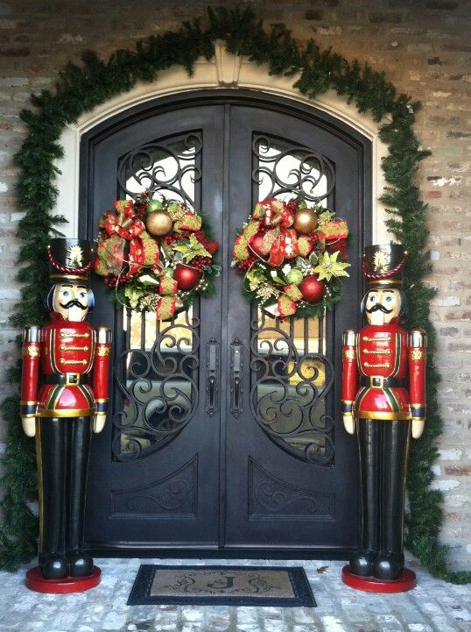
Decorate the outside to look like double doors, all decorated for Christmas:

In your absolute best handwriting, copy out your favourite verse (or two) of Good King Wenceslas:
Good King Wenceslas

Good King Wenceslas looked out
On the feast of Stephen
When the snow lay round about
Deep and crisp and even
Brightly shone the moon that night
Though the frost was cruel
When a poor man came in sight
Gath'ring winter fuel

"Hither, page, and stand by me
If thou know'st it, telling
Yonder peasant, who is he?
Where and what his dwelling?"
"Sire, he lives a good league hence
Underneath the mountain
Right against the forest fence
By Saint Agnes' fountain."

"Bring me flesh and bring me wine
Bring me pine logs hither
Thou and I will see him dine
When we bear him thither."
Page and monarch forth they went
Forth they went together
Through the rude wind's wild lament
And the bitter weather

"Sire, the night is darker now
And the wind blows stronger
Fails my heart, I know not how,
I can go no longer."
"Mark my footsteps, my good page
Tread thou in them boldly
Thou shalt find the winter's rage
Freeze thy blood less coldly."

In his master's steps he trod
Where the snow lay dinted
Heat was in the very sod
Which the Saint had printed
Therefore, Christian men, be sure
Wealth or rank possessing
Ye who now will bless the poor
Shall yourselves find blessing

