Maths

This week we would like you to look back through your Century Tech nuggets and re-do any in which you have scored less than 75%.

To do this, follow these steps:
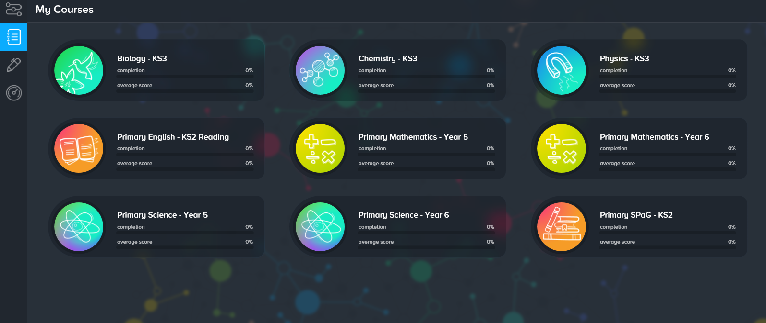
2: Click “Primary Mathematics – Year 6”
1: Click the “My Courses” tab.

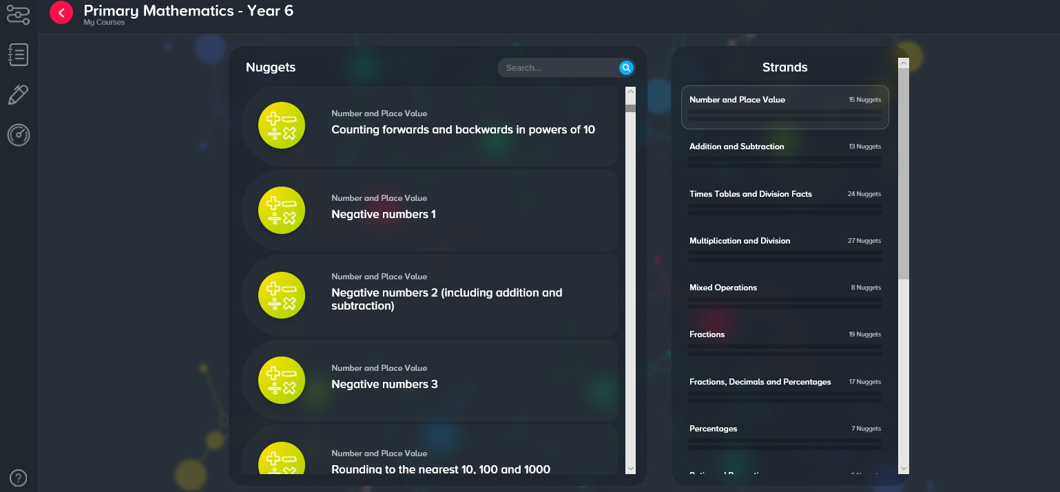
4: If there are any nuggets where you have scored less that 75%, click on the nugget to re-do it.
3: Use this scroll bar to look through the nuggets you have completed.

