
18.6.2021 L.O: To use fractions C: Fractions of amounts 3
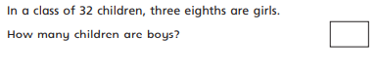
1).

2).
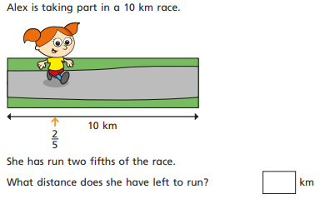

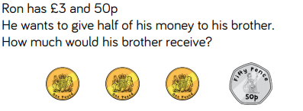
3).

