- Use the words to complete the sentences.
Work out the missing values.
a) 8 cm
3

cm

area = 32 cm2 perimeter = cm

Area and perimeter

perimeter

cm2
b)
cm m
cm

area
m2 inside
around

8 cm
area =
cm2

is the amount of space a two-dimensional shape. It can be measured in units such as
or

is the distance a two-dimensional shape. It can be measured in units such as or
perimeter = 40 cm

c)
area = m2
m
perimeter = 36 m

Work out the areas and perimeters of the shapes.
4

- Work out the areas and perimeters of the shapes.
Shape A Shape B

  - 6 cm
b)
6 cm

4 cm

2 cm

2 cm

4 cm

area = perimeter =

cm2

area =

cm perimeter =

cm2

cm

perimeter =
cm perimeter = cm
What do you notice?

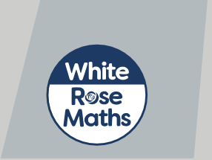area =
cm2 area =
cm2

© White Rose Maths 2019

5
If you start with a rectilinear shape, when you increase the area, the perimeter will increase.
Tommy
Amir
It depends on the shape.


Who do you agree with? Draw some examples to support your answer.

1 cm



6 Two rectilinear shapes, A and B, each have an area of 12 squares.
•
•
Shape A has the largest perimeter possible.
Shape B has the smallest perimeter possible.
Draw shapes A and B.
1 cm
1 cm
What do you notice?
7
Mr Jones has 50 m of fencing.
He wants to make a rectilinear enclosure using all the fencing.
a) Draw an example of a shape he could make. Give units on your diagram.
b) What is the greatest possible area of the enclosure?
c) What is the smallest possible area of the enclosure?
© White Rose Maths 2019
1 cm

