Tick the shapes that have an area of 24 cm2. Each square represents 1 cm2
3

Shapes – same area

- Use the diagram to help you complete the sentences.

5 cm

4 cm

The length of the rectangle is cm.

The width of the rectangle is cm.

The total number of squares in the rectangle is The area of the rectangle is cm2

- Work out the areas of the shapes. Each square represents 1 cm²
  - Draw two different rectangles that have an area of 8 cm2 Label the side lengths of your rectangles.
1 cm
4

1 cm

- b) c)

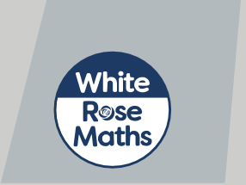cm2

What do you notice?
cm2
cm2

- Write the factors of 8
What do you notice? Talk about it with a partner.

© White Rose Maths 2019


7
Here is a rectangle.
1 cm
1 cm
a) Work out the area of the rectangle.
area =
cm2
b) Draw a different rectilinear shape that has the same area.
Compare answers with a partner.
It is impossible to have a rectilinear shape with an even area if all its sides are odd numbers.
Investigate Dexter’s statement to see if it is true.
1 cm
1 cm
Compare your findings with a partner.
© White Rose Maths 2019
8

Draw two different rectilinear shapes that have an area of 12 cm2
5

1 cm

1 cm

Compare shapes with a partner.

Rosie is finding the area of this shape.
6

3 cm

8 cm


To find the area of the shape, you can multiply 3 by 8, so the area must be 24 cm2

Do you agree with Rosie? Explain your answer.

