There is the same number of counters under each cup. There are 16 counters in total.
3

Solve two-step equations

20



- Here is a part-whole model.

  - Write an equation for the part-whole model.

  - Solve the equation to work out the value of

- Use y to represent the number of counters under each cup. Write an equation in terms of y.

- Solve the equation to find the value of y.

y =

- How many counters are under each cup?
=

- If each multilink cube represents x, form and solve an equation to
Write an algebraic equation to represent each bar model.
Find the values of a and b.
4

find the value x.

40

b)

a = b =
21
a | a | 9

46
3b | 10

x =

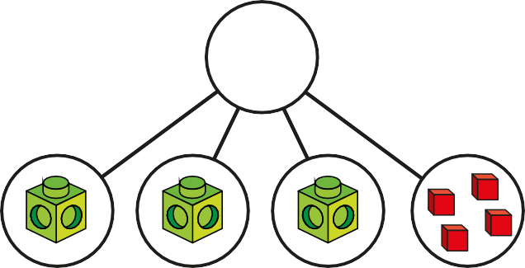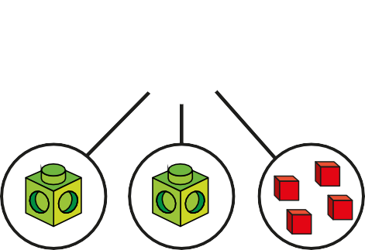

© White Rose Maths 2019

Solve the equations.
5

a) 5x + 1 = 31 d) 9 = 2y + 8

x = y =

b) 3x – 3 = 9 e) 10g – 2 = 46

x =
c) 4p – 11 = 3
g =
f) 4 + 3y = 28

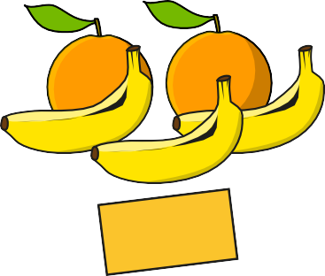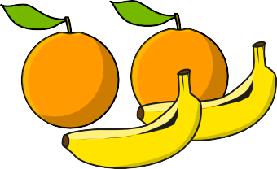
7 Alex is y years old.
Her friend Brett is 3 years older. The total of their ages is 25 How old are Alex and Brett?
Alex is
Brett is
8
a) Work out the cost of one banana and one orange.
One banana costs
One orange costs
b) Compare methods with a partner.
© White Rose Maths 2019

p = y =

Dani thinks of a number. She doubles it and adds 3 She gets the answer 15
6
- Write an equation to represent Dani’s problem.

- Solve the equation to find her number.

