
I know that:
Equivalent means ……………………………………………
Therefore
$\frac{1}{2}$ = $\frac{}{8}$
$\frac{4}{5}$ = $\frac{}{10}$

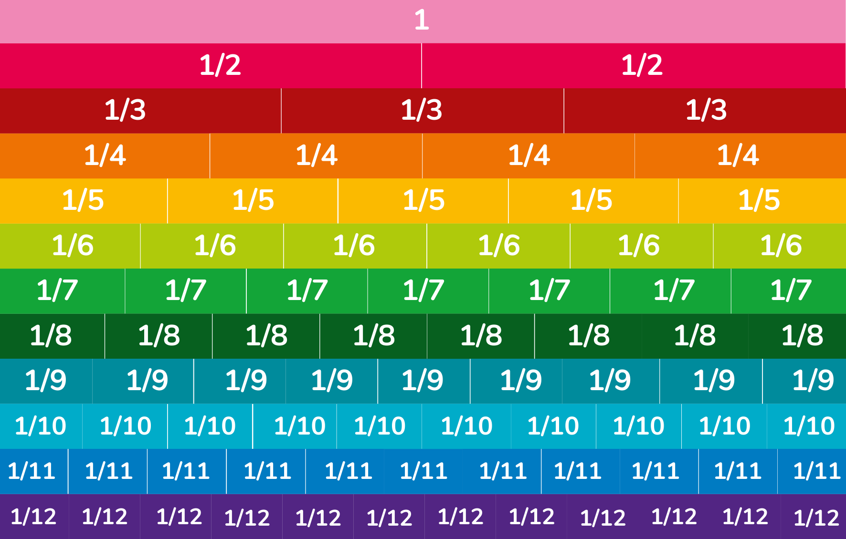
These are examples of ……………………………………………………………………………………………………..

