ORIGAMI CHRISTMAS TREES
- They look super charming on a shelf, you can make a garland from them or tie them to a present. And, all you need is a piece of paper and some scissors. Super easy.
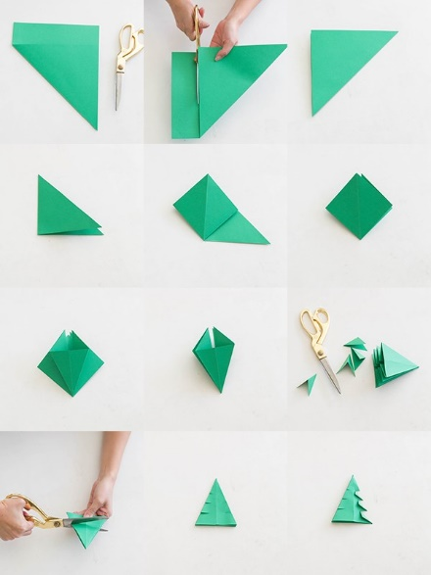

INSTRUCTIONS
Fold top corner of the paper to align with the opposing side of the paper.
2. Cut the bottom of the paper off so that you are left with a square paper folded into a triangle.
3. Fold that in half into a smaller triangle.
4. Open the triangles and fold down to create a square x 2
5. Open the sides of the squares to create a tall triangle x 4
6. Trim off the bottom triangle.
7. Cut 3 rows on each side, spaced evenly.
8. Fold down the bottom three flaps

