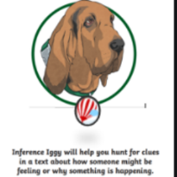
Thursday 6th May 2021
L.O: To understand texts- inference skills
C: Boy
Our task is to write a thought bubble to show what Roald Dahl might be thinking in his head when the Boazers make fun of him..
Paddlers: Write a thought bubble. Snorkellers: Write a thought bubble using evidence from the text. Divers: Write a thought bubble using evidence from the text. Around the edge, add in some emotion words he may be feeling.
RED PEN CHALLENGE: Would you rather go to St Peter’s or Repton? Why?



