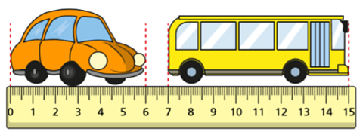
Challenge 1

Here is a toy car and bus.

By how many cm is the bus longer than the car?

Challenge 2
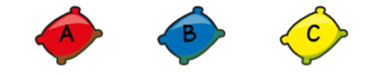
Here are 3 beanbags.

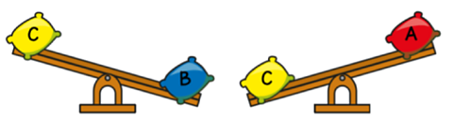
They are placed on a seesaw.

Which beanbag is the heaviest?

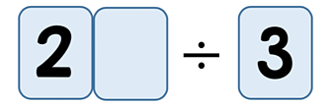
Challenge 3

Amir is dividing a 2-digit number by 3.
His answer is a whole number.

What could the missing digit be?

Challenge 4
Lewis makes a repeating pattern with some shapes.


Lewis repeats the pattern.
What is the shape in the 50ᵗʰ position?

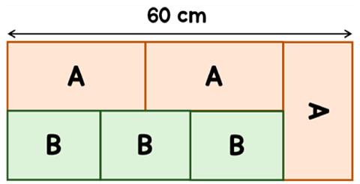
Challenge 5

A large rectangle is made up of smaller rectangles, labelled A and B.

The length of A is double the width of A.
Find the area of one of the rectangles labelled B.

Challenge 6
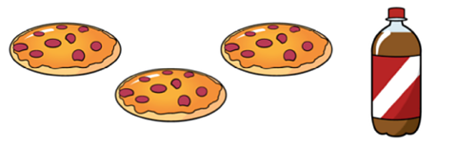
Mina buys 3 pizzas and a bottle of cola.

A pizza costs £3.20 more than a bottle of cola.
The total cost of the items is £19.40
How much does a pizza cost?

Challenge 7
A barrel is half-full with water.
12 litres of water are poured out.
The barrel is now ¹/₅ full.
How much water does the barrel hold when full?

Answers
Challenge 1 - 2 cm
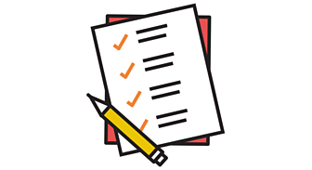
Challenge 2 - B
Challenge 3 - 1, 4 or 7
Challenge 4 - Yellow circle
Challenge 5 - 192 cm²
Challenge 6 - £5.65
Challenge 7 - 40 litres

