Prior Learning – Incarnation
What do you know about Jesus?
_-
Christians believe that Jesus is the Messiah. What do you think this means?

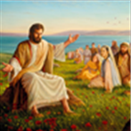
What does incarnation mean? An example is that Jesus was an incarnation.
- When someone is very holy
- When someone prays a lot
- God in human form
- A person who has strong Christian beliefs
Where have you heard this before?
What is the story that introduces us to Jesus in the Bible? Write down all you know about this story and draw a picture to show what you know.

