Monday  Practise:  - 163245 + 273622  - 726519 - 327988  - 12 x 14  - 296 ÷ 8 =  Use & Apply  1. 2.  3. 4.  5.  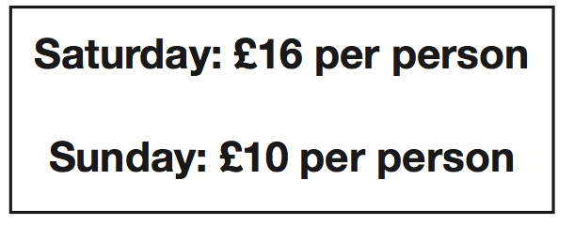  These are the prices of tickets to a cinema.  On Saturday, 32 people go to see a film.  On Sunday, 67 people go to see a film.  How much money did the cinema make altogether at the weekend?  Reasoning:  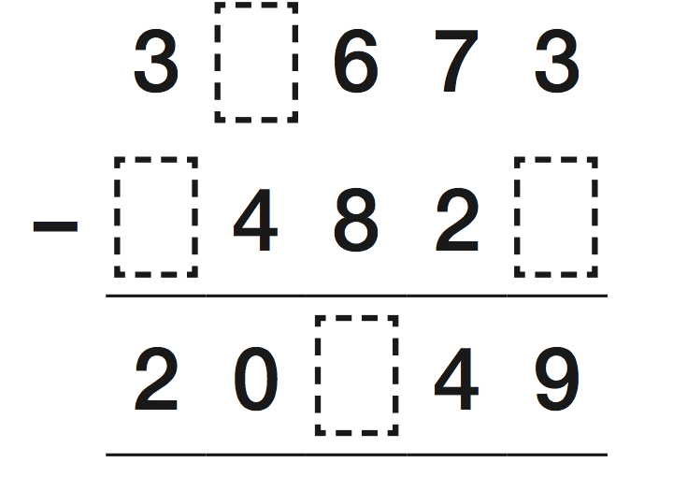 | Tuesday  Practise:  - 23 x 26  - 2071 ÷ 6  Use & Apply  1. 2.  3) There are 18 rows of 16 stickers  on a sheet.  How many stickers on 1 sheet?  How many stickers on 10 sheets?  Reasoning:  - 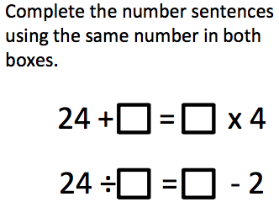  - 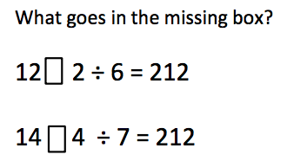

Wednesday  1. 2.  3)  These are the prices of tickets to a cinema.  On Saturday, 116 people go to see a film.  On Sunday, 67 people go to see a film.  How much money did the cinema make altogether at the weekend?  Reasoning:  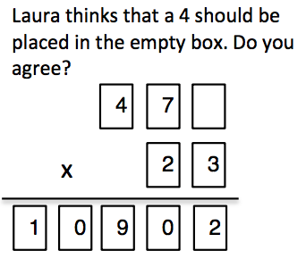  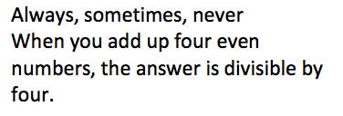  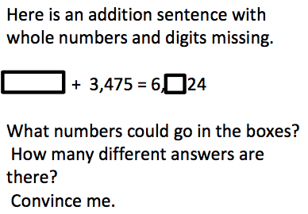 | Thursday  Practise:  - 736 + 625  - 972 - 362  - 6 x 7  - 72 ÷ 6 =  Use & Apply  1. 2.  3. 4.  Reasoning:  My answer is 87. What is the question?  Create 3 addition questions.  Create 3 subtraction questions.

