This number is __________. I know this because it has __ ten-thousands, _____ -thousands, ___ hundreds, ___ tens and ___ ones.
7.10.20
LO: To know and use number
C: Numbers to 100,000
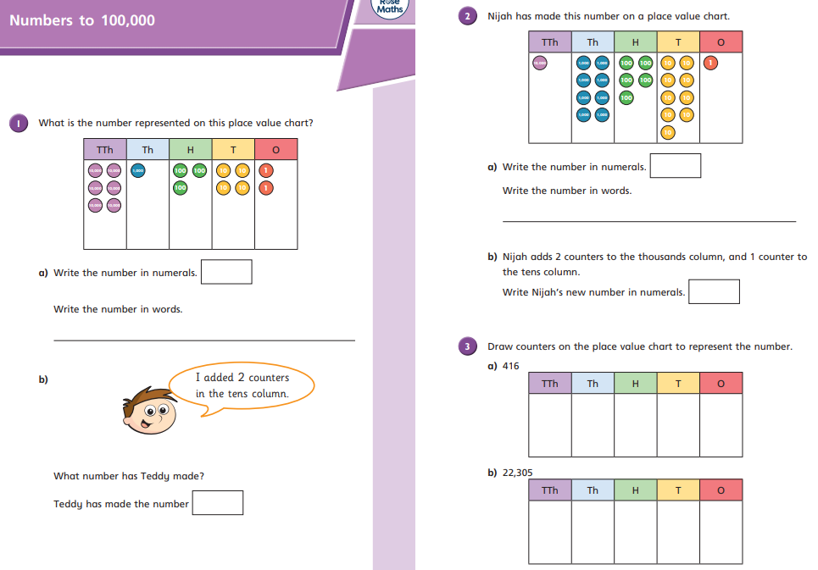

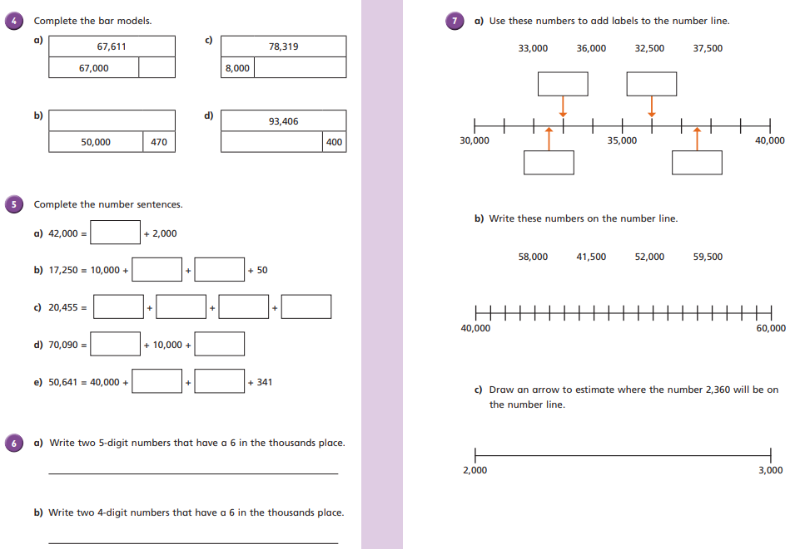

This number is __________. I know this because it has __ ten-thousands, _____ -thousands, ___ hundreds, ___ tens and ___ ones.
8.10.20
LO: To know and use number
C: Compare and order numbers to 100,000
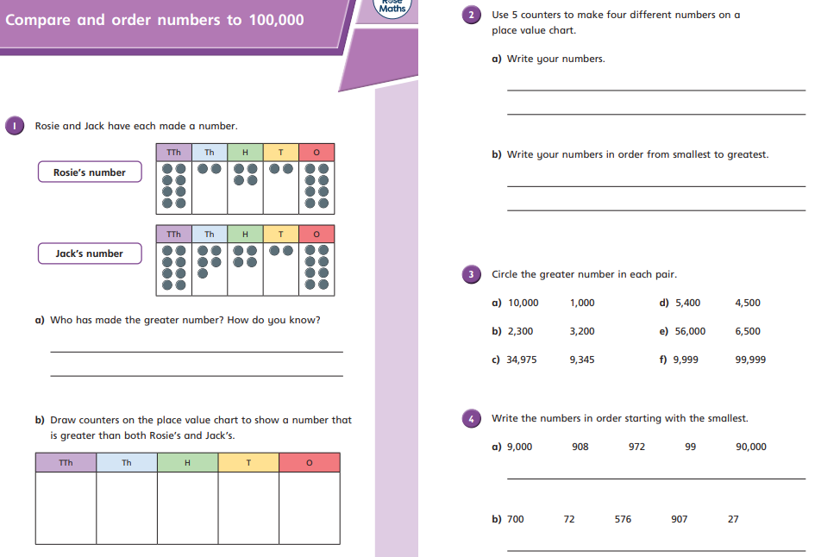
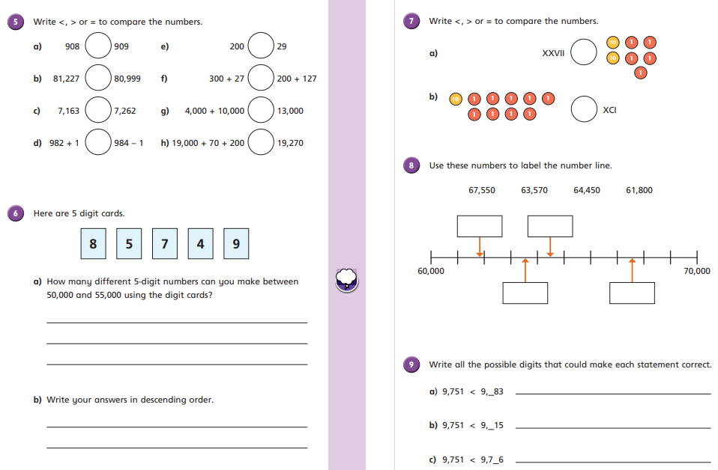

This number is __________. I know this because it has __ ten-thousands, _____ -thousands, ___ hundreds, ___ tens and ___ ones.
9.10.20
LO: To know and use number
C: Compare and order numbers to 100,000


