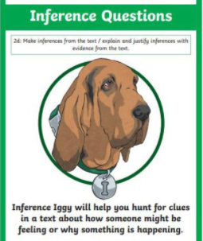
Tuesday 30th March 2021
L.O: To understand texts- inference skills
C: Boy
Paddlers: Use talking tins to discuss your ideas. We could also role-play if we need to.
Snorkellers: Work independently to write justified sentences.
Divers: To use evidence from the text to support your answers.
Questions:
- 1). On p. 91 Why do you think he began to cry?
- 2). On p.94 Why do you think Mrs Dahl kept the letters all those years?
Red Pen:
- Can you spot a link between the letters and the front cover? Why do you think Roald signed his letters this way?

Tuesday 30th March 2021
L.O: To understand texts- inference skills
C: Boy
Paddlers: Use talking tins to discuss your ideas. We could also role-play if we need to.
Snorkellers: Work independently to write justified sentences.
Divers: To use evidence from the text to support your answers.
Questions:
- 1). On p. 91 Why do you think he began to cry?
- 2). On p.94 Why do you think Mrs Dahl kept the letters all those years?
Red Pen:
- Can you spot a link between the letters and the front cover? Why do you think Roald signed his letters this way?

