The nearest multiples of ten to __ are ___ and ___.
___ is closest to ___. So _ rounder to the nearest ten is ___
28.9.20
LO: To know and use number
C: Recap Rounding to the nearest 10
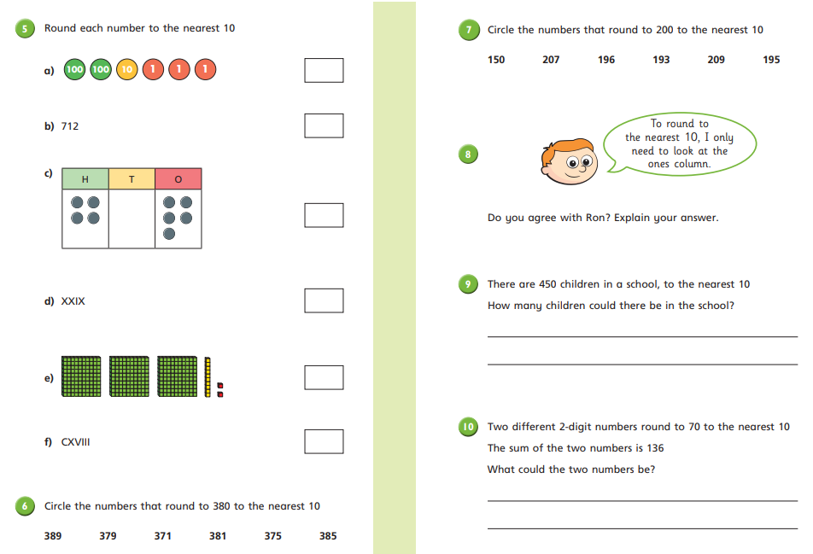

Extension
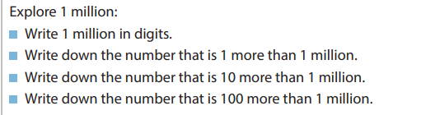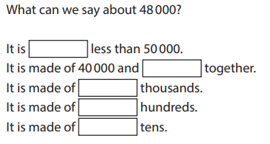

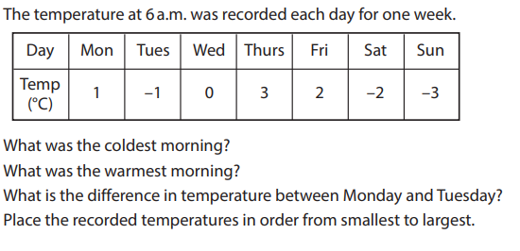

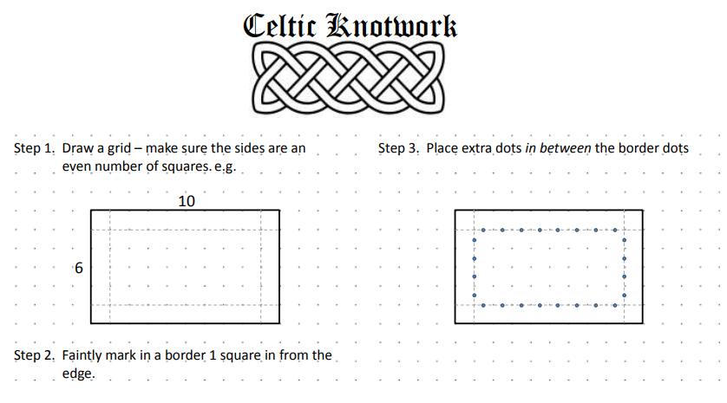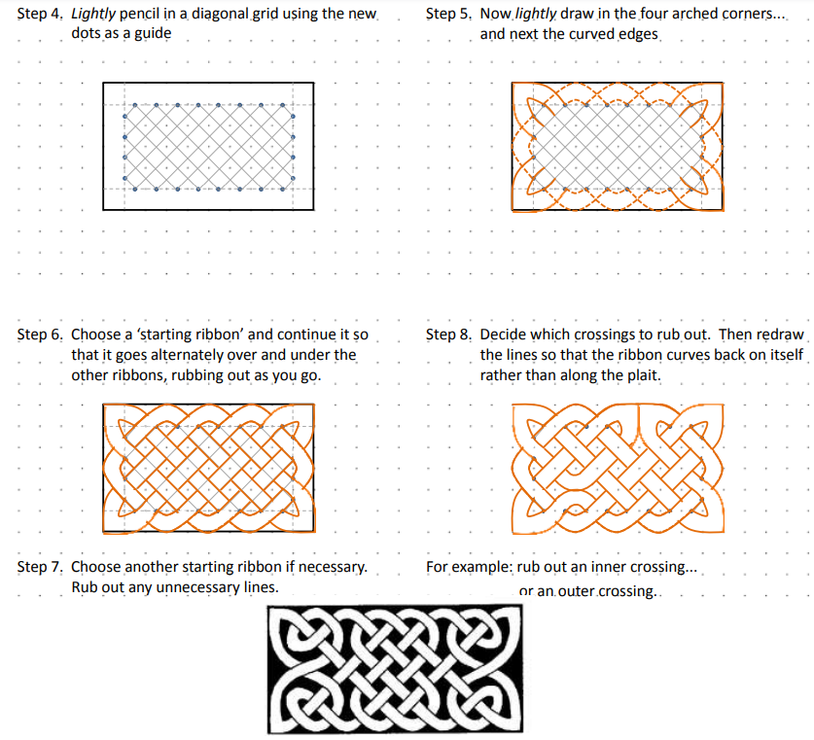

30.9.20
The nearest multiples of 100 to __ are ___ and ___.
___ is closest to ___. So _ rounder to the nearest 100 is ___
LO: To know and use number
C: Recap Rounding to the nearest 100
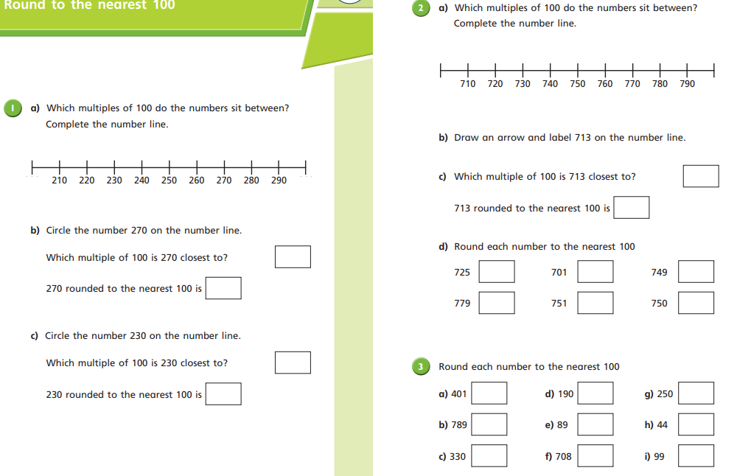

Extension
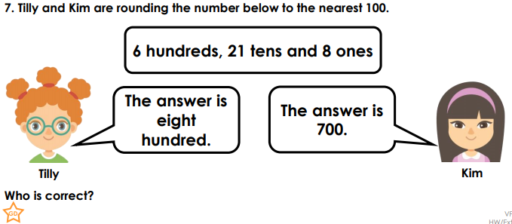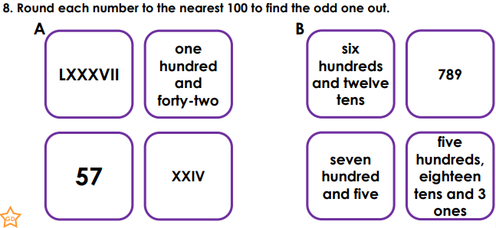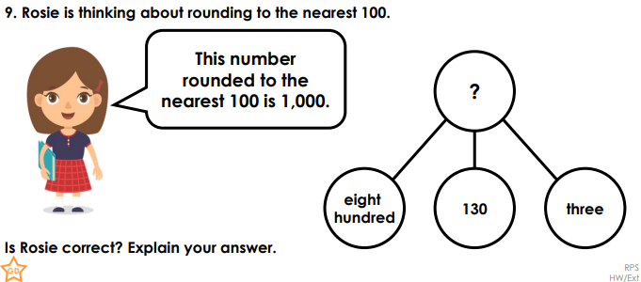

1.10.20
The nearest multiples of 100 to __ are ___ and ___.
___ is closest to ___. So _ rounder to the nearest 100 is ___
LO: To know and use number
C: Rounding to 10, 100 and 1,000
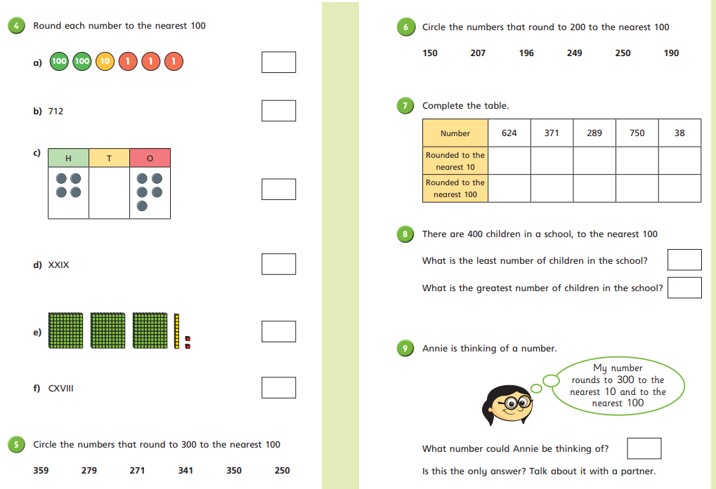

Extension


