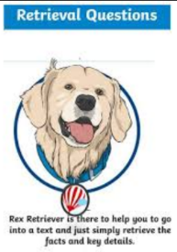
Monday 29th March 2021
L.O: To understand texts- retrieval skills
C: Boy
Paddlers: Use your skim reading skills and fastest finger to find the correct information.
Snorkellers: Work with TA to re-read the text and find the key information.
Divers: Answer the questions by thinking about both what the character’s say and also by what they may be thinking.
Questions
- 1) What was the full postal address of his school?
- 2) Can you identify three items of his school uniform?
- 3) Why did the Headmaster encourage the families to send food parcels? DIVERS: What did he actually tell the families instead?

Red Pen: If you went to boarding school, what three treasures would you keep in your tuck-box and why?

Monday 29th March 2021
L.O: To understand texts- retrieval skills
C: Boy
Paddlers: Use your skim reading skills and fastest finger to find the correct information.
Snorkellers: Work with TA to re-read the text and find the key information.
Divers: Answer the questions by thinking about both what the character’s say and also by what they may be thinking.
Questions
- 1) What was the full postal address of his school?
- 2) Can you identify three items of his school uniform?
- 3) Why did the Headmaster encourage the families to send food parcels? DIVERS: What did he actually tell the families instead?

Red Pen: If you went to boarding school, what three treasures would you keep in your tuck-box and why?

