
Year 5 Distance Learning – w.b.01.06.20
For more detailed information on activities, please see plans below the timetable!
Please read either your school or a home reading book for 30 minutes every day.
Please log onto Century tech an assignment has been created. The nuggets that need to be completed are below.
Monday | Reading  Century tech (Assignment)- power of words | Maths  REVISION: ordering decimals- Watch teaching video and answer questions.  Challenge questions are below | Times Tables/Number Bonds/Telling the Time/Measuring | Playtime! | Writing  See below. | Grammar  and  Spelling  Identifying word classes on context. | Lunchtime! | RE  https://www.youtube.com/watch?v=MLzdQtetedc  The good Samaritan parable. Watch the video and draw a comic strip to retell the story. | French  Practice pronouncing the parts of the body in French using the document below. | PE  Go to school website and see the weekly.
Tuesday | Reading  Century tech  Non-fiction earthquakes | Maths  REVISION: Multiplying unit and non-unit fractions by an integer. See video https://vimeo.com/420244176 and answer questions on the sheet- 02.06.20  Challenge questions are below. | Times Tables/Number Bonds/Telling the Time/Measuring | Playtime! | Writing | Grammar  and  Spelling  Identifying word classes in a sentence. | Lunchtime! | History  Why were the Vikings so successful? Conduct your own research to answer the question. Use the short PowerPoint to help direct your research. | Music  Listen to https://www.youtube.com/watch?v=l3qi3E40aWE  How is it similar and different to the James Brown song “I feel good” Compare the tempo and melodies of the songs, and describe the instruments you can hear. | PE
Wednesday | Reading  Century tech  Inferences in Poetry | Maths  REVISION: Multiplying mixed numbers by an integer. See video https://vimeo.com/420244296 and answer questions.  Challenge questions are below. | Times Tables/Number Bonds/Telling the Time/Measuring | Playtime! | Writing | Grammar  and  Spelling  Modal verbs | Lunchtime! | Science  https://www.bbc.co.uk/bitesize/topics/zsxxsbk/articles/zxw6gdm Design and build a streamlined boat. See below for more detail. | Circle time/PSHCE  Gratitude postcards. | PE
Thursday | Reading  Century tech  The Giant in the Garden | Maths  REVISION- https://vimeo.com/420244399 watch video and answer questions. Challenge questions are below. | Times Tables/Number Bonds/Telling the Time/Measuring | Playtime! | Writing | Grammar  and  Spelling  Hyphen | Lunchtime! | D.T  Viking jewellery- design and make a Viking brooch.  Use items you find around the house, like cardboard, string, wool, tin foil. Ask an adult for help.  Download the document for ideas and examples. |  | PE
Friday | Reading  Century tech  Practice Fiction:Bookworm | Maths  REVISION: https://vimeo.com/420244575 watch video on Fractions as operators.  Challenge questions included. | Times Tables/Number Bonds/Telling the Time/Measuring | Playtime! | Writing | Grammar  and  Spelling  Dashes | Lunchtime! | Computing  Create a leaflet explaining how to use the internet safely. | Handwriting  See below. | PE
Maths- If you complete the Maths- please continue Century tech nuggets on the following topics: Percentages and decimals, measurement.

Maths
Write down an explanation of your method, or tell an adult your method if they are not busy.
Get an adult to check if your answer is correct. If you get any wrong, try and correct them yourself using a different coloured pen/pencil.

Day 1  Challenge questions:  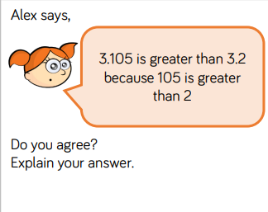 | Day 2  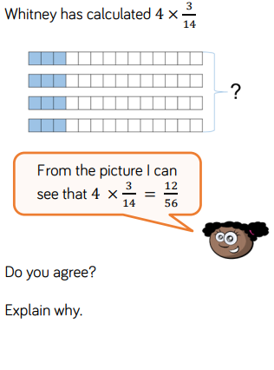 | Day 3  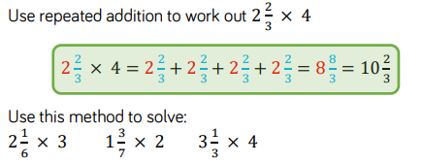 | Day 4  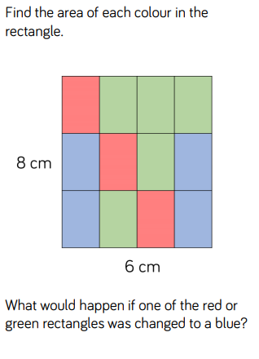 | Day 5  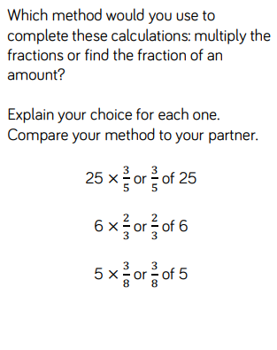

Times Tables/Number Bonds/Telling the Time/Measuring
Spend some time revising these different areas of maths.
Over the week you could:
- Practise whichever ‘Maths Minutes’ you are on at the moment.
- You could watch a Percy Parker video on YouTube or play TT Rockstars.
- Have a look at some of the maths games you could play!
Century Tech
Crickweb
Top marks
TT Rockstars
Hit the Button
- Look at the clock and identify the time. What will the time be in 5 minutes? 30 minutes? Can you work out how long you have spent reading today? How many minutes until lunchtime? etc.
Writing
We are going to be learning about poetry.
This week we are going to learn about the features of poetry and then have a go at writing our own kenning poems related to Viking longships!

Monday – Follow the PowerPoint looking at features of poetry. Look through the examples and identify and underline the features you find.
Tuesday – Follow the PowerPoint looking at kenning poems. Look at the examples and mind map some ideas for your poem!
Wednesday – Plan your poem using the planning template.
Thursday – Write your poem.
Friday – Edit your poem then practice reading it out. You could record your performance as a voice note for your teacher to hear!

Spelling

terribly | considerably | adorably | busy | calendar | centre
considerable | adorable | visible | business | caught | century
The words highlighted light blue are for the groups of children who work are in Mrs Everett’s group for spellings.
Write out the words in different colours, try ‘look, cover, say, write, check,’ write sentences using the spellings in or ask an adult to test you on your spellings.

Circle time/PSHCE
We have spent the last couple of weeks thinking about our mental wellbeing, gratitude and acts of kindness. Many of you suggested that thanking people and giving compliments were great ways of increasing happiness and making the world a happier place. This week, use the postcard template (or draw your own) and write a short gratitude postcard to someone. You should thank the person you’re writing to for something positive they have done for you, for example helping you with something or being a good friend. Perhaps somebody always makes you laugh when you’re sad, or you might want to write to your parents to thank them for looking after you. Colour the back of your postcard to make it attractive and when we are all together again you can exchange postcards, if you want
Science
Can you build the most streamlined boat? This is a 2-week project and we would like you to research and find out as much information about water resistance as you can before you start building. The material you use is up to you, but try and choose something that will allow your boat to float! You will need paper to write up your explanation about why you decided to create your boat using the material/s that you used? Watch this video to give you some ideas about the shapes that might decrease water resistance and therefore allow your boat to travel more quickly and easily through the water. https://www.bbc.co.uk/teach/class-clips-video/science-design-and-technology-ks2-investigating-air-and-water-resistance/z4m6nrd
Remember to test your boat in the bath or a bucket of water to check it floats!

History
Use the PowerPoint and your own research to write an explanation of why you think the Vikings had such success with their voyages, invasions and settlement.
Handwriting
Copy this poem in your best cursive handwriting.
Far up in the deep blue sky,
Great white clouds are floating by,
All the trees are dressed in green,
Many happy birds are seen,
Roses bright and sunshine clear,
Show that lovely June is here.

