This number is __________. I know this because it has __ ten-thousands, _____ -thousands, ___ hundreds, ___ tens and ___ ones.
8.10.20 12.10.20
LO: To know and use number
C: Compare and order numbers to 100,000
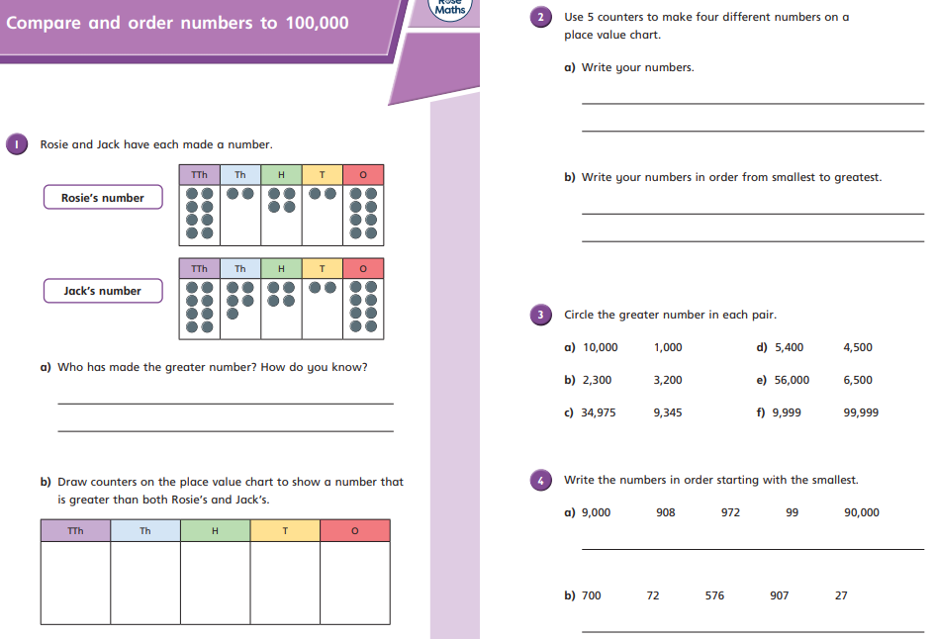
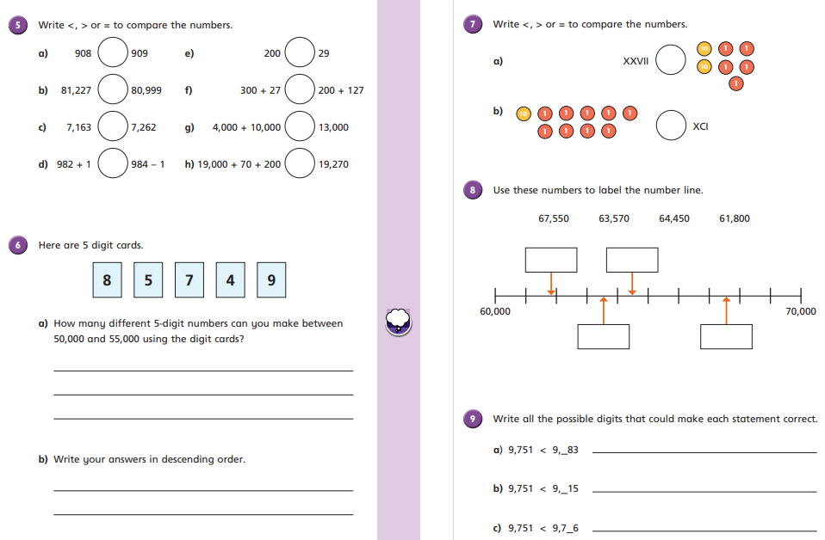

This number is __________. I know this because it has __ ten-thousands, _____ -thousands, ___ hundreds, ___ tens and ___ ones.
9.10.20 13.10.20
LO: To know and use number
C: Compare and order numbers to 100,000
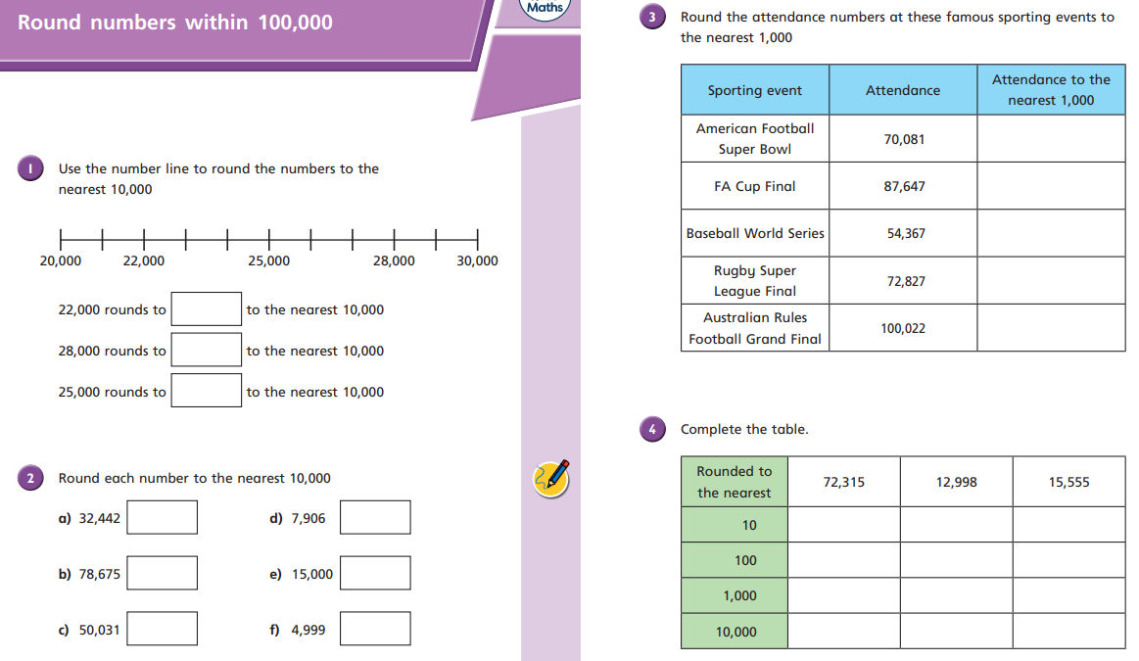

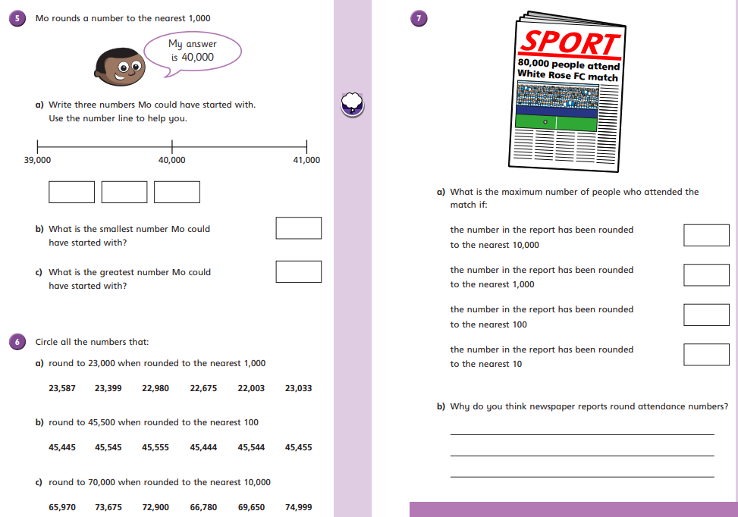

14.10.20
LO: To know and use number
C: Numbers to a million
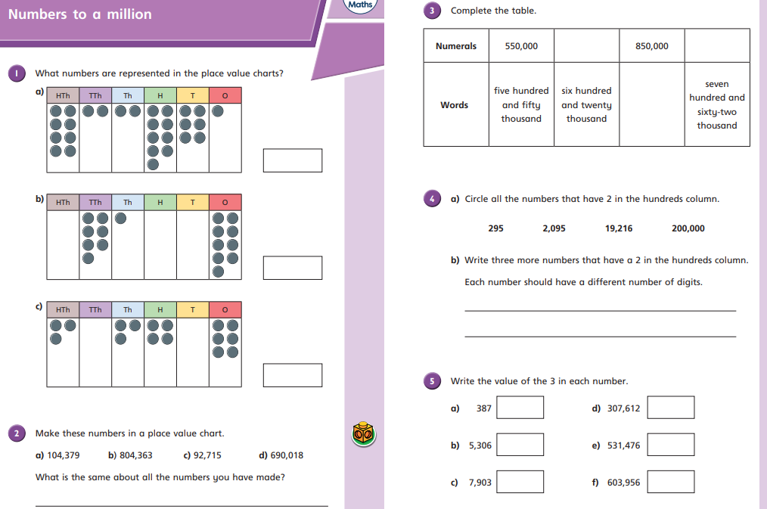
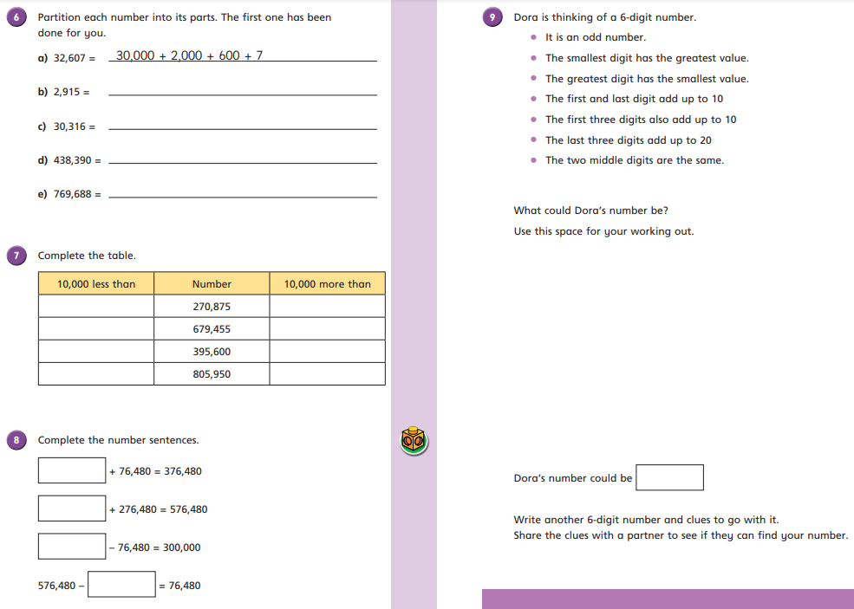

15.10.20
LO: To know and use number
C: Counting in 10s, 100s, 1,000s, 10,000s and 100,000s
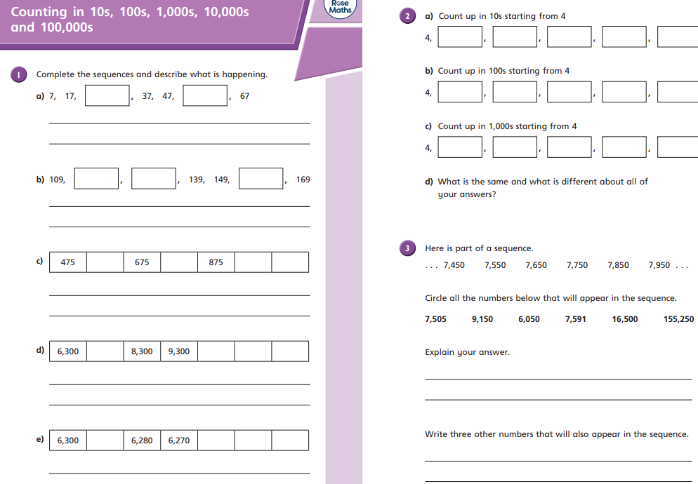
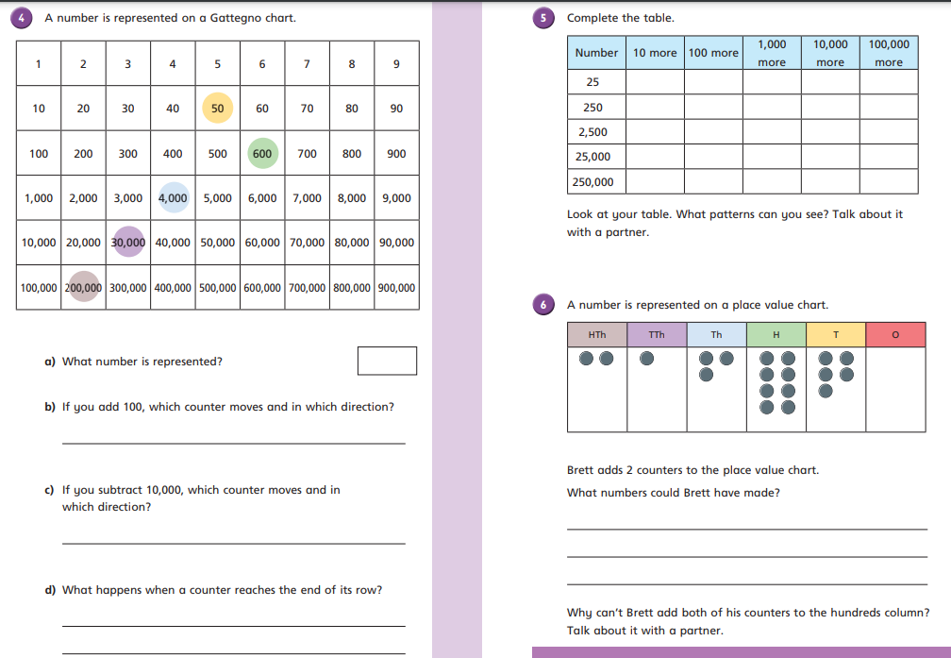

16.10.20
LO: To know and use number
C: Compare and order numbers to one million


