
Year 5 Distance Learning – w.b.11.05.20
For more detailed information on activities, please see plans below the timetable!
Please read either your school or a home reading book for 30 minutes every day.
Please log onto Century tech an assignment has been created. The nuggets that need to be completed are below.
Monday | Reading  Century tech  Reading the question and text | Maths  Watch teaching video on decimal sequences (11.05.20) then answer questions.  Challenge questions are below | Times Tables/Number Bonds/Telling the Time/Measuring | Playtime! | Writing  See below. | Grammar  and  Spelling  Full stops | Lunchtime! | RE  Do you believe God is everywhere and in everything? Explain your answer in a bubble map using what you already know about Hinduism. | French  http://www.crickweb.co.uk/ks2french.html practise how to recognise classroom equipment. | PE
Tuesday | Reading  Clues in the text | Maths  Watch teaching video on x decimals by 10, 100 and 1000 then answer questions.  Challenge questions are below. | Times Tables/Number Bonds/Telling the Time/Measuring | Playtime! | Writing | Grammar  and  Spelling  Colons to introduce lists | Lunchtime! | History  Viking letter (see below) | Music  https://www.youtube.com/watch?v=CdvITn5cAVc listen to the song and write down what type of music it is and how it makes you feel? | PE
Wednesday | Reading  Number questions | Maths  Watch teaching video on ÷ by 10, 100 and 1000 above.  Challenge questions are below. | Times Tables/Number Bonds/Telling the Time/Measuring | Playtime! | Writing | Grammar  and  Spelling  Colons for clauses | Lunchtime! | Science  2 week project- you need to build and write an written explanation on the most streamlined aeroplane you can build. Further explanation is below this timetable. | Circle time/PSHCE  Acts of kindness  See below | PE
Thursday | Reading  Structure of a text | Maths  REVISION- https://www.mathspad.co.uk/interactives/decimalsTool/decimalsTool.php  Challenge questions are below. | Times Tables/Number Bonds/Telling the Time/Measuring | Playtime! | Writing | Grammar  and  Spelling  Semi-colons for a list | Lunchtime! | D.T  See Science. |  | PE
Friday | Reading  Understanding the whole text | Maths  Ordering decimals sheet- 15.05.20  Challenge questions included. | Times Tables/Number Bonds/Telling the Time/Measuring | Playtime! | Writing | Grammar  and  Spelling  Semi-colons for clauses | Lunchtime! | Computing  Go into Scratch: https://scratch.mit.edu/projects/249143200/editor?tutorial=animate-an-adventure-game animate an adventure game. | Handwriting  See below | PE

Maths- If you complete the Maths- please continue Century tech nuggets on the following topics: Percentages and decimals, measurement.

Maths
Write down an explanation of your method, or tell an adult your method if they are not busy.
Get an adult to check if your answer is correct. If you get any wrong, try and correct them yourself using a different coloured pen/pencil.

Day 1  Challenge questions:  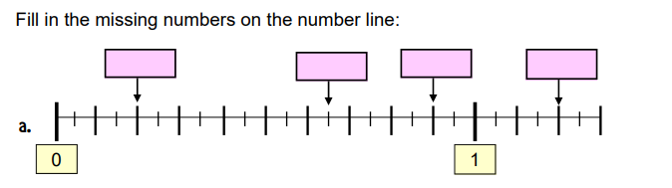  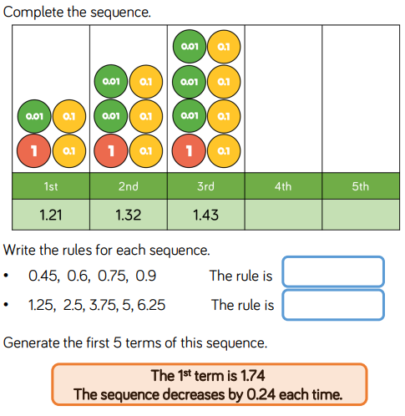  *term means number. It’s just a fancy way of saying number in a sequence. | Day 2  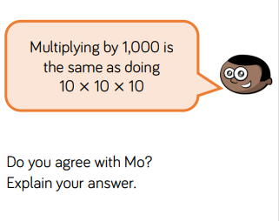 | Day 3  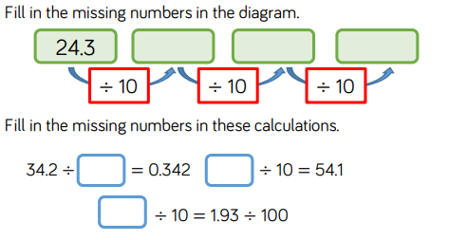 | Day 4  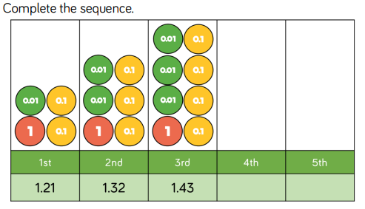 | Day 5  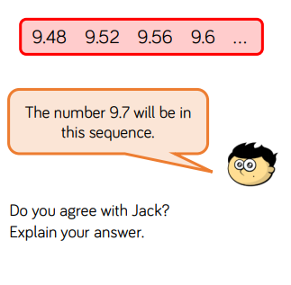

Times Tables/Number Bonds/Telling the Time/Measuring
Spend some time revising these different areas of maths.
Over the week you could:
- Practise whichever ‘Maths Minutes’ you are on at the moment.
- You could watch a Percy Parker video on YouTube or play TT Rockstars.
- Have a look at some of the maths games you could play!
Century Tech
Crickweb
Top marks
TT Rockstars
Hit the Button
- Look at the clock and identify the time. What will the time be in 5 minutes? 30 minutes? Can you work out how long you have spent reading today? How many minutes until lunchtime? etc.
Writing
This is your first week on Persuasion texts.
This week we are thinking about the word persuasion and what it means. We will watch a video to learn about what persuasion and persuasive writing is and look at forms of persuasion such as advertisements and letters.

Monday – Use the Monday PowerPoint to look at techniques used to make writing persuasive, and then have a go at using and identifying the techniques yourself.
Tuesday – Use the Tuesday-Wednesday PowerPoint and “Reasons planning sheet” to help you plan for your letter.
Wednesday – Use the Tuesday-Wednesday PowerPoint and “Blank plan”, “Techniques planning” and word mats to help plan your letter.
Thursday – Finish planning your letter and start writing it!
Friday – Finish writing your letter then edit.

Spelling

Legible | Comfortable | Reasonable | Ordinary | Peculiar | Popular
dependable | understandable | enjoyable | Particular | perhaps | position
The words highlighted light blue are for the groups of children who work are in Mrs Everett’s group for spellings.
Write out the words in different colours, try ‘look, cover, say, write, check,’ write sentences using the spellings in or ask an adult to test you on your spellings.

PE
Joe Wicks is doing a daily P.E. session for children from 9am every day this week!
Here is the link for his YouTube channel should you wish to participate. https://www.youtube.com/user/thebodycoach1
Circle time/PSHCE
https://www.youtube.com/watch?v=rwelE8yyY0U Small actions can make a big difference. This idea has really been highlighted during the Coronavirus pandemic, with people showing small and big acts of kindness to strangers. Being kind is not only a great way to improve the wellbeing of others, but also improves our own mental wellbeing. This week, list some of the different ways that you can help create a happier, healthier world. For example, it might be through helping others, giving to charity or picking up litter.
Science
Can you build the most streamlined aeroplane? This is a 2 week project and we would like you to research and find out as much information about air resistance as you can before you start building. The material you use is up to you, but we would like you to be creative as you will need paper to write up your explanation about why you decided to create your aeroplane using the material/s that you used? Also, how did you build your aeroplane so that it’s streamlined?

History
Write a letter from a Viking who has just arrived in Britain to his family back in his homeland. In your letter, try to include facts and information from what you have learnt over the past few weeks. For example you could describe: the longboat you travelled in to get to Britain, your reasons for leaving your homeland, the things that attracted you to a life in Britain or what you notice about the local British people when you arrive (Anglo-Saxons). Try to include as much historical detail from your history learning as possible.
Handwriting
Copy this poem in your best cursive handwriting.

One sunny May morning,
I planted some seeds,
I watered them daily,
And pulled out the weeds.

I watered and weeded,
Till one July day,
I went to my garden,
And picked a bouquet!

