__ lots of ___ make ____.
The value of the __ is ____.
21.9.20
LO: To know and use number
C: Recap 1,000s, 100s, 10s and 1s
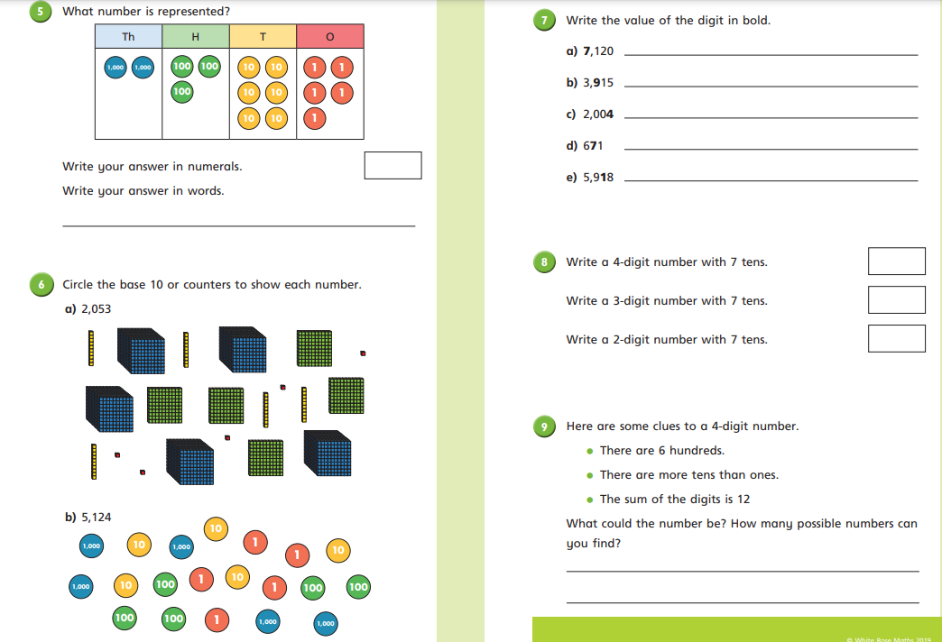

22.9.20
The number being represented is _____.
I know this because there are __ thousands, __ hundreds, __tens and __ ones.
LO: To know and use number
C: Numbers to 10,000
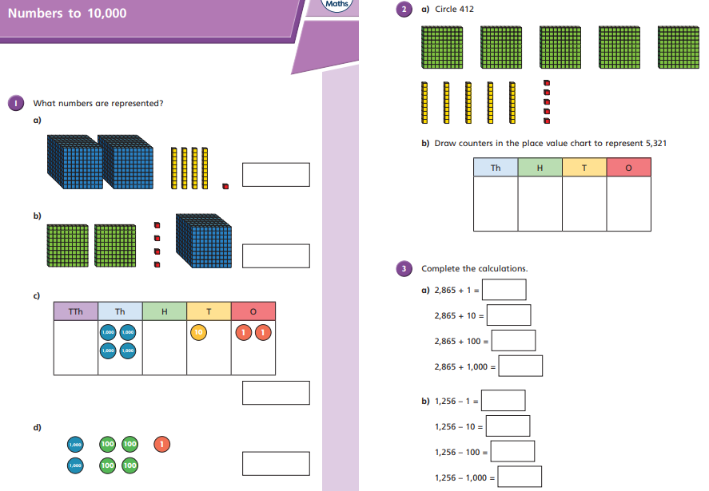

23.9.20
The number being represented is _____.
I know this because there are __ thousands, __ hundreds, __tens and __ ones.
LO: To know and use number
C: Numbers to 10,000
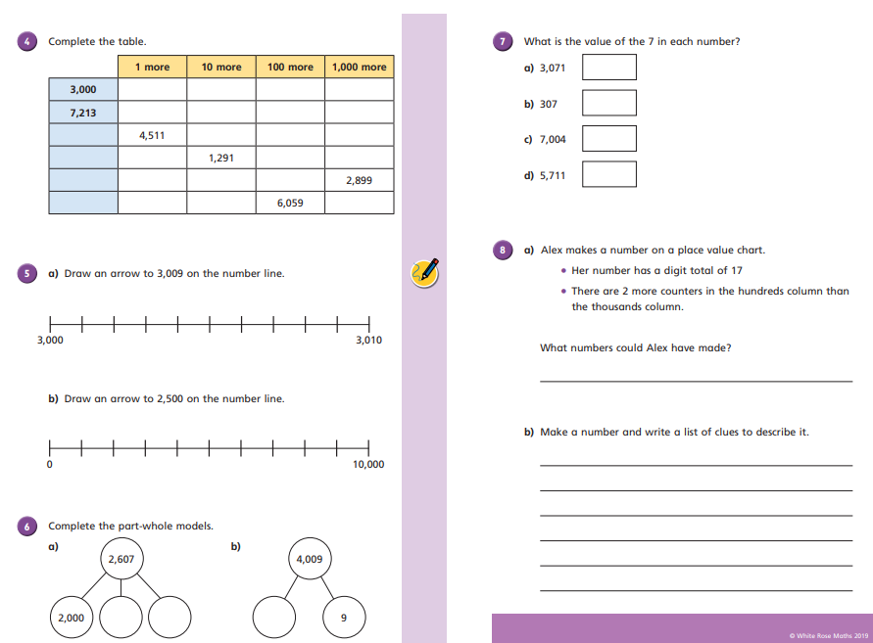

23.9.20
The nearest multiple of ten to ___ is ___.
___ is ___ when rounded to the nearest ten.
LO: To know and use number
C: Recap – rounding to the nearest ten


