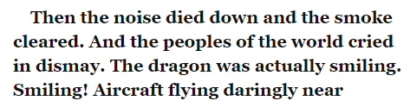
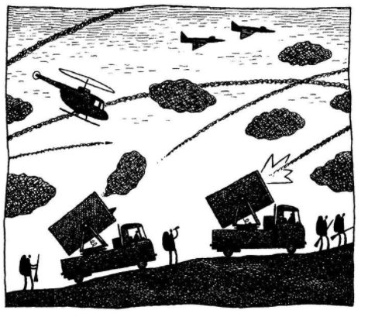
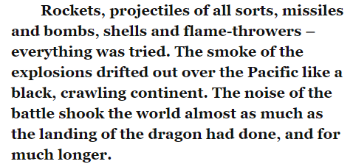
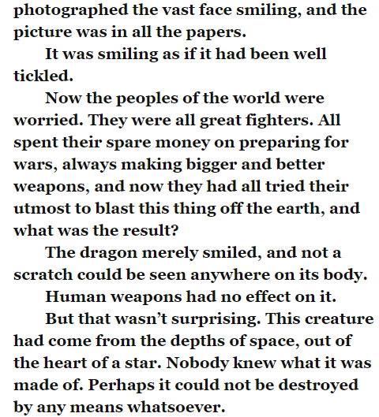

- Why was the dragon smiling?

- Copy one phrase from the text which shows that the dragon did not get hurt during the attack.

- Using what you have read in the text, what do you think the word ‘lament’ means?

- Match the event to where it happened. Use a ruler.

spilling teacups
jolting pictures
cracking statues
Russia
London
California

- Why do you think the author repeats the word ‘terribly’? Tick one.
  - To make the reader laugh
  - To show how friendly the creature is
  - To show how scary the monster is

- What happened to anyone that was sat on the mountain-top?

- What is the size of the dragon’s head compared too?

