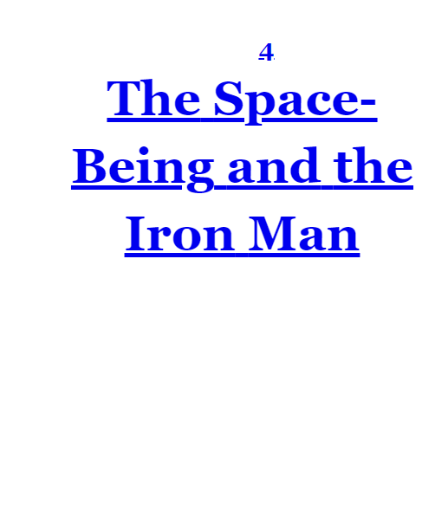
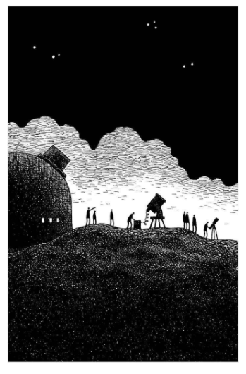
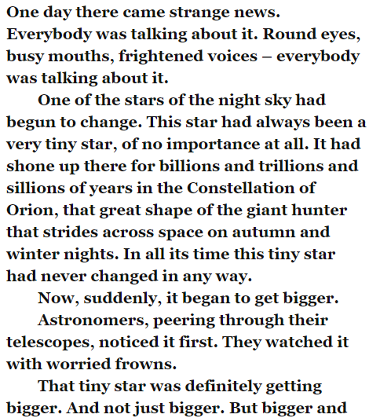

- Look at the first paragraph. Find and copy one word that means ‘scared’.

- Look at the third paragraph. Find and copy one sentence or phrase that shows the astronomers are concerned by what they are seeing.

- What do you think might have caused the star to change?

