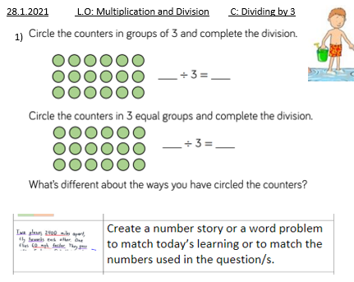

28.1.2021 L.O: Multiplication and Division C: Dividing by 3



