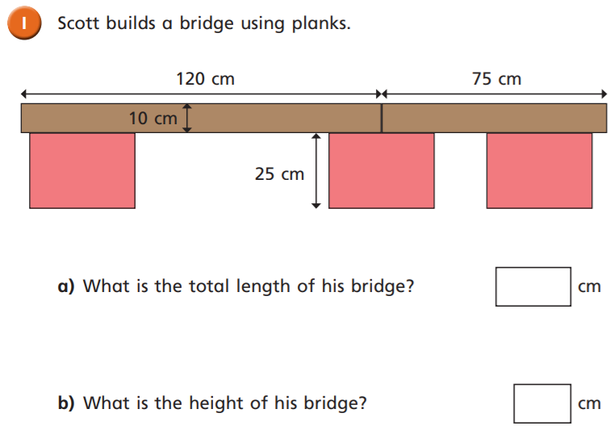
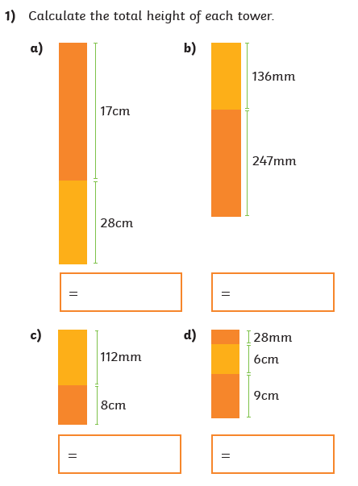
05.05.2021
LO: To use measure
C: Add length

1)

2)
05.05.2021
LO: To use measure
C: Add length

1)

2)

