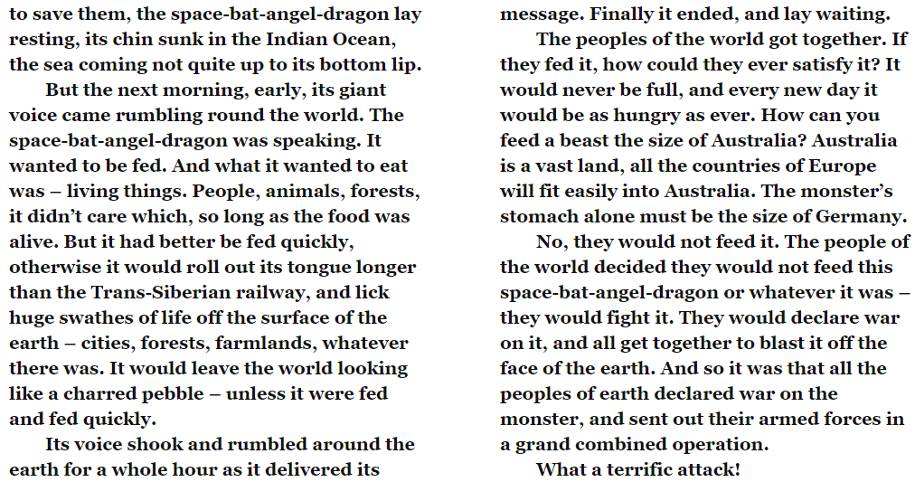
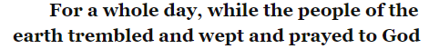

- Whilst the villagers ‘prayed to God’, what did the dragon do?

- What does the dragon like to eat?

- To show the reader how big the monster is, what does he compare him to? Why is this a good comparison?

- Match the event to where it happened. Use a ruler.

spilling teacups
jolting pictures
cracking statues
Russia
London
California

- Why do you think the author repeats the word ‘terribly’? Tick one.
  - To make the reader laugh
  - To show how friendly the creature is
  - To show how scary the monster is

- What happened to anyone that was sat on the mountain-top?

- What is the size of the dragon’s head compared too?

