
Dear Diary,
Last night I could barely sleep a wink I was so excited and nervous to start my apprenticeship with my Dad at the cloud tower. I almost missed my first day of work because I snored through the ringing alarm. I darted out of bed, brushed my teeth and whizzed out the door!
As I got to the cloud tower I looked up and all I could see was clouds. My dad started to clamber up the steep, creaky old ladder. Reluctantly I followed him. As I stepped onto the platform my dad got out an old battered suitcase. I wondered what was in it. Carefully, he lifted out an old metal pole with a ring on the top. I wondered what he would use it for.

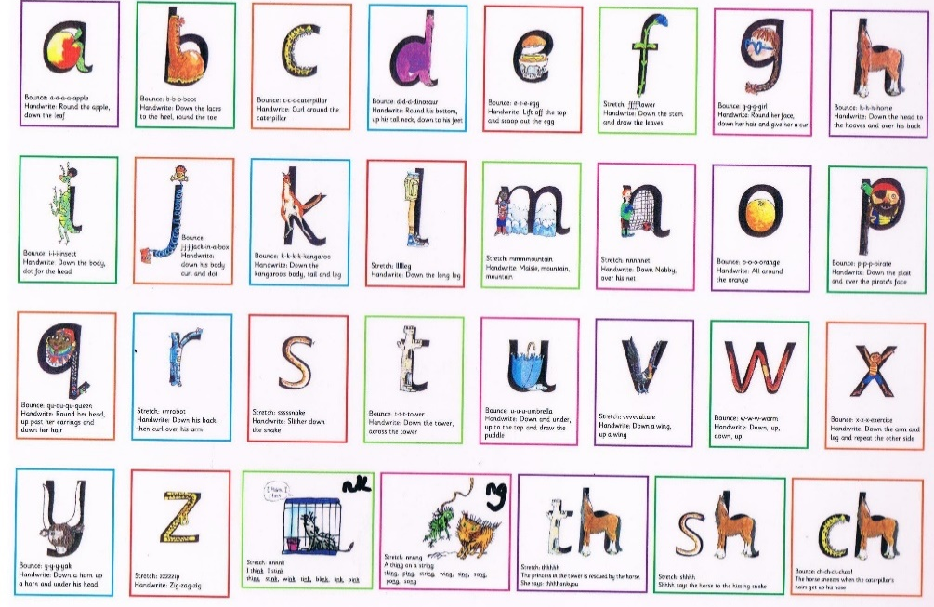

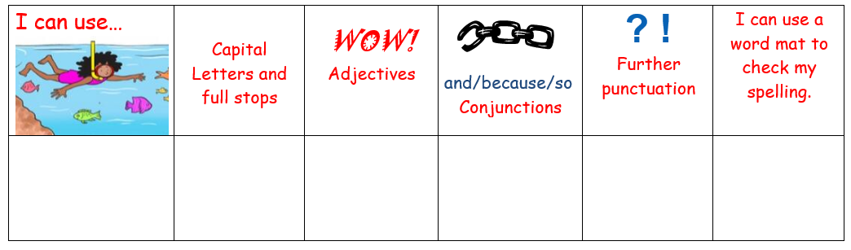

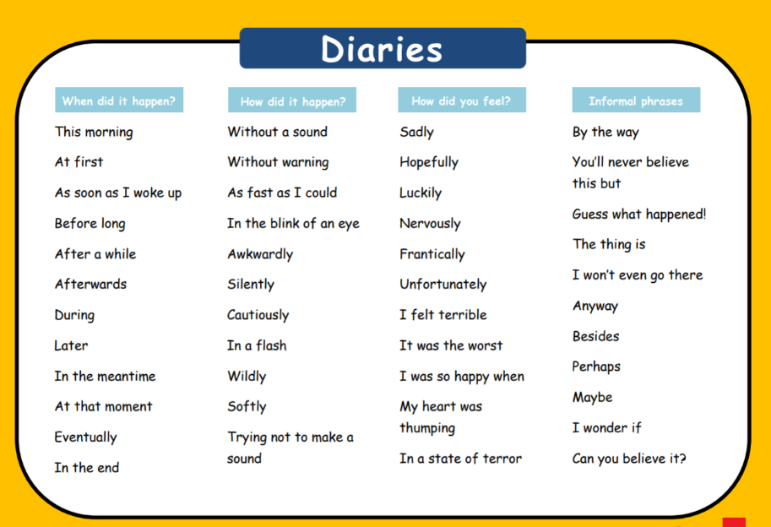
Calmly dad placed the ring into the holder. Without a sound, he calmly ambled up to it and blew. Astonishingly a white, fluffy cloud appeared and floated gently away. My heart was thumping but dad gestured that I should give it a try. Nervously I crept up to the instrument. I planted my feet firmly on the floor. I drew a big breath in down to my toes and with an enormous puff released the air through the ring. Only a wisp came out. Unfortunately I had failed.
My dad tried to encourage me to keep trying and persevere. Cautiously I approached the instrument again. My heart sank as again nothing happened. I kept trying and trying and trying with all my might. But then, the instrument snapped in two. I was so embaressed.

