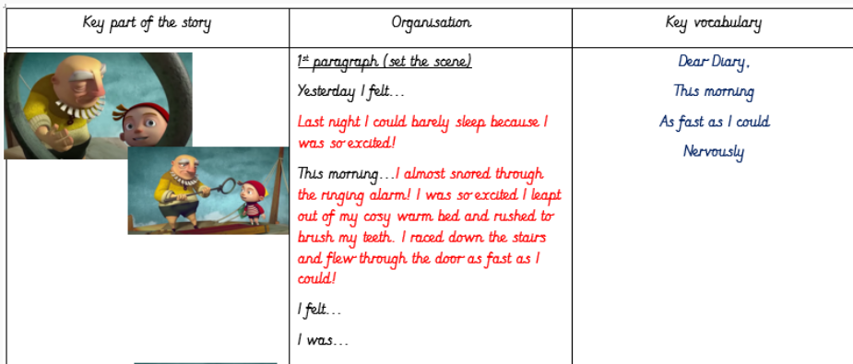
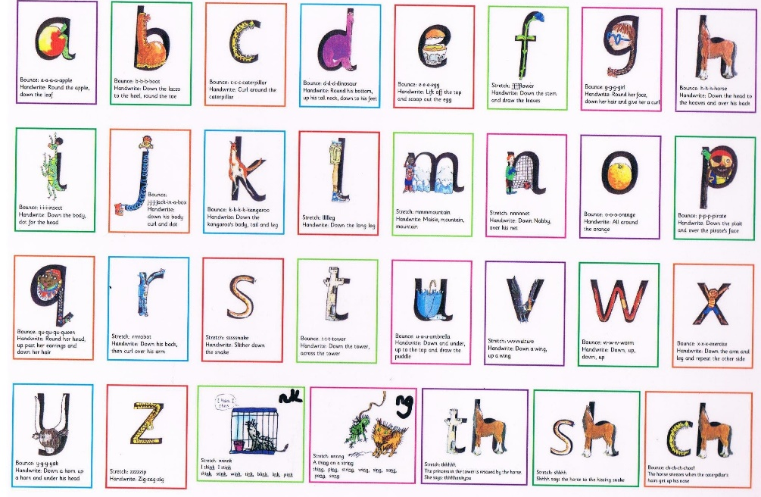

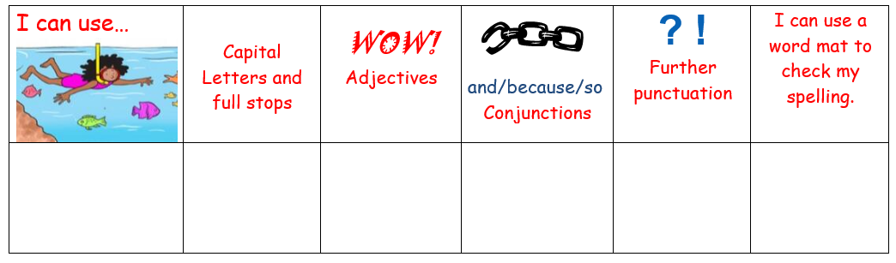
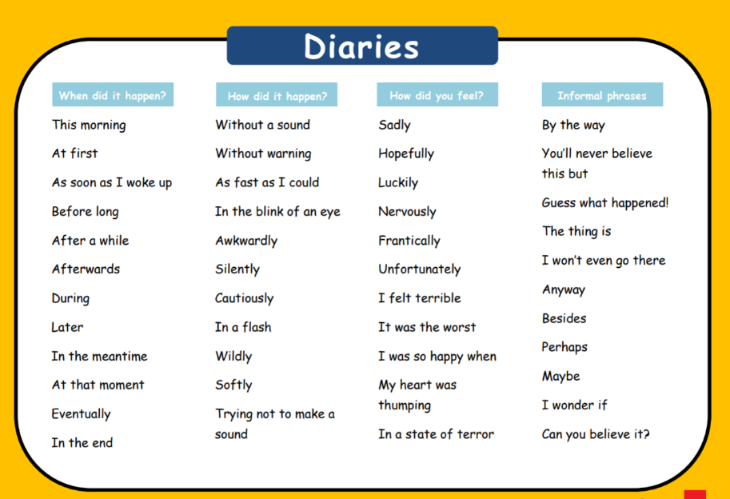
Dear Diary,
Last night I could barely sleep a wink I was so excited and nervous to start my apprenticeship with my Dad at the cloud tower. I almost missed my first day of work because I snored through the ringing alarm. I darted out of bed, brushed my teeth and whizzed out the door!
As I got to the cloud tower I looked up and all I could see was clouds. My dad started to clamber up the steep, creaky old ladder. Reluctantly I followed him. As I stepped onto the platform my dad got out an old battered suitcase. I wondered what was in it. Carefully, he lifted out an old metal pole with a ring on the top. I wondered what he would use it for.

