Key part of the story | Organisation | Key vocabulary
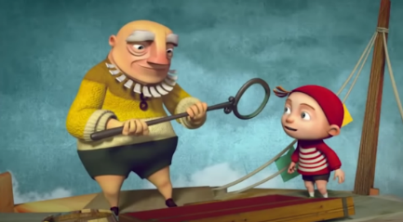  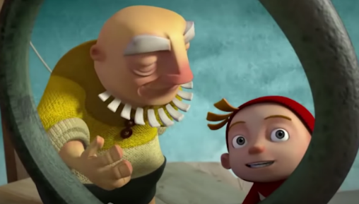 | 1st paragraph (set the scene)  Yesterday I felt...  This morning...  I felt...  I was...
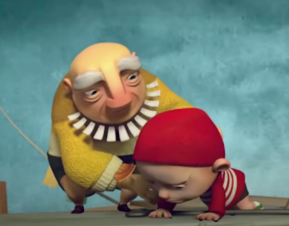   | 2nd paragraph (main events)  First,  Next,  Then,  It was ...  I felt...
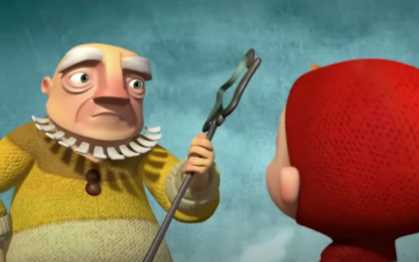   | 3rd paragraph (what happened at the end)  After that...  Finally,  After a long practise...

