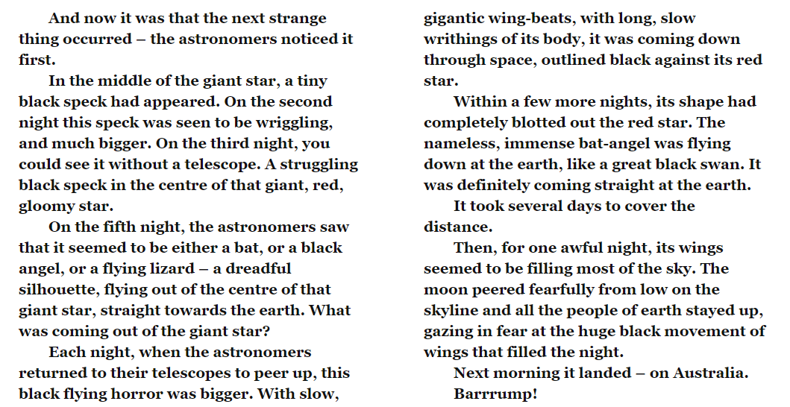

- What 3 things do the astronauts think the object in the sky could be?

- What does writhing mean?

- Read this section carefully and draw a picture of what you think this creature/object is. What does it look like in the sky? What is around it?

- How does the author emphasis the fact that the star’s size keeps increasing?

- How do you think the author wants the reader to feel when they read ‘blazing down, the size of the moon, a deep gloomy red?

- How did the astronomers know that the star had stopped moving?

- Why does the author ask lots of questions at the end of this section of text?

