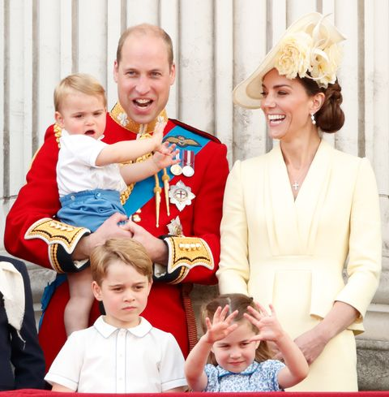
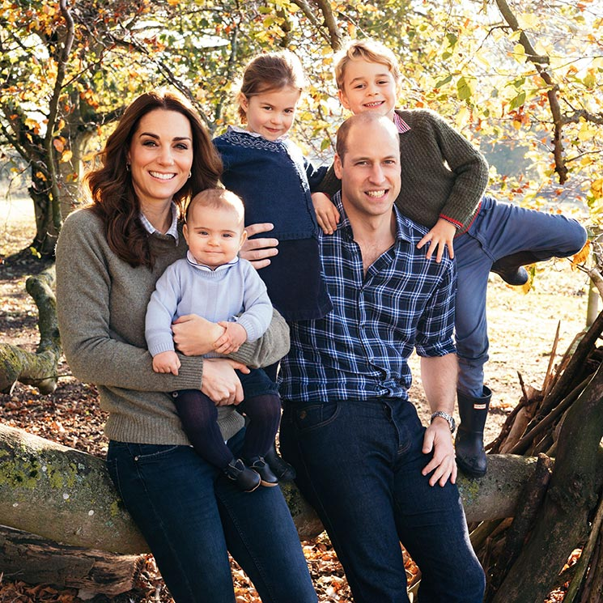
Look at the pictures of the Royal Family.
Which features have the children inherited from which parent?
Look at the pictures of the Royal Family.
Which features have the children inherited from which parent?

